GRAIN AND FORAGE LEGUME YIELDS, WITH OR WITHOUT INTERCROPPING

AND THE EFFECT OF LEUCAENA GREEN LEAF MANURING

ON NITROGEN ECONOMY OF CORN

A DISSERTATION SUBMITTED TO THE GRADUATE DIVISION OF THE
UNIVERSITY OF HAWAII IN PARTIAL FULFILLMENT
OF THE REQUIREMENTS FOR THE DEGREE OF

DOCTOR OF PHILOSOPHY

IN

AGRONOMY AND SOIL SCIENCE

AUGUST 1984

BY

Shiva Kumar Chaudhary

Dissertation Committee

A. Sheldon Whitney, Chairman
Peter P. Rotar
James A. Silva
Yoshinori Kanehiro
Douglas Friend

We certify that we have read this dissertation and that in our opinion it is satisfactory in scope and quality as a dissertation for the degree of Doctor of Philosophy in Agronomy and Soil Science.
ACKNOWLEDGEMENT
The author wishes to express his whole-hearted appreciation to Drs. A. S. Whitney and P. P. Rotar or their guidance, advice, and encouragement in bringing this long-term effort to a successful conclusion. The author is indebted to Dr. James A. Silva for his valuable suggestions especially in statistical analysis and review of the manuscript and to Drs. Y. Kanehiro and D. Friend for serving on his advisory committee and reviewing the manuscript.
The author is indebted to and wishes to express his appreciation to the Department of Agronomy and Soil Science and the NifTAL Project for their continued support and without whose financial assistance this work would not have been possible.
His gratitude is extended to the Farm Manager, Mr. Herbert Omizo, and the staff of the Waimanalo Research Station, and Mr. Y. Oshiro and Mr. Y. Nakatani of Mauka Campus for their support and assistance
provided during the entire experimental period. Thanks are also extended to Mr. Miguel Alvarey and Mrs. M. R. Reiss for helping in typing the manuscript.
The author extends his special thanks to his wife, Meera Chaudhary, for her unfailing support, continued encouragement, and understanding. Thanks are also extended to his daughters, Neetu and Reetu, for their understanding and patience in waiting several years for their parents to return. The author is grateful to his parents and other members of his family for their encouragement and support.
ABSTRACT
Field experiments involving growing of two grain legumes and two forage legumes with or without corn were conducted during five consecutive seasons in a very fine, kaolinitic, isohyperthermic, Vertic Haplustoll soil in Hawaii to evaluate the yield potentiality and N economy of these Cropping Systems.
Grain legumes evaluated were mungbeans (Vigna radiata) and soybeans (Glycine max). Corn grain yields increased in intercrops as compared to the grain yields in control plots of corn (no N application). The increases in intercropped corn grain yields over grain yields in control plots were 158, 163, and 163% in season 1, and 181, 146, and 118% in season 3 in corn/determinate mungbeans, corn/indeterminate mungbeans, and corn/soybean intercrops, respectively. Grain yields of mungbeans and soybeans were slightly depressed in intercroppings as compared to their monocroppings. Harvest indices and plant heights of intercropped corn and legume crops were not significantly different than those of their monocrops.
Total biomass produced by corn/grain legume intercropped plots (6.11 to 10.88 Mg ha⁻¹) were much higher than the biomass produced by control plots (3.08 to 4.33 Mg ha⁻¹) of corn. Total grain produced by corn/grain legume intercroppings (1.58 to 3.45 Mg ha⁻¹ ) were 4 to 6 times higher than the grain produced by control plots of corn (0.39 to 0.55 Mg ha⁻¹). LAI increased in corn/legume intercrops as compared to their monocrops. LER values in these intercropping systems were in the ranges of 1.9 to 2.2 in season 1 and 1.6 to 1.9 in season 3.
The grain yields and the plant heights of corn following grain legume plots in season 2 and season 4 were comparable with those of corn monocrops at 33 to 67 kg ha⁻¹ levels of N application.
Nitrogen contributions from grain legumes to associated corn crop were none in season 1 and 10 to 25 kg N ha⁻¹ in season 3. N contributions from legumes to the following corn, however, were 40 to 58 kg N ha⁻¹ in season 2 and 31 to 75 kg ha⁻¹ in season 4. The residual N contribution to the following corn was the highest by indeterminate mungbeans (58.0 to 75.0 kg N ha^{-l}) followed by soybeans (40.0 to 62.5 kg N ha⁻¹) and determinate mungbeans (35.0 to 47.0 kg N ha⁻¹). Nitrogen fixation by mungbeans and soybeans were not depressed in intercroppings as compared to their monocroppings, except in soybeans in season 1 where soybeans were shaded by corn.
Forage legumes evaluated were leucaena (Leucaena leucocephala) and desmodium (Desmodium intortum). Grain yields of corn intercropped with leucaena were slightly higher than in control plots in all seasons
except season 2, where corn was shaded by leuceana. Grain yields of corn intercropped with leucaena were 128, 60, 122, and 102% of control plots of corn in season 1 to 4, respectively. Grain yields of corn intercropped with desmodium were slightly lower than the control plots of corn in all seasons except season 4. Grain yields of corn intercropped with desmodium were 72, 71, 91, and 118% of control plots of corn in season 1 to 4, respectively. In general, corn did better with leucaena than with desmodium. However, corn seemed to perform better with leucaena during summer and better with desmodium during winter periods. Seasonal forage yields of leucaena and desmodium were not different in intercrops than in their monocrops. Total biomass produced by corn/forage legume intercropped plots (4.5 to 17.0 Mg ha⁻¹) were much higher than the biomass produced by control plots (3.08 to 4.33 Mg ha⁻¹) of corn. LAI was higher in intercropping than in the control plot of corn. Total LER values in corn/leucaena and corn/desmodium intercrops were in the ranges of 1.40 to 2.10 and 1.60 to 1.81, respectively.
Nitrogen produced by leucaena was from 630 to 653 kg ha⁻¹ yr⁻¹ and by desmodium was from 508 to 608 kg ha⁻¹ yr⁻¹. Total N yields obtained from corn/leucaena intercroppings were 7 to 21 times and from corn/desmodium intercroppings were 7 to 14 times as much as the N yields obtained from die control plots of corn. N contributions from forage legumes to associated corn were none in season 1 and season 2, however, there was some N contribution from legume to associated corn in season 3 and season 4 (19 to 30 kg N ha⁻¹ from leucaena and 9 to 17 kg N ha⁻¹ for desmodium). Corn following forage legumes in season 5 received residual N of 21 to 31 kg ha⁻¹ from leucaena plots and 23 to 30 kg ha⁻¹ from desmodium plots.
In another field experiment, leucaena forage was incorporated into soil as green manure for corn and the residual effects were evaluated in the second season. Corn grain yields obtained from the leucaena green manuring at the rates of 47, 94, and 141 kg N ha⁻¹ were equivalent to corn grain yields obtained from the urea-N rates of 18, 35, and 58 kg N ha⁻¹, respectively. The efficiency of leucaena green manure to increase corn grain yield as compared to urea-N applications were 37 to 41%. The amount of residual N from leucaena green manure to the following crop of corn were equivalent to urea-N application rate of 13 to 30 kg N ha⁻¹. Recoveries of N from urea-N were 39.4 to 47.0% and from leucaena-N were 26.3 to 30.5% in season 1. Recoveries of residual leucaena-N in season 2 were 5.0 to 7.1%. The total N recovered from the applied leucaena green manure were 31.7 to 37.6% by the two crops of corn.
A pot experiment was conducted where ¹⁵N-tagged mungbean plant materials, shoot, root, and shoot + root, were applied to a wheat crop and a second crop of wheat was grown to evaluate the residual ¹⁵N remaining. Total dry matter yields and total N uptake by the first crop of wheat increased with increasing rates of mungbean-N. Total dry matter and total N yields by wheat crop 1 obtained from the 100 kg N ha⁻¹ rate of all sources of mungbean-N were comparable with those from 33 kg ha⁻¹ rate of urea-N. Except the higher rates of mungbean-N applied (at and above 100 kg N ha⁻¹), the residual effects from all other mungbean-N treatments were not different than the control plot. In both the wheat crops, straw overyielded the grain at all levels and from all sources of N applied. In contrast, N uptake by grain was always higher than that by straw of wheat.
Wheat N derived from mungbean-N increased with increasing rates of mungbean-N applied and were higher (10.9 to 70.4%) by the first crop of wheat and lower (5.4 to 43.5%) by the second crop of wheat. Most of the mungbean-N applied were recovered by the first crop of wheat (11.1 to 33.9%) and only less than 6% of the N was recovered by the second crop of wheat. Recoveries of N were higher from shoot than from root treatments. Of the two methods used, the difference method overestimated the N recovery over the isotopic method.
TABLE OF CONTENTS

ACKNOWLEDGEMENT ...........................................3

ABSTRACT ..................................................4

LIST OF TABLES ............................................11

LIST OF APPENDIX TABLES ...................................13

LIST OF FIGURES ...........................................14

LIST OF APPENDIX FIGURES ..................................16

CHAPTER I. INTRODUCTION ...................................17

CHAPTER II. REVIEW OF LITERATURE ..........................19

Terminology ..........................................19
Competition and Yield Advantages
in Intercropping ...................................20
Nitrogen Transfer from Legume to
Non-legume .........................................27
Green Leaf Manuring ..................................35
The Use of ¹⁵N-Labeled Fertilizers ................... 40
Evaluation of Intercropping
Experiments ........................................43

CHAPTER III. GRAIN LEGUMES WITH OR WITHOUT
INTERCROPPING WITH CORN (Zea mays L.) ................47

INTRODUCTION .........................................47

MATERIALS AND METHODS ................................49

Removal of Available N from Soil .....................49
Fertilization ........................................50
Planting of the Experiment ...........................50
Weed and Insect Control ..............................51
Harvesting ...........................................51
Plant Height, Number of Pods, per
Plant and LAI ......................................54
Nitrogen Fixation ....................................54
Dry Matter Yield .....................................54
Nitrogen Content .....................................54
Nitrogen Recovery ....................................55
Evaluation ...........................................55

RESULTS AND DISCUSSION ................................56

Performance of Corn in Intercropping ..................56
Performance of Grain Legume in
Intercropping .......................................62
Total Performance in Intercropping ....................66
Corn Following Grain Legumes ..........................70
Environmental Effects .................................77
Nitrogen Yield and Transfer ...........................79
N Recovery from Urea .................................86
Soil Nitrogen .........................................90
Effects on Nitrogen Fixation ..........................90

SUMMARY AND CONCLUSIONS .................................95

CHAPTER IV. FORAGE LEGUMES WITH OR WITHOUT INTERCROPPING
WITH CORN (Zea mays L.) ............................99

INTRODUCTION .......................................99

MATERIALS AND METHODS .................................100

Planting ..............................................101
Weed and Insect Control ...............................102
Harvesting ............................................102
Plant Height and LAI ..................................103
Dry Matter Yield ......................................103
Nitrogen Contents .....................................103
Evaluation ............................................104

RESULTS AND DISCUSSION ................................104

Performance of Corn in Intercropping ..................104
Performance of Forage Legumes .........................110
Total Performance in Intercropping ....................116
N Yields and Transfer .................................119
Performance of Corn Following Forage
Legumes .............................................123

SUMMARY AND CONCLUSIONS ...............................125

CHAPTER V. EVALUATION OF LEUCAENA (Leucaena Leucocephala
(Lam.) de Wit) AS A GREEN LEAF MANURE FOR CORN
(Zea mays L.) ..............................................132

INTRODUCTION .......................................132

MATERIALS AND METHODS .................................133

Treatments ............................................133
Planting ..............................................134
Observations ..........................................135
Evaluation ............................................135

RESULTS AND DISCUSSION ................................136

Performance of Corn in Season 1 .......................136
Performance of Corn in Season 2 .......................138
Nitrogen Recovery .....................................145 Correlations ..........................................148

SUMMARY AND CONCLUSIONS ...............................148

CHAPTER VI. NITROGEN UPTAKE BY WHEAT CROPS FROM
¹⁵N-LABELED LEGUME PLANT MATERIALS .....................153

INTRODUCTION ..........................................153

MATERIALS AND METHODS .................................154

Tagging of Mungbeans ..................................155
Treatments ............................................155
Planting of Wheat .....................................156
Harvesting ............................................156
Evaluation ............................................158

RESULTS AND DISCUSSION ................................159

Yield of Wheat Crop 1 .................................159
Nitrogen Uptake by Wheat Crop 1 .......................161
Yields of Wheat Crop 2 ................................165
Nitrogen Uptake by Wheat Crop 2 .......................165
Nitrogen Recovery by Wheat ............................168

SUMMARY AND CONCLUSIONS ...............................176

APPENDIX TABLES .............................................178

APPENDIX FIGURES ............................................189

LITERATURE CITED ............................................205
LIST OF TABLES

Table page

3.1 Sequence of crop combinations grown in four
consecutive seasons ..................................52

3.2 Spacing, plant density, planting and harvesting
dates, and growing periods of crops ..................53

3.3 Corn grain yields in intercrops and percent
increase over the control plots ......................60

3.4 Harvest indices of corn in seasons 1 and 3 ...........61

3.5 Plant height, number of pods per plant and
harvest indices of two grain legumes .................65

3.6 Grain yields of corn and legume intercrops ...........69

3.7 Leaf area indices of corn and legumes
in season 1 ..........................................71

3.8 Land equivalent ratios in corn/grain
legumes intercrops ...................................72

3.9 Grain and dry matter yields of corn
following grain legumes ..............................74

3.10 Harvest indices and plant heights of
corn in seasons 2 and 4 ..............................76

3.11 Percent N in plant tissues of grain
legumes in seasons 1 and 3 ...........................84

3.12 Percent N in corn ear leaves at 50% silking
in seasons 1 through 4 ...............................85

3.13 Estimated amount of N contributed to corn by
grain legs based on N uptake by corn from
applied urea-N .......................................89

3.14 Percent N recovery from urea fertilizer ..............91

3.15 Nitrogenase acitivity in legumes in
seasons 1 and 3 ......................................93

3.16 Correlation coefficients for the relationships
between variables related to N₂ fixation .............94

4.1 Percent change in grain yields, of corn
intercropped with forage legumes
compared to control plots (monocropped
corn without N) .......................................108

4.2 Harvest indices and plant heights of corn in monocrops
compared to intercrops with forage legumes ............109
4.3 Dry matter accumulation of leucaena and
desmodium during their growing period .................113

4.4 Leaf area indices of corn and forage
legumes in season 1 ...................................118

4.5 Land equivalent ratios in corn/forage
legumes ...............................................120

4.6 Correlation coefficients for the relationships
among dry matter yield, N yield and % N in
leucaena and desmodium ................................124

4.7 Performance of corn following forage
legumes in season 5 ...................................127

5.1 Performance of corn with leucaena
green manuring in season 1 ............................137

5.2 N yield and percent N in plant tissues
of corn in season 1 ...................................140

5.3 Performance of corn in season 2 (residual effects
of leucaena green manure from season 1) ...............142

5.4 N yield and percent N in plant tissues
of corn in season 2 ...................................147

5.5 Percent N recovery from leucaena green manure
and urea in season 1 and season 2 .....................149

5.6 Correlation matrix of several variables of
corn in seasons 1 and 2 ...............................150

6.1 Treatments, rate of N, and amount of urea and
plant materials applied ...............................157

6.2 Yield of wheat crop 2 .................................166

6.3 Percent N in plant tissues and N
uptake by wheat crop 2 ................................169

6.4 Nitrogen recovery by two crops of wheat
estimated by different methods ........................175
LIST OF APPENDIX TABLES

Table page

1 Grain and dry matter yields of corn and
grain legumes in seasons 1 and 3 ....................178

2 Seasonal total dry matter yields
in all the crops ....................................179

3 Solar radiation, temperature and rainfall during
the period of experiment at Waimanalo Research
station in Hawaii ...................................180

4 Seasonal N yields in all the crops ..................181

5 Grain yield of corn intercropped with forage
legumes in seasons 1 through 4 ......................182

6 Seasonal dry matter, N yield, and percent N of
leucaena and desmodium ..............................183

7 Annual dry matter, and N yields of leucaena and
desmodium during their growing period ...............184

8 Nitrogen content in soil before and after
planting in each season .............................185

9 Yield of Wheat crop 1 ...............................186

10 Percent N in plant tissues and N
uptake by wheat crop 1 ..............................187

11 Atom % ¹⁵N in plant tissues of
two crops of wheat ..................................188
LIST OF FIGURES

Figure Page

3.1 Effects of urea N application on grain
yield of corn in seasons 1 and 3 ..........................57

3.2 Dry matter yields of corn in monocrops compared
to intercrops in seasons 1 and 3 ..........................58

3.3 Plant heights of corn in monocropped compared to
intercropped in seasons 1 and 3 ...........................63

3.4 Dry matter yields of grain legumes
in seasons 1 and 3 ........................................64

3.5 Total dry matter yields in corn/grain legume
intercrops (C=corn and L=legume) ..........................67

3.6 Effects of urea N application on grain yields
of corn in seasons 2 and 4 ................................75

3.7 Effects of environmental conditions
on corn grain yields ......................................78

3.8 Total N yields in seasons 1 and 3 .........................80

3.9 Nitrogen yields in sequential crops of
corn in seasons 2 and 4 ...................................82

3.10 Percent N in corn ear leaves at 50% silking
at four levels of urea N application ......................87

3.11 Nitrogen uptake by corn at four levels
of urea N application .....................................88

4.1 Effects of urea N application on grain
yield of corn in seasons 1 to 4 ....................106

4.2 Dry matter yields of corn in monocrops as compared
to intercrops in seasons 1 and 4 ..........................107

4.3 Seasonal yields of leucaena and desmodium in
intercrops as compared to monocrops .......................111

4.4 Environmental effects on dry matter yield and dry
matter accumulation of leucaena and desmodium .............114

4.5 Total dry matter yields in monocrops of corn
compared to corn/forage legume intercrops .................117

4.6 Total N yields in monocrops of corn compared
to corn/forage legume intercrops ..........................121

4.7 Effects of urea N application on grain
yield of corn in season 5 .................................126

4.8 Effects of urea N application on N
uptake of corn in season 5 ...............................128

5.1 Effects of urea N application on grain
yield of corn in season 1 ................................139

5.2 Effects of urea N application on N
uptake by corn in season 1 ...............................141

5.3 Effects of urea N application on grain
yield of corn in season 2 ................................144

5.4 Effects of urea N application on
N uptake by corn in season 2 .............................146

6.1 Wheat yield as affected by urea-N
and mungbean-N applications ..............................160

6.2 Relationship between urea-N application
and dry matter yield of wheat crop .......................162

6.3 Nitrogen uptake by wheat crop 1 as affected
by urea-N and mungbean-N applications ....................163

6.4 Relationship between urea-N application
and N uptake by wheat crop 1 .............................164

6.5 Relationship between urea-N application and
dry matter yield of wheat crop 2 .........................167

6.6 Relationship between urea-N application
and N uptake by wheat crop 2 .............................170

6.7 Nitrogen derived by two crops of wheat from
mungbean plant materials and soils .......................172
LIST OF APPENDIX FIGURES

Figure Page

1 Planting patterns of crops in: A) monocrops,
and B) intercrops .........................................189

2 Growth of soybeans in: A) monocrop, B) intercrop
in season 1 (shaded), and C) intercrop in season
3 (not shaded) ............................................192

3 Growth of determinate mungbeano as A) monocrop and
B) intercrop, and of indeterminate mungbeans as
C) monocrop and D) intercrop ..............................195

4 Leucaena Shading corn in season 2 .........................198

5 Growth of leucaena A) monocrop and B) interccop,
and desmodium C) monocrop and D) intercrop ................199

6 Growth of wheat crop 1 at various rates of
A) urea-N, B) mungbean shoot-N, C) root-N,
and D) shoot + root-N applications ........................202
CHAPTER I
INTRODUCTION

The shortage and ever increasing prices of food commodities have put greater pressure on research organizations to study the efficiency of farm inputs used for food production. Increased crop production is limited by several factors, including the high cost and short supply of industrial fertilizers, particularly nitrogen. Increasing price of nitrogenous-fertilizers, and the difficulties in transportation and distribution, make them effectively unavailable to the small landholder.
Legumes hold great potential as source’s of high protein food and feed, and have received considerable attention from research organizations. Above all, because of their ability to fix significant amounts of atmospheric nitrogen, legumes become more important and offer an alternative for increasing nitrogen input in various cropping systems and soil management practices.
Multiple cropping (or polycropping) has been a long standing practice in many of the developing countries. Polycropping systems include both simultaneous and sequential mixed cropping and imply a more efficient use of resources (space, soil fertility, moisture, solar radiation, and other environmental growth factors) within the farmer’s socio-economic circumstances to maximize yield with minimum risk, minimum input and maximum ecological stability.
Legumes are frequently grown with non-legumes in some form of polycropping systems. Legumes may contribute nitrogen to associated non-legumes by releasing or excreting N from their roots or to succeeding non-legume crops from the plant residues left in the soil. The inclusion of legumes in cropping systems thus has the potential for improving the nitrogen economy of the whole system.
Corn is one of the major cereal crops widely used in cereal/legume intercropping. The choice of legumes in cropping systems depends on their compatibility with other non-legume crops. Legumes differ in their N fixing capacity and N requirements for their growth. It is therefore important to assess the compatibility and the N contribution of several legumes to the corn crop in order to develop a cropping system which may provide maximum N contribution from legume to non-legume, and thereby greatly reduce the input of nitrogenous fertilizers.
Legumes can also contribute N to non-legumes, when used as an N source, in the form of green manures. The use of legumes as green manures has been in practice for a long time in many parts of the world. Green manuring is the use of fresh plant material to modify soil conditions with the objective of improving the soil as a medium for plant growth. Green plant material may be placed on the soil surface as mulches or may be incorporated into the soil, and all plants may be considered as green manures when they are grown or harvested for this purpose.
The degree of N benefit from legumes either intercropped with nonlegumes or used as green manures depends on the amount of N remaining in either the legume residues or in the legumes added into the soil. Not
all the organic N added into the soil is mineralized or is readily available to the companion crop, therefore, it is important to evaluate the proportion of the added N that is utilized.
The studies reported here represent an attempt to a) compare the N contribution of two grain and two forage legumes to a corn crop, b) examine the potential of leucaena foliage as a green manure to corn, and c) determine the uptake of N by a cereal crop from the legume plant residues with the use of ¹⁵N-labeled fertilizer.
CHAPTER II
REVIEW OF LITERATURE

Terminology
Legumes are frequently grown with non-legumes in some form of polycropping system (intercropping, relay cropping, mixed cropping or strip cropping). Intercropping is defined as the growing of two (or more) crops simultaneously on the same area of ground. Crops are usually grown simultaneously for a significant part of their lifecycle, hence intercropping is distinguished from "relay cropping" in which growing periods only briefly overlap. Crops are grown in separate rows in intercropping, and any arrangement where there is irregular broadcasting or mixing within the row is defined as "mixed cropping". In strip cropping, two or more crops are grown simultaneously in different strips wide enough to permit independent cultivation but narrow enough for the crops to interact agronomically.
Several other terms are used to describe various cropping systems; multiple cropping or polycropping is defined as a cropping system in two or more crops are grown on the same field in a year. Intercropping and sequential cropping are forms of multiple cropping. Sequential cropping is a system where two or more crops are grown in sequence on the same field per year.
Several other related terminologies commonly used in multiple cropping systems are sole cropping, monoculture or monocropping, rotation cropping, cropping pattern, cropping systems, and mixed farming. Sole cropping is the growing of one crop variety in pure stands, and is also called solid planting. Monoculture is the repetitive growing of the same crop on the same land. Rotation cropping is the repetitive cultivation of an ordered succession of crops on the same land. A cropping pattern is the yearly sequence and spatial arrangement of crops or of crops and fallow in a given area. A cropping system is the cropping patterns used on a farm and their interaction with farm resources, other farm enterprises, and available technology which determine their makeup. Mixed farming is the cropping systems which involve the raising of crops, animals, and/or trees, and such systems are also called farming systems.

Competition and Yield Advantages in Intercropping
Intercropping systems are more complex than monoculture systems. There is both inter - and intra - crop competition in intercropping systems in contrast to only intra-crop competition in monocultures. Allen et al. (l976), in a review of the literature, classified interaction between two species populations as follows: a) commensalistic, where the interaction between crop species has a positive net effect on one species and no effect on the other species, b) amensalistic, where the interaction between crop species has a negative net effect on one species and no effect on the other species, c) monopolistic, where the interaction between crop species has a positive net effect on one species a negative effect on the other species, and d) inhibitory, where the interaction between crop species has a net negative effect on all species.
Several other terms are also used to describe the interaction between two species growing together (Willey, 1979a). When the actual yield of each species is less than expected it can be termed as "mutual inhibition" and is rare in practice. In the second situation, where the yield of each species is greater than expected, it can be termed "mutual cooperation" and is not unusual. In the third situation, where one species yields less than expected and the other yields more, it can be termed as "compensation" and is the commonest situation.
In general, there are yield advantages in intercropping over monocropping. These yield advantages occur when: 1) the combined intercrop yield exceeds the yield of the higher-yielding sole crop, 2) the intercropping gives a full yield of a "main" crop plus some additional yield of a second crop, and 3) where the combined intercrop yield exceeds a combined sole crop yield (Willey, 1981).
Legumes are well known for their important role in various cropping systems (Francis et al., 1975; Dart and Krantz, 1977; Moomaw et al., 1977; Pinchinat, 1977). Intercropping of short-duration pulses with pastures and field crops are very common in many parts of the world (Mahapatra et al., 1975; Saxena and Yadav, 1975, Singh and Prasad, 1975; Singh and Singh, 1975). Various grass/legumes mixtures in forage production are also widely practiced (Kretschmer et al., 1973; Keya, 1974; Kitamura and Nishimura, 1976).
Yields of both legume and non-legume are of often reduced in intercropping as compared with yields when they are grown alone (Dalal, 1974; Syarifuddin et al., 1974). Yields of legumes are usually more depressed than that of non-legumes in intercropping (Agboola and Fayemi, 1971). Finlay (1974), using several legumes, reported that reduction in yields on the intercropped legumes ranged from 18 to 43%.
Other reports (Roquib et al., 1973; Ahmed, 1976; Fisher, 1977; Gunasena et al., 1978) have shown a reduction on yield of legume but no effect on non-legume. Singh (1977) added 5 legumes to a crop of sorghum and reported that the sorghum intercrop yield exceeded the sole crop with all legumes: increases ranged from 8.4% with soybean to 34% with cowpea for fodder. Remison (1978) reported a stimulatory effect in corn and cowpea mixtures and an increase in relative yield total in mixtures as compared to monocultures. The value of the total yield of both legume and non-legume intercrop is almost always higher than that from either of the monocrops (Gomez and Zandstra, 1976; Ahmed and Gunasena, 1979).
The yield depression in one crop or both in intercroppinq system may be due to the competition effects and shading of one crop by another (Willey, l979a). The yield potentiality in a legume/non-legume intercropping depends on their growth patterns, nutritional requirements, and compatibility of the crops involved (Willey, 1979a, 1979b).
Competition among plants occurs for water, nutrients and light (Donald, 1963; Rhodes, 1970). In intercropping, plants may have top competiton for light and root competition for nutrients including water or both. Kitamura et al., (1981) using Desmodium intortum and Setaria anceps studied top competition between the two species. When only top competition was allowed, desmodium was a better competitor for light than setaria. But when only root competition was allowed, the root growth of setaria was dominant over desmodium, and the growth of desmodium was depressed. When both (top and root) competition was allowed (the normal situation in legume-grass mixtures), desmodium was a poor competitor. When legumes and grasses are grown together, competition among plants moderate the effects of environmental factors such as light (Stern and Donald, 1962), water, and soil nutrients (Blaser and Brady, 1950).
In general, shading decreases the photosynthetic capacity of leaves (Woledge, 1978) and thereby decreases the dry matter yield (Eriksen and Whitney, 1982). Wong and Wilson (1980) studied the effects of shading on the growth and nitrogen content of green panicgrass and siratro in pure and mixed swards. They reported that shading increased the shoot yield of green panicgrass while shoot yield of siratro decreased with shading. Nitrogen accumulation in green panicgrass was markedly improved by shading. Shaded green panicgrass had a higher leaf area index, better distribution of leaf area with height, and lower extinction coefficients. Individual leaves of green panicgrass grown in shade had greater photosynthetic activity than those grown in full sunlight, while shaded siratro had a lower leaf area index and lower photosynthetic potential than in the full sunlight. They suggested that the better growth of green panicgrass under shade might be due to improved N status of the plants compared with those in full sun. N uptake into the whole plant of green panicgrass was increased by up to 34 and 52% under 60 and 40% sunlight, respectively. Singh et al.(1974) have also reported higher photosynthetic rates for leaves of Panicum capillare grown at 70 and 50% light compared with full sun.
Mungbeans are a convenient crop for intercropping as they nature in a short period of time and thrive under a wide range of conditions. Agboola and Fayemi (1972) reported that the yield of corn in
corn/mungbean intercropping (3,080 kg ha⁻¹) was significantly higher than the yield in monocrop (l,790 kg ha⁻¹). Several other researchers (Gunasena et al., 1979; Das and Mathur, 1980; Kalra and Gangwar, 1980; Miah and Carangal, 1980; Rathore et al., 1980) reported that corn yield was higher in corn/mungbean intercropping than that in a monocrop of corn.
In experiments involving grain legumes intercropped with corn, no adverse effect of mungbeans was found on the yields of corn but the mungbeans yields were decreased (Agboola and Fayemi, 1971; Ahmed, 1976; Singh and Chand l980).
Ahmed (1976) used several legumes intercropped with corn and reported that mungbean/corn intercropping provided the highest economic return among the crops tested. Advantages of growing mungbeans as an intercrop over monocrop have been observed with many crops: Corn (Yingchul, 1976; Gunasena et al., 1978; Ahmed and Gunasena, l979), sorghum and pearlmillet (De et al., 1978; Singh et al., l978), sugarcane (Chandra, 1978) and sunflower (Campos and Macaso, l976).
Growth habit or type of mungbeans may also have influence on the yield potentiality when grown with cereals. In soybeans, determinate type plants attain most of their growth before flowering begins but indeterminate types continue to grow even after flowering begins (Egli and Leggett, 1973). Reproductive and vegetative development of indeterminate soybeans occurs simultaneously over a longer time than determinate soybeans (Scott and Aldrich, 1970). Similar growth patterns may be true for determinate and indeterminate types of mungbeans, and thus indeterminate type mungbeans may have a longer reproductive period than determinate ones. A longer reproductive period is usually associated with higher yield in mungbeans (Kua et al., l970).
Soybeans are another grain legume widely used in intercropping with non-legumes. Nair et al. (1979) using soybeans, cowpeas, pigeon peas and groundnuts as intercrops with corn in India, reported that soybeans were the most suitable in intercropping among the legumes tested. In a comparison of pure and mixed cultures of corn, rice, soybeans and pigeon peas grown in various combinations, the advantages of soybean/corn intercropping were most apparent (Chatterjee and Roquib, 1975).
Jagannathan et al. (1979) reported that the cultivation of corn and soybeans in 1:2 and 1:1 ratios increased the yield of corn grain equivalents compared with corn in pure stands. The corn grain protein content was increased in the mixed stands in the 1:2 ratio. The protein and oil contents in soybean seeds were not affected. Other experiments showed an increase in corn yield when intercropped with soybeans over the monocrop (Narang et al., 1969; Kalra and Gangwar, 1980; Rathore et al., 1980; Singh et al., 1980; Srivastava et al., 1980).
Other experiments showed decrease in corn yield when intercropped with soybean over the monocrops (Wong and Kalpage, 1976; Dalal, 1977; Cordero, 1978; Gunasena et al., 1979; Singh and Chand, 1980). Cordero (1978) reported that corn yield was 17% less when intercropped with soybeans. However, the leaf area duration of corn in corn/soybean mixtures was twice as long as in the monoculture and the productivity of the intercrop was 20 to 40% greater than when the crops were grown alone.
Most studies involving corn/soybean intercrops indicated that corn yields were usually not affected but the soybean yields decreased (Roquib et al., 1973; Ahmed, 1976; Singh, 1977; Mohta and De, 1980; Chowdhury, 1981; Searle et al., 1981). Mohta and De (1980) evaluated several systems of intercropping corn and sorghum with soybeans. They reported that the corn yields were not affected by intercropping with soybeans but sorghum yields were reduced. Though the seed yield of soybeans when intercropped was less than that of a monocrop, the combined grain yield of the two crops grown as intercrop was more than the individual components. Land equivalent ratio (LER) increased to a maximum of 48 and 31% by intercropping corn and sorghum with soybeans compared with the cereal monocrops. Superiority of intercropping soybeans with cereals over monocrop has also been demonstrated by other workers (Finlay, 1974; Beat 1977; Ibrahim et al., 1977).
Cordero and Mecollum (1979) applied various levels of N in corn/soybean intercrops and reported that as the rate of N application was increased, the corn yields increased and the soybean yields decreased. With the increased level of N, corn had better growth and was dominant over soybeans.
Leucaena leucocephala is a perennial tree legume that has recently attracted much attention. Efforts have been made to study corn/leucaena intercropping (Mendoza et al., 1975; Guevarra, 1976; IITA, 1979; Rosa et al., 1980; Kang et al., 1981b; Mendoza et al., 1981).
Guevarra (1976) observed no yield reduction in the yield of any crop in the corn/leucaena intercropping. He reported that crude protein yield in the corn/leucaena intercrop was 1.44 t ha⁻¹, which was twice the protein yield (0.75 t ha^{-l}) of corn alone with a nitrogen application of 75 kg N ha⁻¹, and three times the protein yield (0.47 t ha^{-l}) of corn with no nitrogen application.
At the International Institute of Tropical Agricultuce (IITA, 1979), intercropping of leucaena with corn, and with corn and cassava was studied. The corn yields in corn/cassava (3.1 t ha⁻¹) and corn/leucaena (2.8 t ha⁻¹) were higher than the corn alone (2.5 t ha⁻¹). Corn yield in corn/leucaena/cassava (l.8 t ha⁻¹) was lower than the corn alone but the cassava yield in corn/leucaena/cassava intercropping (29.2 t ha⁻¹) was higher than the corn/cassava intercropping (20.2 t ha⁻¹). This indicated that the joint effect of both crops adversely affected corn. The marked difference in cassava yields between corn/cassava and corn/leucaena/cassava indicated a beneficial effect of leucaena. This experiment suggested that intercropping of leucaena with corn and corn/cassava is a feasible recommendation for the establishment of leucaena in cropping systems.
Rosa et al. (1980) working on Leucaena/corn intercropping reported that leucaena decreased the time of maturity of the corn crop, and increased the ear length, ear diameter and grain yield of corn. Grain yields of corn were increased from 48.5 g/ plant in pure stand to 69.9-74.4 g/ plant in intercropping. Erosion on hills during heavy rains was greater in pure corn stands than intercropped corn.
Desmodium intortum is another perennial legume of interest in the tropics. Increases in forage yield and crude protein yield/ha by inclusion of desmodium with grasses has been observed by several workers (Younge et al., 1974; Whitney et al., 1967; Whitney and Green, 1969; Whitney, 1970). So far, only few studies have been made where desmodium was grown with cereal crops.

Nitrogen Transfer from Legume to Non-legume
The practice of intercropping a cereal and legume is based on the hypothesis that the cereal can utilize nitrogen fixed by the legume. The legume way increase the supply of available nitrogen in the root medium, but it may also compete with the non-legume for this nitrogen (Simpson, 1965). Most of the experiments have shown that non-legume benefits more from the increase in nitrogen supply than it suffers from competition by the legume, and there is a net transfer of nitrogen to the non-legume (Walker et al., 1954; Bryan, 1962).
In general, legumes are weaker competitors far mineral N than grasses (Henzell and Vallis, 1977). When legumes are substituted for non-legumes on a soil where the N supply is limiting, the remaining non-legumes are able to take up more mineral N per plant than they would in a pure stand of non-legumes, which is termed as the "N-sparing effect" of substituting nodulated legume for non-legume plants (Vallis et al., 1967).
In general, it is found that non-legume crops are unlikely to benefit from associated legumes sown at the same time unless the non-legume plants continue to take up N after the legume plants have begun to senesce and die. Thus, it seems that there may be two opposing considerations in the choice of the relative time of sowing legumes and non-legume crops in mixture. If the legume is sown early it may compete with the non-legume for soil mineral N but there could be an opportunity later for rapid and effective transfer of N to the non-legume companion crop. On the other hand, if the legume is sown late, the non-legume will already have taken up soil mineral N but there will be little or no opportunity for N transfer immediately and some legume N may even be lost before another crop can use it (Henzell and Vallis, 1977).
The non-legume may receive N fixed by a legume while grown together (Henzell and Vallis, 1977; Whitney, 1977), and or while grown after tile legume in rotation (Talleyrand et al., 1977; Lal et al., 1978; Singh and Awasthi, 1978; Ahlawat et al., 1981). Two major pathways by which N may be transferred from legume to non legume: 1. Above ground transfer including a) urine and dung of grazing stock, b) leaching of nitrogenous compounds from leaves by rain, c) decay of fallen leaves or other litter, and 2. Underground transfer including a) direct excretion of nitrogenous compounds from legume root systems and use by non-legume root system, and b) sloughing off and decay of nodule and root tissue (Virtanen et al., 1937; Walker et al., 1954; Whitney and Kanehiro, 1967; Scott, 1973).
Virtanen et al. (1937) conducted extensive experiments which showed that leguminous plants were able to excrete N into the substrate in which they were growing and that the N may be utilized by associated non-leguminous plants. Similar results showing N excretion were reported by other workers (Wilson and Wyss, 1937; Wilson and Burton, 1938; Whitney and Kanehiro, 1967).
In grain legumes, some evidence of N excretion was shown by Vest (1971) in experiments where non-nodulating soybeans, grown in half and halt mixture with two nodulating cultivars, had higher yields, higher percent protein and larger seed size than the non-nodulating line grown in pure culture.
In another experiment, Burton et al. (l983), growing nodulating and non-nodulating soybean isolines in pure and in mixed cultures, reported that the average performance of the non-nodulated component of the mixture was 38% greater than the average yield of the non-nodulated line in pure cultures, indicating that non-nodulated isolines benefited from nodulated isolines in mixed culture. Singh et al. (1974) found that yield and percent N of non-nodulating soybeans increased as the frequency of nodulating border rows increased, indicating the N release from nodulated plants to non-nodulated plants.
Release of N from the legume and its transfer to an associated non-legume is significant only when vigorous legume growth occurs. This N transfer is more common in perennial than in annual legumes (Whitney et al., 1976). Seasonal conditions such as long days, low temperatures and shading seem to favor N excretion (Wilson and Wyss, 1937; Wilson, 1940; Wyss and Wilson, 1941; Butler et al., 1959). Carbon/nitrogen ratios have also been reported as a governing factor in N fixation and N excretion by legumes (Virtanen, 1947). Brief wilting has also been found to cause N excretion (Katznelson et al., 1955).
Most of the experiments indicated that the transfer of N from living root system of legumes is only a small percentage of the total N fixed (Henzell, 1962; Simpson, 1965; Vallis et al., 1967; Whitney and Kanehiro, 1967; Henzell et al., 1968). The amounts of N turnover by the decomposition of sloughed nodules, root tissues and foliar residues are probably more important than the direct transfer of N between the legumes and non-legumes (Misra and Misra, 1975; Subbarao, 1975; Tiwari and Bisen, 1975; Simpson, 1976; Henzell and Vallis, 1977; Vallis, 1978; Whitney, 1982).
The availability of N from legume residues depends on the rate of the mineralization process. The proportion of N released during decomposition of the residues in governed by the chemical of these residues, especially the N content, the manner in which the residues are returned to the soil, and the environmental conditions. The chemical composition of legume residues depends to a large extent on the proportion of different plant parts and their maturity (Henzell and Vallis, 1977).
Amounts of N returned to the soil in the form of legume residues vary widely according to the legume yield and whether or not it is utilized for grain, forage, grazing or green manure. N content in grain legume residues may be lower than that in pasture legumes (Henzell and Vallis, 1977). Henzell and Vallis (1977) reported a N-content ranges of 3-5% in tops and 2-4% in roots in some pastures legumes. Hanway and Weber (1971) recorded 2% N in the fallen leaves from a mature soybean crop and 0.9% N in the stems and roots. Plant residues containing more than 1.8% N usually mineralize N immediately, and those with less than 1.2% N usually immobilize it temporarily (Alexander, 1961).
Part of the N in legume residues quickly becomes available for reuptake and the remaining N after the initial flush of mineralization becomes available only very slowly for later crops (Henzell and Vallis, 1977; Vallis, 1978). Bartholomew (1965) estimated that about 60% of the N in legume residues is likely to be mineralized in time for the following crop. The remainder is lost or is incorporated into the soil organic matter which may become slowly available for later crops. Henzell and Vallis (1977) reported that as much as 30% of the tropical legume residues were mineralized and taken up by the companion grass after 24 weeks.
The rate of mineralization of plant materials also depends on the method of its application. Fresh plant material mineralizes at a faster rate than dried material (Schreven, 1968) and buried residues decay at a faster rate than do surface residues (Moore, 1974).
The mineralization process is affected by several other factors. Higher soil temperature enhances mineralization, higher soil moisture reduces mineralization (Cassman and Munns, 1980). Cultivation may also enhance the rate of mineralization (Arnott and Clement, 1966; Powlson, 1980). Addition of phosphorus in P deficient soils has been found to enhance nitrification (Purchase, 1974). Grass root extracts have been reported to suppress nitrifying bacteria (Theron, 1951), however, in lower concentration grass and legume root extracts have also been reported to increase the rates of N mineralization and nitrification (Odu and Akerle, 1973).
Mineral N from decomposing plant material may also be lost from the soil in a solution or in a gas form by leaching, volatilization and denitrification (Tanaka and Mavasero, 1964; Watson and Lapins, 1964; Bartholomew, 1965; Cornforth and Davis, 1968; Kilmer, 1974).
In an experiment, when crop residues were plowed under the soil, the N in the returned herbage was subject to loss unless taken up by plants (Watson and Lapins, 1964). It was reported that when dried clover and grass herbage (3.86% N) was applied to an annual grass pasture, that for each 100 lbs. of herbage N applied, 11 lbs. were taken up by grass plants, 46 lbs. were lost by volatilization or leaching, and the remaining 43 lbs. were recovered in the soil. Other experiments have also shown the loss of N from plant residues of soybeans (Suttle et al., 1979), corn (Terman and Allen, 1974) and spring wheat (Boatwrite and Haas, 1961). Losses of N from urine (54% N loss) after 8 weeks of urine application in summer (Watson and Lapins, 1969) and losses of up to 80% of N from cattle dung lying on the soil surface in a warm climate have been reported (Gillard, 1967). Loss of nitrates by leaching may be reduced by growing deep-rooted crops like corn, and the role of a deep-rooted crop (like corn) in reducing losses of nitrate is further enhanced in intercropping systems (Singh et al., 1978).
Significant losses of N are common from the N-fertilizer applied in to the soil. A review of the literature by Allison (1966) indicated that average crop recovery is about 50% of the N applied. Other experiments (Soper et al., 1970; Toews and Soper, 1978) with barley have shown similar recovery (50%) from N fertilizers broadcasted. N recovery, however, was increased to 60% by band application of N fertilizers.
The amount of N contribution from legume to an associated non-legume or to a subsequent crop depends on the N fixing ability and N requirement of the legume. The amount of N fixed is determined by many factors including plant species, plant density, climatic conditions effectiveness of bacterial strain, soil ph and nutrient status, and the amount of available N in soil (Allison, 1965).
The quantity of N fixed by legumes is variable and a wide range in amount of N fixed by legumes has been reported from a few kilograms to 700 kg N ha⁻¹ yr⁻¹ (Nutman, 1971; Date, 1973; Jones, 1974; Graham and Hubbell, 1975). Annual legumes seem to fix appreciably less N ha⁻¹ yr⁻¹ than perennial legumes due to a shorter growing season for annuals (Nutman, 1971) . In perennials at least one third of the fixed N is concentrated in the root mass, while in annual legumes, when ripe for harvesting, most of the N assimilated from the atmosphere is in the tops of the plants (Sundara Rao, 1975).
A wide range of amounts of N fixed by mungbeans has been reported by several workers, 6 to 32 kg N ha⁻¹ yr⁻¹ (Gomez and Zandstra, 1976) and 325 kg N ha^{-l} yr⁻¹ (Agboola and Fayemi, l972). Many workers (Agboola and Fayemi, 1972; Misra and Misra, 1975; Saraf and De, 1975; Singh and Singh, 1975) demonstrated that mungbeans were more beneficial in rotation with cereal crops than as a companion crop. Residual N from mungbeans were reported to be 22 kg N ha⁻¹ (Agboola and Fayemi, 1972) and 25 kg ha⁻¹ (IARI, 1976) in one season. Agboola and Fayemi (1972) reported an excretion of 3% N fixed by mungbeans at flowering time.
Various estimates of amounts of N fixed by soybeans have been reported. In several experiments, soybeans fixed 84 kg N ha⁻¹ (Weber, 1966a, 1966b), 93 to 160 kg N ha⁻¹ (Vest, 1971), 148 to 163 kg N ha⁻¹ (Weber et al., 1971), and 17 to 369 kg N ha⁻¹ (Gomez and Zandstra, 1976). Schroder and Hinson (1974) studied the nodulating and nonnodulating soybeans grown in rotation with winter rye and in mixture with rye, and reported that roots of modulating soybeans left a considerable amount of N in the soil. Saxena and Tilak (1975) reported that wheat following a soybean crop received 30 kg N ha⁻¹ as a residual N from the soybean crop.
Perez-Escolar et al.(1978), using soybean, mungbean and wingbean legumes followed by corn crop, reported that in all cases corn following the legume had higher yields than corn following corn. About 80% of the maximum corn yield was attained when corn followed the legumes and with no fertilizer N applied. Shrader et al. (1966) showed that approximately 90 kg N ha⁻¹ was available to corn following soybeans.
Leucaena (Leucaena leucocephala) has been reported to fix a very high amount of atmospheric nitrogen. The amount of N fixed was reported as 500 kg N ha⁻¹ yr⁻¹ (Guevarra, 1976) and a range of 310 to 800 kg N ha⁻¹ yr⁻¹ (Brewbaker et al., 1972; Gomez and Zandstra, 1976). Guevarra (1976), working with corn/leucaena intercropping, incorporated leucaena in the soil and reported that leucaena contributed significantly to reducing the nutritional requirement of the intercropped corn. Yield of intercropped corn with leucaena incorporation in the soil was comparable to yield of corn where 75 kg N was applied as urea. Harvesting and incorporation of leucaena in intercropped corn at early stage of corn was more beneficial than at later stages.
Sears (1953) reviewed a number of New Zealand experiments and concluded that 50 lbs. out of 230 lbs. N A⁻¹ fixed annually by white clover was transferred to associated grass at one location, and 140 lbs. out of 500 lbs. N A⁻¹ yr⁻¹ was transferred at another location. Herriott and Wells (1960) found that white clover transferred about 50% of its fixed N to rye grass and about 33% to orchard grass. In other cases, however, only a small amount or no N transfer from legume to associated grasses have been reported (Walker et al., 1956).
Whitney et al. (1967) reported that Desmodium intortum fixed 340 lbs. N ha⁻¹ yr⁻¹ and about 5% was transferred to the associated grasses. Transfer of fixed N from desmodium to the associated grass was reported to be as little as 1.66% in sand culture (Henzell, 1962) to as much as 20% to pangolagrass (Whitney and Green, 1969). In small plots (nongrazed) transfer of nitrogen is small but in grazed plots (through animal urine, trampling, etc.) transfer would be expected to be much greater (Henzell and Vallis, 1977). Henzell et al. (1966) reported the accumulation of 90 to 100 lbs. of N A⁻¹ yr⁻¹ in soil by desmodium.
One of the problems usually observed in cereal/legume intercropping is shading of legumes by cereals. Shading decreases the availability of light to the legume and thus less photosynthates are available for the rhizobium to continue N fixation (Bethlenfalvay and Phillips, 1977; Eriksen and Whitney, 1982). Reduced nodulation and reduced nitrogen fixation in legume in cereal/legume intercropping has also been reported in soybean (Reddy and Chatterjee, 1973; Wahua and Miller, 1978a, 1978b), dry beans (Graham and Rosas, 1978) and desmodium (Whiteman, 1970).
Kitamura et al. (1981) studied the competition between Desmodium intortum and Setaria anceps and reported that nodule numbers were depressed by both top and root competition but the legume plants were able to compensate by increases in nodule size and increases in acetylene reduction activity per unit of nodule weight (specific nitrogenase activity).
Increase in nodule activity in soybean has been observed with up to 18% shading (Trang and Giddens, 1980) and with 20% shading (Wahua and Miller, 1978a, 1978b). Shading reduced the number of small-sized
nodules, and increased the efficiency of bigger-sized nodules in up to 20% shading then nodule activity rapidly declined with increasing shade.
Studies of ICRISAT (1977) included the efficiency of nitrogen fixation in pigeon peas when interplanted with sorghum. Pigeon peas had better nodulation when the roots intermingled with those of intercropped sorghum. Thompson (1977) reported an apparent increase in nodule number and weight of soybeans growing with corn. He explained that the cereals depleted soil nitrogen, thus stimulating the nitrogen fixation by legumes.

Green Leaf Manuring
Green manuring has been in practice from ancient times and at the present is becoming of increasing importance due to the increasing costs and unavailability of nitrogenous fertilizers in many parts of the world. Green manure crops are those crops grown solely to benefit concurrent of subsequent crops by increasing soil fertility and improving soil physical properties. Green-leaf manure crops are grown on adjacent sites and periodic loppings or prunings are used to fertilize another crop. Legumes, having N fixing capacity and high N content in foliage, can play a vital role as green manure crops.
Much of the experimental work on green manures has been done with rice. In a pot study, Mahalingam et al. (1975) found the yield response to green-leaf manure N equivalent to calcium ammonium nitrate and greater than ammonium sulfate when N was applied equally for the sources at 67 kg ha⁻¹. Ali and Morachan (1974) reported that IRRI rice varieties produced 5.3 and 5.9 t ha⁻¹ grain, respectively, for Crotalaria juncea green-leaf manure (25 t ha⁻¹ and an equal amount of N (187.5 kg ha⁻¹ as ammonium sulfate, compared to 4.2 t ha⁻¹ grain when the N was supplied as farm yard manure. Patnalik and Rao (1979), reviewing N sources of rice, concluded that on an equal-N basis, at moderate levels of 20 to 40 kg N ha⁻¹, green manure was as efficient as inorganic N.
In one experiment in Peru, Wade and Sanchez (1983) used kudzu (Pueraria phaseoloidy) and guinea grass (Panicum maximum) as mulches or as incorporated green manures under three fertilizers treatments. Kudzu incorporated at the rate of 8 tons fresh material/ha/crop produced yields which were 90% of the crops receiving complete inorganic fertilization (120 kg N ha⁻¹). The beneficial effects of incorporating kudzu as green manure were associated with the amounts of N, P, K, Ca and Mg released from the decomposing material, and decreased Al saturation. Mulching produced about 75% of the crop yield achieved with completely fertilized plots.
In corn experiments, Ruiz and Laird (1961) found that C. juncea green manure provided 84 to 97 kg ha⁻¹ N in the green matter which resulted in a grain yield greater than the fallowed control by over one ton, and equivalent to inorganic N at 80 kg ha⁻¹. Stickler et al. (1959) in Iowa reported a corn response (95% of maximum yield) to 122 kg ha⁻¹ N in green-manured legume tops and roots as compared to from 56 to 112 kg ha⁻¹ inorganic N.
Residual effects of green manures on corn are generally nonsignificant, but occasional responses are reported. Eusebio and Umali (1952) working with pulses, reported that cowpea green manure increased yields of the second successive corn crop also. In Indonesia, Van de Goor (1954) reported that C. juncea grown after corn as green manure for rice increased corn yield in the following cycle. Rattray and Ellis (1952) found that the second corn crop grown after a green manure crop produced only one-half the yields of the first crop.
Evans (1981) using C. juncea as a green-leaf manure in a corn crop reported that green-leaf manure produced corn yields equivalent to urea at low (under 100 kg ha⁻¹) N rates and that the residual effects of
green manure to next crop of corn was less than 50 kg ha⁻¹ N rate of urea application.
Leucaena with a capacity for fixing high amounts of atmospheric nitrogen (310 to 800 kg N ha⁻¹ yr⁻¹) and its multiple uses (Brewbaker et al., 1972; Gomez and Zandstra, 1976) has attracted attention of researchers for its use as green-leaf manure because of its high N content in foliage. Only limited work has been done on the leucaena as a green-leaf manure.
There are two basic types of systems involving leucaena use as a fertilizer and soil ammendment. In the first, hedge rows of leucaena are intercropped with food crops, also called as "alley cropping." In this system leucaena foliage are periodically pruned and mulched or incorporated into the soil for use by the companion food crop growing in the same field. The second involves sole cropping of leucaena for cutting and transporting to another field. This "cut and carry" system constitutes an export of nutrients from one field to another.
Guevarra (1976) intercropped corn with leucaena to compare the yield and N uptake response of corn to N supplied from leucaena greenleaf manure and from urea. He estimated the N contribution of leucaena green manure (forage) to the corn on the basis of: 1) the concentration of N in the corn plant tissue samples, 2) the weight of corn seedlings, and 3) grain yields. He reported that the yield of intercropped corn with leucaena incorporation was comparable to yield of corn where urea was applied at the rate of 75 kg N ha⁻¹. The efficiency of leucaena in supplying N to corn was about 38% of that of urea.
In studies at the International Institute of Tropical Agriculture (IITA) in Nigeria, Kang et al. (1981a) used leucaena prunings as green-leaf manures in pot studies and in field trials in which crops were
grown between widely spaced hedges of leucaena in a system they called "alley cropping." They found that incorporation of prunings produced higher corn N-uptake, ear leaf N concentration, and grain yields than when applied as mulch. In the alley cropping trial, grain yields were significantly increased over the control (no N applied). Application of l00 kg ha⁻¹ of fertilizer N, 10 t ha⁻¹ of leucaena prunings, or 50 kg ha⁻¹ fertilizer N plus 5 t ha⁻¹ of pruning treatments produced 4.5, 3.7, and 3.5 t grain ha⁻¹, respectively, in contrast to 2.6 t ha⁻¹ for the no N control. Kang et al. (1981b) in field studies also reported the suitability of leucaena as a green-leaf manure in corn/leucaena alley cropping system as a low N-input system.
In four year of study of corn with leucaena in alley cropping, 5 to 6 annual prunings of leucaena yielded 5 to 8 tons of dry prunings
ha⁻¹ yr⁻¹, which contained 180 to 250 kg N ha⁻¹ yr⁻¹ (Kang et al., 1981b).
This annual green-leaf manure addition sustained corn grain yields at 3.8 tons ha⁻¹ yr⁻¹ with no N fertilizer application while yields declined with no green-leaf manure.
In the above trial (Kang et al., 1981b), 5 corn rows per “alley” were harvested separately during two seasons. In the first season, corn yields were significantly lower in the rows bordering leucaena badges. In the second season, in which the timing of leucaena prunings was done so as to minimize shading of the corn, there was no significant difference between yields from various rows. This indicates that shading is a main factor of competition between intercropped corn and leucaena and that timing of leucaena pruning must be done to minimize this shading.
In another experiments (Mendoza et al., 198l), corn was grown alone or intercropped between hedges of leucaena 3 m apart and herbage from leucaena was applied as green manure at 9.44 t ha⁻¹. Application of green manure increased corn fodder yields from 3.59 t in corn alone to 8.24 t dry matter ha⁻¹. In a further trial corn intercropped with leucaena hedges 3 or 4.5 m apart and with 9.85 and 7.84 t green manure ha⁻¹ yielded 11.02 and 9.94 t fodder ha⁻¹ and 8.99 and 7.58 t marketable ears ha-¹, respectively. Pure corn stands given 45 to 90 kg N gave 4.59 and 14.44 t fodder ha⁻¹ and 9.07 and 8.11 t marketable ears ha⁻¹, respectively.
At IITA in 1981, Read (1982) studied several important leucaena green-leaf manure management alternatives, including; application of fresh vs dried leaves, mulching vs incorporation of leaves, and split application vs application of complete rates at planting. Results of the corn in this trial showed that dry weight gain in corn at 40 days was significantly higher with fresh-leaf than with dry-deaf application. Incorporation was significantly better than mulching with fresh but not, with dry leucaena leaves. He also found that there was, no difference in applying the leucaena at planting and splitting the application with 1/3 at planting and 2/3 four weeks later. Read (1982) determined the field decomposition rates of leucaena by measuring loss of organic matter in 2 mm mesh nylon bags. It was found that the decomposition rate of fresh and dried leucaena foliage was significantly faster when buried rather than mulching.
In Hawaii, Evensen (1983) evaluated both mulching and incorporation methods of leucaena application in corn, where leucaena green leaves were applied at the rates of 57, 114, and 171 kg N ha⁻¹. This study showed that incorporation of leucaena leaves was superior than the mulching method. N recovery by corn in this study were found to be 57.9, 31.7 and 18.4% for urea, leucaena leaves incorporated, and leucaena leaves mulched, respectively.

The Use of ¹⁵N-Labeled Fertilizers
Tracer techniques based an the use of the stable isotope ¹⁵N are common in nitrogen research. The ¹⁵N isotope was discovered by Naude (1930), and practical methods for its use was reported by Urey et al. (1937). The first application of ^{l5}N in agronomic research was by Norman and Werkman (1943), who used it to study the uptake of nitrogen by soybeans.
The use of tracers is based on the fact that ¹⁴N and ¹⁵N occur naturally in a almost constant ratio. The ratio of ¹⁴N to ¹⁵N in nature is found to be 272:1 (Hauck and Bremner, 1976). Addition of ^{l5}N material in a system causes a change in ¹⁴N to ^{l5}N ratio in that system, which gives an idea of the extent to which the tracer has interacted with and become a part of the system. At present, the ratio of (¹⁴N¹⁴N) to (¹⁴N¹⁵N) is measured by mass a spectrometer and recently also by an emmision spectrometer.
Reviewing the literature, Hauck and Bremner (1976) indicated that nitrogen tracers have been used to study nitrogen mineralization - immobilization reactions in soil, gains of N by, and losses of N from soil and water, plant recovery of applied N, N movement through soils to water, N balance in ecological systems, and virtually all known aspects of N cycle processes.
Several recent works indicated extensive use of ¹⁵N-tracer technique in many areas of research: N fertilizer efficiency (Tomar and Soper, 1981; Wetselaar, 1983), N leaching (Malhi and Nyborg, 1983; Priebe et al., 1983; Sompangse et al., 1983), denitrification (Malhi and Nyborg, 1983; Novak and Blackmer, 1983), decomposition of plant residues (Herridge, 1982), N transfer from legume to grass (Ismaili, 1983) and N excretion by legumes (Burton et al., 1983).
The use of ¹⁵N-tracers has made it possible to study the proportion of N derived from fertilizers, soil and atmospheric fixation. In nonleguminous plants, where the N sources are only soil N and fertilizer N, the proportion of N derived from the applied fertilizer can easily be measured with the use of ¹⁵N-labeled fertilizer. In case of leguminous plants, where three sources of N are available for plant’s use, however, this analysis becomes complex.
The first use of ¹⁵N in N₂ fixation research was by Burris and Miller (1941) in studies of N₂ fixation by Azotobacter vinelandii. Since then there has been extensive use of ¹⁵N-tracers for measuring N₂ fixation. Even with the use of ¹⁵N-tracer, the problem remains there as the total N of plants consist of labeled N from fertilizers, and unlabeled N from soil and fixed N and it is difficult to separate soil N from fixed N, since both are unlabeled. This problem was resolved by Fried and Broeshart (1975) who suggested the use of non-fixing crop as the reference crop adjacent to fixing crop. In this method ¹⁵N-labeled fertilizer is applied to both non-N-fixing and N-fixing crops grown under identical soil conditions. The available amounts of soil plus fixed N are determined using the legume crop, and the available amount of soil N is determined using the reference crop.
Legg and Sloger (1975) developed a ¹⁵N-tracer technique better suited for evaluation of N₂ fixation under field conditions in which they incorporated ¹⁵N into the soil organic N, and then this ¹⁵N-labeled soil organic matter was used as the tracer material. The use of ¹⁵Nlabeled soil organic matter (Legg and Sloger, 1975) may have two advantages over the ¹⁵N studies in which ¹⁵N-labeled fertilizer is used as the tracer material (Fried and Broeshart, 1975). The first advantage is that incorporation of ¹⁵N into the soil organic fraction using carbon substrate also ties up the available soil N, thus, the N input from the soil results from mineralization of labeled soil organic N, in contrast to ¹⁵N fertilizer methods, where the N inputs from soil consist of soil and fertilizer N. The second advantage is that the incorporation process reduces the amount of combined N available to the plants and thus promotes N₂ fixation. The ¹⁵N fertilizer method, in contrast, increases the amount of available N which tends to depress N₂ fixation levels (Harper, 1976). The use of ¹⁵N-tracers for the measurement of N₂ fixation has recently become popular (Fried and Broeshart, 1981; Broadbent et al., 1982; Rennie, 1982; Rennie et al., 1982; Talbott et al., 1982; Wagner and Zapata, 1982; Jones and Foster, 1983).
¹⁵N-tracer techniques have also been used in studies dealing with evaluation of uptake of N from plant residues (Yaacob and Blair, 1980; Herridge, 1982). Herridge (1982) grew a wheat crop on soil amended with ¹⁵N -labeled plant residues of Medicago spp. and deported that only 11-17% of the ¹⁵N-labeled medicago residues added to the soil were utilized by a succeeding wheat crop, while 72 to 78% remained in the soil organic pool.
In another experiment, Yaacob and Blair (1980) used soil from plots that had grown 1, 3, or 6 crops of soybeans or siratro. ¹⁵N - labeled residues from soybeans and siratro were added to half the plots in the experiment and the other half was left unamended, and then rhodegrass was grown. They reported that N uptake by the grass increased with number of previous cycles and was higher in siratro than soybean soils. The total recovery of 15N from soybean residues were 14.7, 14.6 and 16.8% from soils cropped to 1, 3 and 6 previous soybean crops, respectively. In contrast, the total ¹⁵N recovery from siratro residues were 13.7, 42.4 and 55.5% from soils cropped to 1, 3 and 6 siratro crops, respectively.
In an experiment, Pomares-Garcia and Pratt (1978) used various rates of manure and sludge combined with ¹⁵N-labeled ammonium sulfate and grew barley and sudangrass as test crops. He reported that 37.2 to 70.2% of the N from ammononium sulfate was recovered by the first cutting of barley forage and a range of 0.7 to 8.9% recovered by sudangrass, which was the last crop of the cropping sequence.
In a recent study, Ladd et al., (1983) grew two crops of wheat on a soil mixed with ground ¹⁵N-labeled legume material (Medicago littoralis) and reported that the first wheat crop took 20.2 to 27.8% of the legume N applied at the rate of 48.4 kg ha⁻¹. The uptake of N from legume residues to a second wheat crop declined to 4.8% of legume N applied. For both first and second wheat crops, uptake of N from legume residues was approximately proportional to legume N input over the range of 24.4 to 96.8 kg ha⁻¹. The proportions of wheat N derived from added legume N were 32 to 65% for grain and 5 to 6% for roots. These studies indicate that ¹⁵N-labeled organic residues can successfully be used in the evaluation of N uptake from plant residues.

Evaluation of Intercropping Experiments
The evaluation of cropping system in intercropping situation become more complex as compared to monocropping situations, where only one crop is involved. When two crops are grown in intercropping, one crop interferes with another, and therefore, they cannot be considered growing independently, hence yield performances cannot he evaluated separately in intercropping experiments.
To fully analyze the intercropping situation, one needs to combine the performances of all crops in some way, however, and this is where difficulties arise. Strict addition of yields is usually meaningless where they are of very different types, but this is usually the case in most intercropping experiments. It was suggested that the yield performances in intercropping experiments be converted in terms of some common parameters (Willey, 1979b).
Usually two approaches are used to evaluate intercropping experiments. One is an economic approach, where crop yields are converted in terms of money, and then cost/benefit, profitability or monetary advantages are calculated. The other is an energetic approach, where crop yields are converted in terms of calories, proteins, nitrogen, digestible nutrients, dry matter etc. to evaluate the total productivity in the intercropping situation. These conversions to common parameters provide opportunity to better evaluate the intercropping situation even with crops of diverse nature. Objections were raised however by Pearce and Gilliver (1978) in using these two approaches for evaluation, who said that the monetary value is subject to fluctuating market conditions. Caloric value may appeal to the dietician but it does not enter into the consciousness of the peasant farmer, who is the one to be persuaded.
The main objective of most intercropping experiments has been to investigate the output of the intercrop compared with the monocrop situation and to whether or not intercropping provides any advantage over monocropping. The most commonly used method of evaluating intercropping experiments is the use of the Land Equivalent Ratio (LER). LER is defined as the relative land area under monocrops that is required to produce the yields achieved in intercropping under the same management (Willey, 1979a). LER is calculated as the sum of the ratios of dry weight yields of each crop in a mixture over its yields in pure culture. LER provides an accurate assessment of competitive relationships between components as well as overall productivity of the intercrop system. When, LER = 1 , the overall yield per unit of area of intercrop is never greater than that of the most productive monocrops, and there is no yield advantage in intercropping. In another situation, if LER > 1, it implies that the intercrop outyields the monocrop and there are yield advantages in intercrop over monocrop.
Another method used in competition studies is the Relative Yield Total (RYT) by de Wit and Van den Bergh (1965). RYT is calculated in the same way as LER, but it is on a yield basis rather than a land-area basis as in LER. A mixture of crops could be economically advantageous if the RYT is greater than 100%.
In addition to LER and RYT, methods such as calculations of Relative Crowding Coefficient, Aggressivity and Competition Index are used to describe competitive relationships and to evaluate yield advantages in intercropping experiments (Willey, 1979a). Relative Crowding Coefficient was proposed by de Wit (1960) and examined in detail by Hall (1974a, 1974b). In this method, each species has its own coefficients (K) which gives a measure of whether the species has produced more, or less yield than expected. Relative Crowding Coefficient is calculated as the ratio of yield of a species in mixture over the yield difference between yield in pure stand and yield in mixture. If the product of Relative Crowding Coefficient of all species, K > l, then there is yield advantage, if K = 1 there is no differences, and K < l then there is yield disadvantage.
Aggressivity, proposed by McGilchrist (1965), gives a simple measure of how much the relative yield increase in species "a" is greater than that for species "b". In a mixture of two species, Aggressivity can be calculated as the difference between the ratio of mixture yield of "a" over expected yield of "a" to mixture "b" over expected yield of "b". An Aggressivity value of zero indicates that the component species are equally competitive. For dominant species this value is positive and for dominate species the value is negative.
A Competition Index was suggested by Donald (1963). The basic process is the calculation of equivalence factors for each species. For species "a" the equivalence factor is the number of plants of species
"a" which is equally competitive to one plant of species "b". If a given species has an equivalence factor of less than one it means it is more competitive than the other species. The competition index is the product of the two equivalence factors. If the competition index is less than one there has been an advantage of mixing species.
In terms of economic approach of evaluation, monetary advantage is quite often calculated, where monetary advantage = value combined intercrop yield X (LER - 1)/LER. Income Equivalent Ratios are sometimes used (conversion of LER into income terms). It is the land area needed under sole cropping to produce the same gross income as in one hectare of intercropping at the same management level. However, Land Equivalent Ratio and Relative Yield Total are most commonly used to evaluate intercropping experiments.
CHAPTER III
GRAIN LEGUMES WITH OR WITHOUT INTERCROPPING
WITH CORN (Zea mays L.)

INTRODUCTION

Legumes are frequently grown with cereals in multiple cropping systems to increase food production per hectare of land. In addition to increased productivity per hectare of land, the practice of intercropping a cereal and legume is based on the hypothesis that the cereal can utilize nitrogen fixed by the legume. Legumes may contribute N to associated cereals or to succeeding cereal crops.
In general, yield advantages are observed in intercropping over monocropping. Among the several crops used in intercropping, corn is one of the major cereal crops widely used in cereal/legume intercroppings. Among the several grain legumes intercropped with corn, mungbean is becoming popular as it matures in a short period of time and thrives under a wide range of conditions (Ahmed, 1976). Yields of corn in corn/mungbean intercrops were significantly higher than the yields of corn as monocrops in several studies (Agbboola and Fayemi, 1972; Gunasena et al., 1979; Das and Mathur, 1980; Rathore et al., 1980). Other studies of corn/mungbean intercropping indicated that corn yields were not affected but the yields of mungbeans were depressed (Agboola and Fayemi, 1971; Ahmed, 1976; Singh and Chand, 1980).
Soybeans are also widely used in intercropping with corn (Chatterjee and Roquib, 1975; Nair et al., 1979). A wide range of results have been reported in corn/soybean intercropping experiments. Some experiments showed increase in corn yields when intercropped with soybeans over monocrops (Narang et al., 1969; Jagannathan et al., 1979; Kalra and Gangwar, 1980; Singh et al., 1980; Srivastava et al., 1980). Other experiments showed a decrease in corn yields when intercropped with soybeans over monocrops (Wong and Kalpage, 1976; Dalal, 1977; Cordero, 1978). Most studies involving corn/soybean intercropping, however, indicated that corn yields were usually not affected but the soybean yields were depressed (Roquib et al., 1973; Singh, 1977; Mohta and De, 1980; Chowdhury, 1981; Searle et al., 1981).
The N contribution from legume to an associated or to a succeeding crop basically depends on the N fixing ability and N requirement of the legume. The quantities of N fixed by legumes vary widely from a few kilograms to over 700 kg N ha⁻¹ yr⁻¹ (Date, 1973; Jones, 1974; Graham and Hubbell, 1975).
The amount of N fixed by mungbeans has been reported to vary from 6 to 32 kg N ha⁻¹ yr⁻¹ (Gomez and Zandstra, 1976) to as much as 325 kg N
ha⁻¹ yr⁻¹ (Agboola and Fayemi, 1972). Many researchers have demonstrated that mungbeans were more beneficial in rotation with cereal crops than as the companion crop (Agboola and Fayemi, 1972; Mora and Misra, 1975; Saraf and De, 1975; Singh and Singh, 1975; IARI, 1976).
Estimates of amount at N fixed by soybeans vary widely from 17 to 369 kg N ha⁻¹ (Weber, 1966a, 1966b; Vast, 1971; Weber et al., 1971; Gomez and Zandstra, 1976). Residual N from soybeans supplied to a following crop has varied from 30 to 90 kg ha⁻¹ (Shrader et al., 1966; Saxena and Tilak, 1975).
The N contribution from legumes to associated non-legumes or to succeeding crops may be different, since legumes differ in their abilities to fix atmospheric N₂. The N economy may also differ due to different growth habits of legumes. No work has been reported which examines the N contribution from determinate and indeterminate types of the same grain legume species. Therefore, there is need to investigate the N contribution from such legume types to an associated cereal crop.
Research on cereal/legume intercropping has been done at different locations under very different environmental conditions. Considerable variability among sites occurs due to differences in initial soil fertility and/or other environmental factors. To avoid the confounding effect of these site specific variations and to provide more precise comparisons of legumes in cropping systems, it becomes important that legumes be intercropped with cereal at one location in over several crop cycles.
The experiment reported here was conducted to evaluate the yield potentiality and N economy of intercropping two grain legume species with corn.

MATERIALS AND METHODS

A field experiment involving intercropping of two annual grain legumes (mungbeans and soybeans) with a main, crop of corn was conducted during four consecutive growing seasons beginning June 15, 1981 at Waimanalo Research Station located at an elevation of 20 meters and at a latitude of 21ºN. The soil at this site is class tied as the very fine kaolinitic, isohyperthermic family of Vertic Haplustolls and belongs to the Waialua series.

Removal of Available N from Soil
Two crops of sweet corn were grown in the field to reduce the amount of available N from the soil before starting the experiment. The first and the second crop of sweet corn were planted an October 8, 1980 and January 30, 1980 respectively in order to insure the proper growth of sweet corn, P and K were applied at the rates of 100 and 90 kg ha⁻¹, respectively. The second sweet corn crop showed sever N deficiency, and as a consequence very poor growth was observed. N content in ear leaves of the first and the second crop of sweet corn at the 50% silking stage were 2.70 and 1.22%, respectively. The second crop of sweet corn was harvested on May 15, 1981.

Fertilization
After plowing and tilling of soil, P as triple super phosphate and K as muriate of potash were applied at the rates of 120 and 100 kg ha⁻¹, respectivley, for all crops in each season. N was applied as urea at four levels ( 0, 33, 67, 100 kg N ha⁻¹) only for the corn monocrop in each season. Treatments loving legume monocrops and legume intercrops with corn were not supplied with N.

Planting of the Experiment
Corn variety H 763 was grown us the main crop. Mungbeans (Vigna radiata) var. VC 1974A (determinate) and var. V 2013 (indeterminate), and soybeans (Glycine max (L.) Merr.) var. Davis were the grain legumes used in this experiment.
Legume seeds were inoculated with effective strains of Rhizobium before planting. Mungbean seeds were inoculated with a mixture of TAL 169, TAL 420 and TAL 441 strains of Rhizobium sp., and soybean seeds were inoculates with a mixture of TAL 102, TAL 377 and TAL 379 strains of Rhizobium japonicum.
The experiment was arranged in a randomized complete block design with 4 replications and 10 treatments. The sequence of crop combinations and crop rotation used are given in Table 3.1. Monocrops of corn were grown at four levels of N (0, 33, 67, and 100 kg ha⁻¹) and were continued from seasons 1 to 4 by adding the same given rates of N in each season (treatments 1 to 4). Mungbeans (both determinate and indeterminate) and soybeans were grown with or without corn (treatments 5 to 8) in seasons 1 and 3, and those grain legume plots were followed by a monocrop of corn in season 2 and season 4.
Spacing and plant density of crops grown in this experiment are presented in Table 3.2. Mungbeans and soybeans were planted at densities of 606,061 and 400,000 plants ha⁻¹, respectively, in both monocrops and intercrops. Monocrops and intercrops of corn were planted at the densities of 53,333 and 40,000 plants ha⁻¹, respectively. Corn rows in intercrops had wider spacing than that of monocrops. Row spacing in soybeans was 50 cms in season 1, but was changed to 33 cms in season 3, maintaining the same plant density. Planting patterns are shown in Appendix figure 1. Planting dates are presented in Table 3.2.

Weed and Insect Control
In the plots where only corn was planted, both Atrazine and Lasso preemergence herbicides were applied at the rate at 2 kg ha⁻¹ of each. However, in the plots where legumes were grown, only Lasso was applied at the rate of 2 kg ha⁻¹. Weeds were also controlled by hand weeding whenever necessary.
Diazinon and Sevin (at the rate of 12 ozs each in 100 gallons of water) were used to control insects (mainly Rose beetle) whenever needed.

Harvesting
Corn and all grain legumes were harvested whenever they matured. Harvesting dates are presented in Table 3.2. Sampling areas at the time of harvesting in corn monocrops and intercrops were 6.75 and 6.00 m², respectively (Appendix Figure 1). A sampling area of 6 m² was used for
mungbeans and soybeans in both monocrop and intercrop cultures.
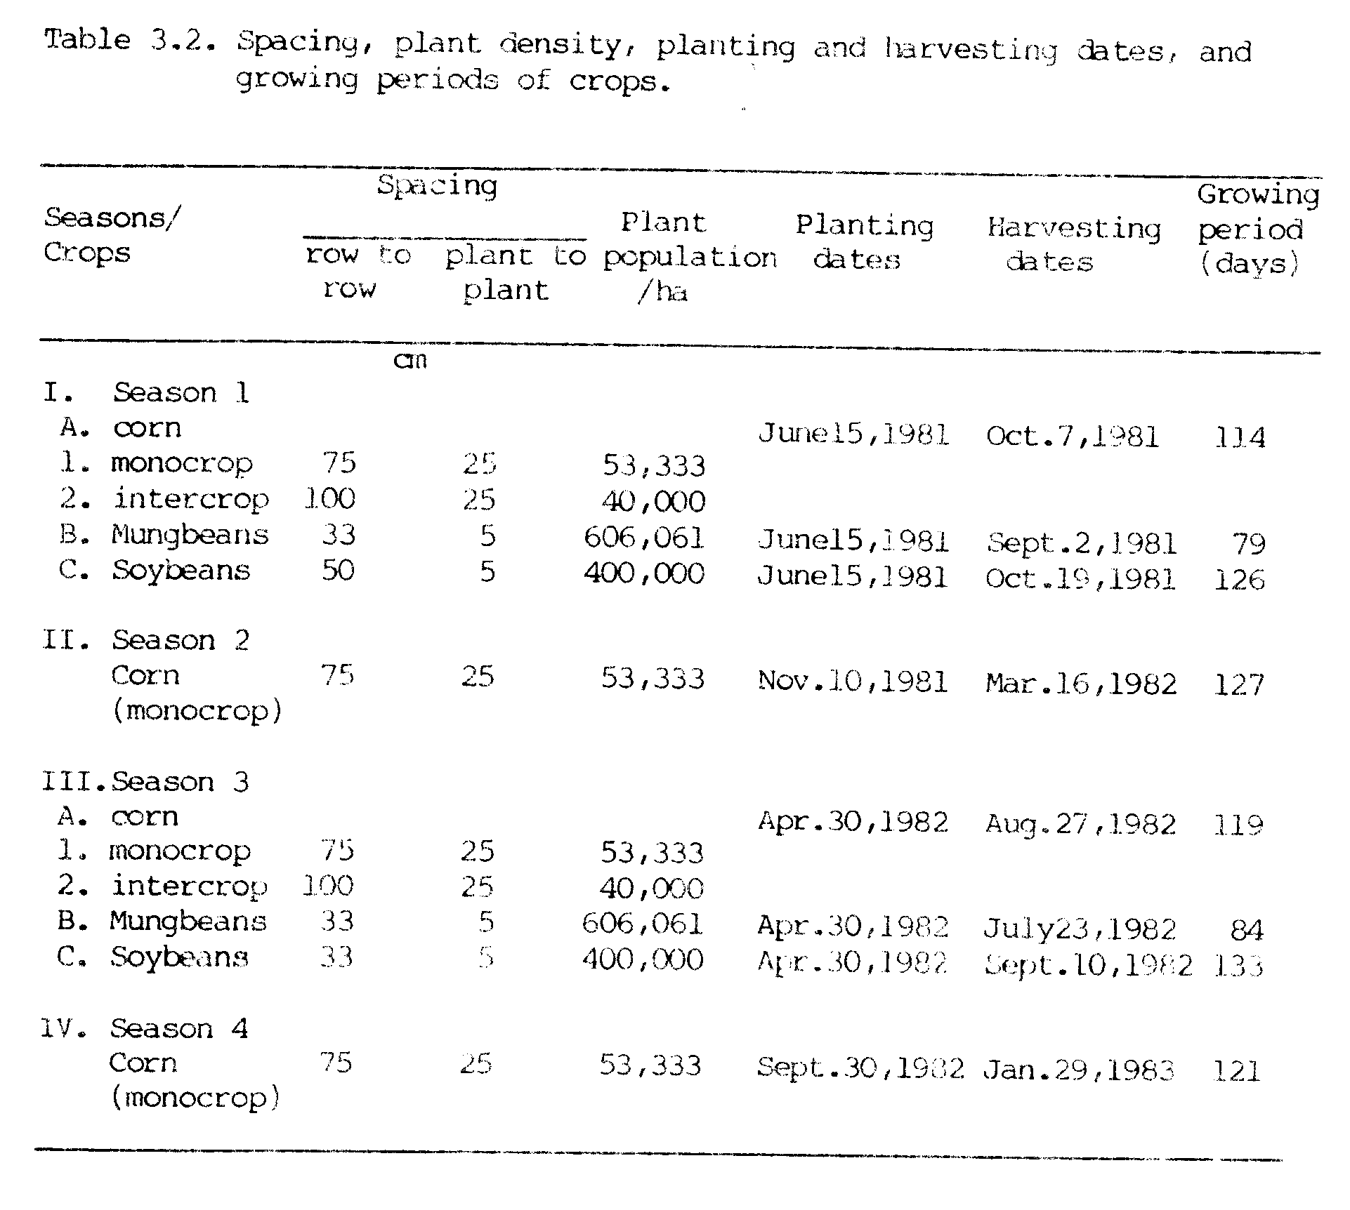
Plant Height, Number of Pods Per Plant and LAI
Plant heights of 10 plants from each treatment were measured at time of flowering in each crop and mean values were used for plant heights.
Pods from each of 10 plants from mungbeans and from soybeans were counted at maturity and mean values were used as the number of pods/plants for these two crops.
Leaves from 5 plants in each of the treatments in corn, mungbeans and soybeans were taken and then leaf areas were measured with a Leaf Area Meter (LICOR -CI-3100). Leaf Area Indices (LAI calculated as leaf area per unit of land) were measured only in season 1.

Nitrogen Fixation
N₂ fixation by legumes was estimated by the Acetylene reduction technique (Hardy et al., 1968). Four plants were dug at the time of flowering from each of the treatments and ethylene produced/plant/hour (total nitrogenase activity, TNA) and ethylene produced/gram of nodules/hour (specific nitrogenase activity, SNA) were calculated. Number of nodules/plant and nodule mass/plant were also recorded. The ratios of ethylene produced/plant/hour by monocrop Of legumes to intercrop of legumes were also calculated.

Dry Matter Yield
Grain yields and stover (above ground material excluding grain) yields were measured in corn, mungbeans and soybeans. Total dry matter production was calculated by the addition of all components. Yields are reported in Megagrams per hectare (Mg ha⁻¹), which is a metric ton or million grams per hectare.

Nitrogen Content
Ear leaf samples from corn plants were taken at the 50% silking stage in each season, and then were analyzed for N content. Grain, stover, root and nodule samples were also taken after each harvest and then were analyzed for N content by the Microkjeldahl method (Bremner, 1965a), and total N production was calculated.
Soil samples from individual plots were taken before and after each crop season, and were analyzed for available NH₄-N and NO₃-N by the steam distillation method (Bremner, 1965b).

Nitrogen Recovery
Nitrogen recoveries from the applied urea fertilizer were calculated in all seasons. N recovered was calculated as:
N uptake by plants N uptake by plants
with N added - with no N added
% N recovery = ---------------------------------------- X 100
Rate of N applied

Evaluation
Productivity per hectare of land was estimated by calculating land equivalent ratios (LER) for all intercroppings plots. The calculation was done as:
Corn intercrop yield Legume Intercrop yield
LER = -------------------- + -----------------------
Corn monocrop yield Legume monocrop yield
A harvest index (HI) was calculated for each crop as: HI = economic yield/ biological yield, where grain yield was the economic yield and above ground total dry matter was used as the biological yield.
Nitrogen contributions from legumes to their associated corn crops were estimated by comparing the N uptake by corn in intercropping with the N uptake by corn in monocropping at 4 levels of N application. Nitrogen contributions to the succeeding crop of corn were also estimated by the same approach.
Data were analyzed by an analysis of variance technique. F tests, Duncan’s multiple range tests, simple correlation techniques and regression analyses also were used wherever applicable.

RESULTS AND DISCUSSION

Performance of Corn in Intercropping
Grain yield of corn grown as a monocrop increased dramatically with increasing rates of applied N (Figure 3.1). Grain yields varied from 0.39 to 4.28 Mg ha⁻¹ in season 1 and from 0.55 to 4.82 Mg ha⁻¹ in season 3 as N rates were increased from 0 to 100 kg ha⁻¹. Figure 3.1 shows very good linear response of N application by corn with a reasonably high R² of 0.88 in both seasons 1 and 3. The slopes of the regression lines show that with every kg of N applied, grain yields of coal increased by about 37 kg in season 1 and 43 kg in season 3. Low yields without applied N (control plots) were probably due to the removal of available soil N by two crops of sweet corn grown previously which also may account for the good response of corn to N.
Corn grain yields in intercroppings were higher than the grain yields in control plots (no N application) in both seasons 1 and 3 (Figure 3.2 and Appendix Table 1). Compared to grain yields of corn in control plots in season 1 (0.39 Mg ha⁻¹) and season 2 (0.55 Mg ha⁻¹), the grain yields in intercrops were 0.61, 0.63 and 0.63 Mg ha⁻¹ in season 1, and 1.00, 0.80 and 0.65 Mg ha⁻¹ in season 3 in corn/determinate mungbeans (MBD), corn/indeterminate mungbeans (MBI) and corn/soybeans, respectively. The increase in corn grain yields were 158, 168 and 163%
over the control in season 1, and 181, 146 and 118% over the control in season 3 in corn/MBD, corn/MBI and corn/soybean intercroppings, respectively (Table 3.3). The results showed that corn when intercropped with mungbeans or soybeans did not suffer competition from legumes, instead had yield advantages in the companionship of grain legumes grown in this investigation.
These results agree with other findings where increase in corn yields were found when intercropped with mungbeans (Agboola and Fayemi, 1972; Gunasena et al., 1979; Das and Mathur, 1980; Rathore et al., 1980) and with soybeans (Narang et al., 1969; Nair et al., 1979; Kalra and Gangwar, 1980; Singh et al., 1980; Shrivastava et al., 1980).
Total dry matter of corn in monocrops increased with increasing rates of N application (Figure 3.2). The increase in total dry matter yields were from 3.08 to 10.01 Mg ha⁻¹ in season 1 and from 4.33 to 13.36 Mg ha⁻¹ in season 3 at N rates of 0 and 100 kg ha⁻¹, respectively. The total dry matter yields of corn in intercrops, however, were not different from those in the control plots in both seasons 1 and 3 (Appendix Table 1).
Harvest indices (HI) of corn increased from 0.12 to 0.43 in season 1 and from 0.13 to 0.36 in season 3 as N rates increased from 0 to 100 kg ha⁻¹ (Table 3.4). HI of corn when intercropped increased slightly (a range of 0.20 to 0.24 in season 1 and a range of 0.15 to 0.19 in season 3), but not significantly compared to the control plots of corn (0.12 and 0.13 in seasons 1 and 3, respectively). This slight increase in HI in intercrops was not unexpected as there was an increase in grain yields, but no change in total dry matter of corn in intercrops.
Plant height of corn increased with increasing rates of N application in both seasons 1 and 3 (Figure 3.3). There was a slight but non-significant increase in plant height of intercropped corn compared to
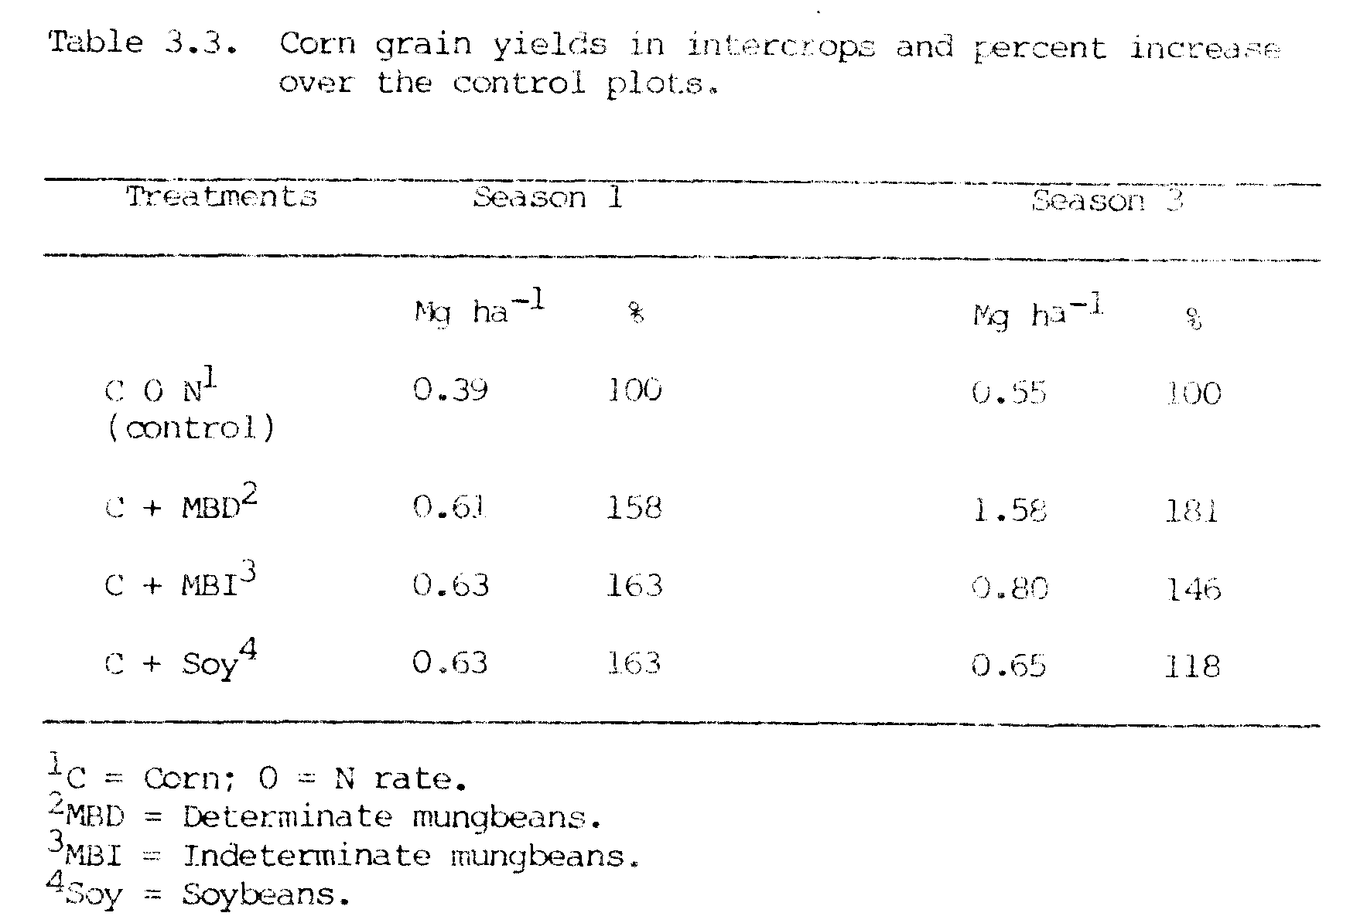
the monocropped corn (control plot) in season 1. In season 3, there was a significant increase in plant height of intercropped corn compared to the control plot of corn. In season 3, plant heights of corn were 1635, 1656 and 1613 mm in corn/MBD, corn/MBI and corn/soybean intercroppings, respectively, compared to 1376 mm in the control plot of corn. These results also indicate that corn grown with mungbeans or soybean did not suffer from competition with legumes.

Performance of Grain Legumes in Intercropping
Grain and total dry matter yields of mungbeans and soybeans were depressed when grown as intercrops compared to their monocrops in both seasons 1 and 3 (Figure 3.4 and Appendix Table 1). Except for the grain yields and total dry matter of indeterminate mungbeans in season 3, the reduction in grain yields and total dry matter in all other treatments of mungbeans were significant. Soybean grain yield was not significantly reduced when intercropped in season 3, but was significantly reduced in season 1. This may have been due to greater shading of soybean by corn in season 1 than in season 3, as the distance between corn rows and soybean rows was 25 cm in season 1 and 33 cm in season 3 (Table 3.2 and Appendix Figure 2).
Plant heights, number of pods/plant and harvest indices of mungbeans and soybeans are presented in Table 3.5. Plant heights and number of pods/plant of intercropped mungbeans generally were not significantly affected by intercropping. However, the height and number of pods/plant of soybeans were significantly reduced by intercropping in season 1, where soybean was shaded by corn. There were no significant changes in harvest indices of mungbean and soybean in intercrops compared to monocrops in both seasons 1 and 3. Among the
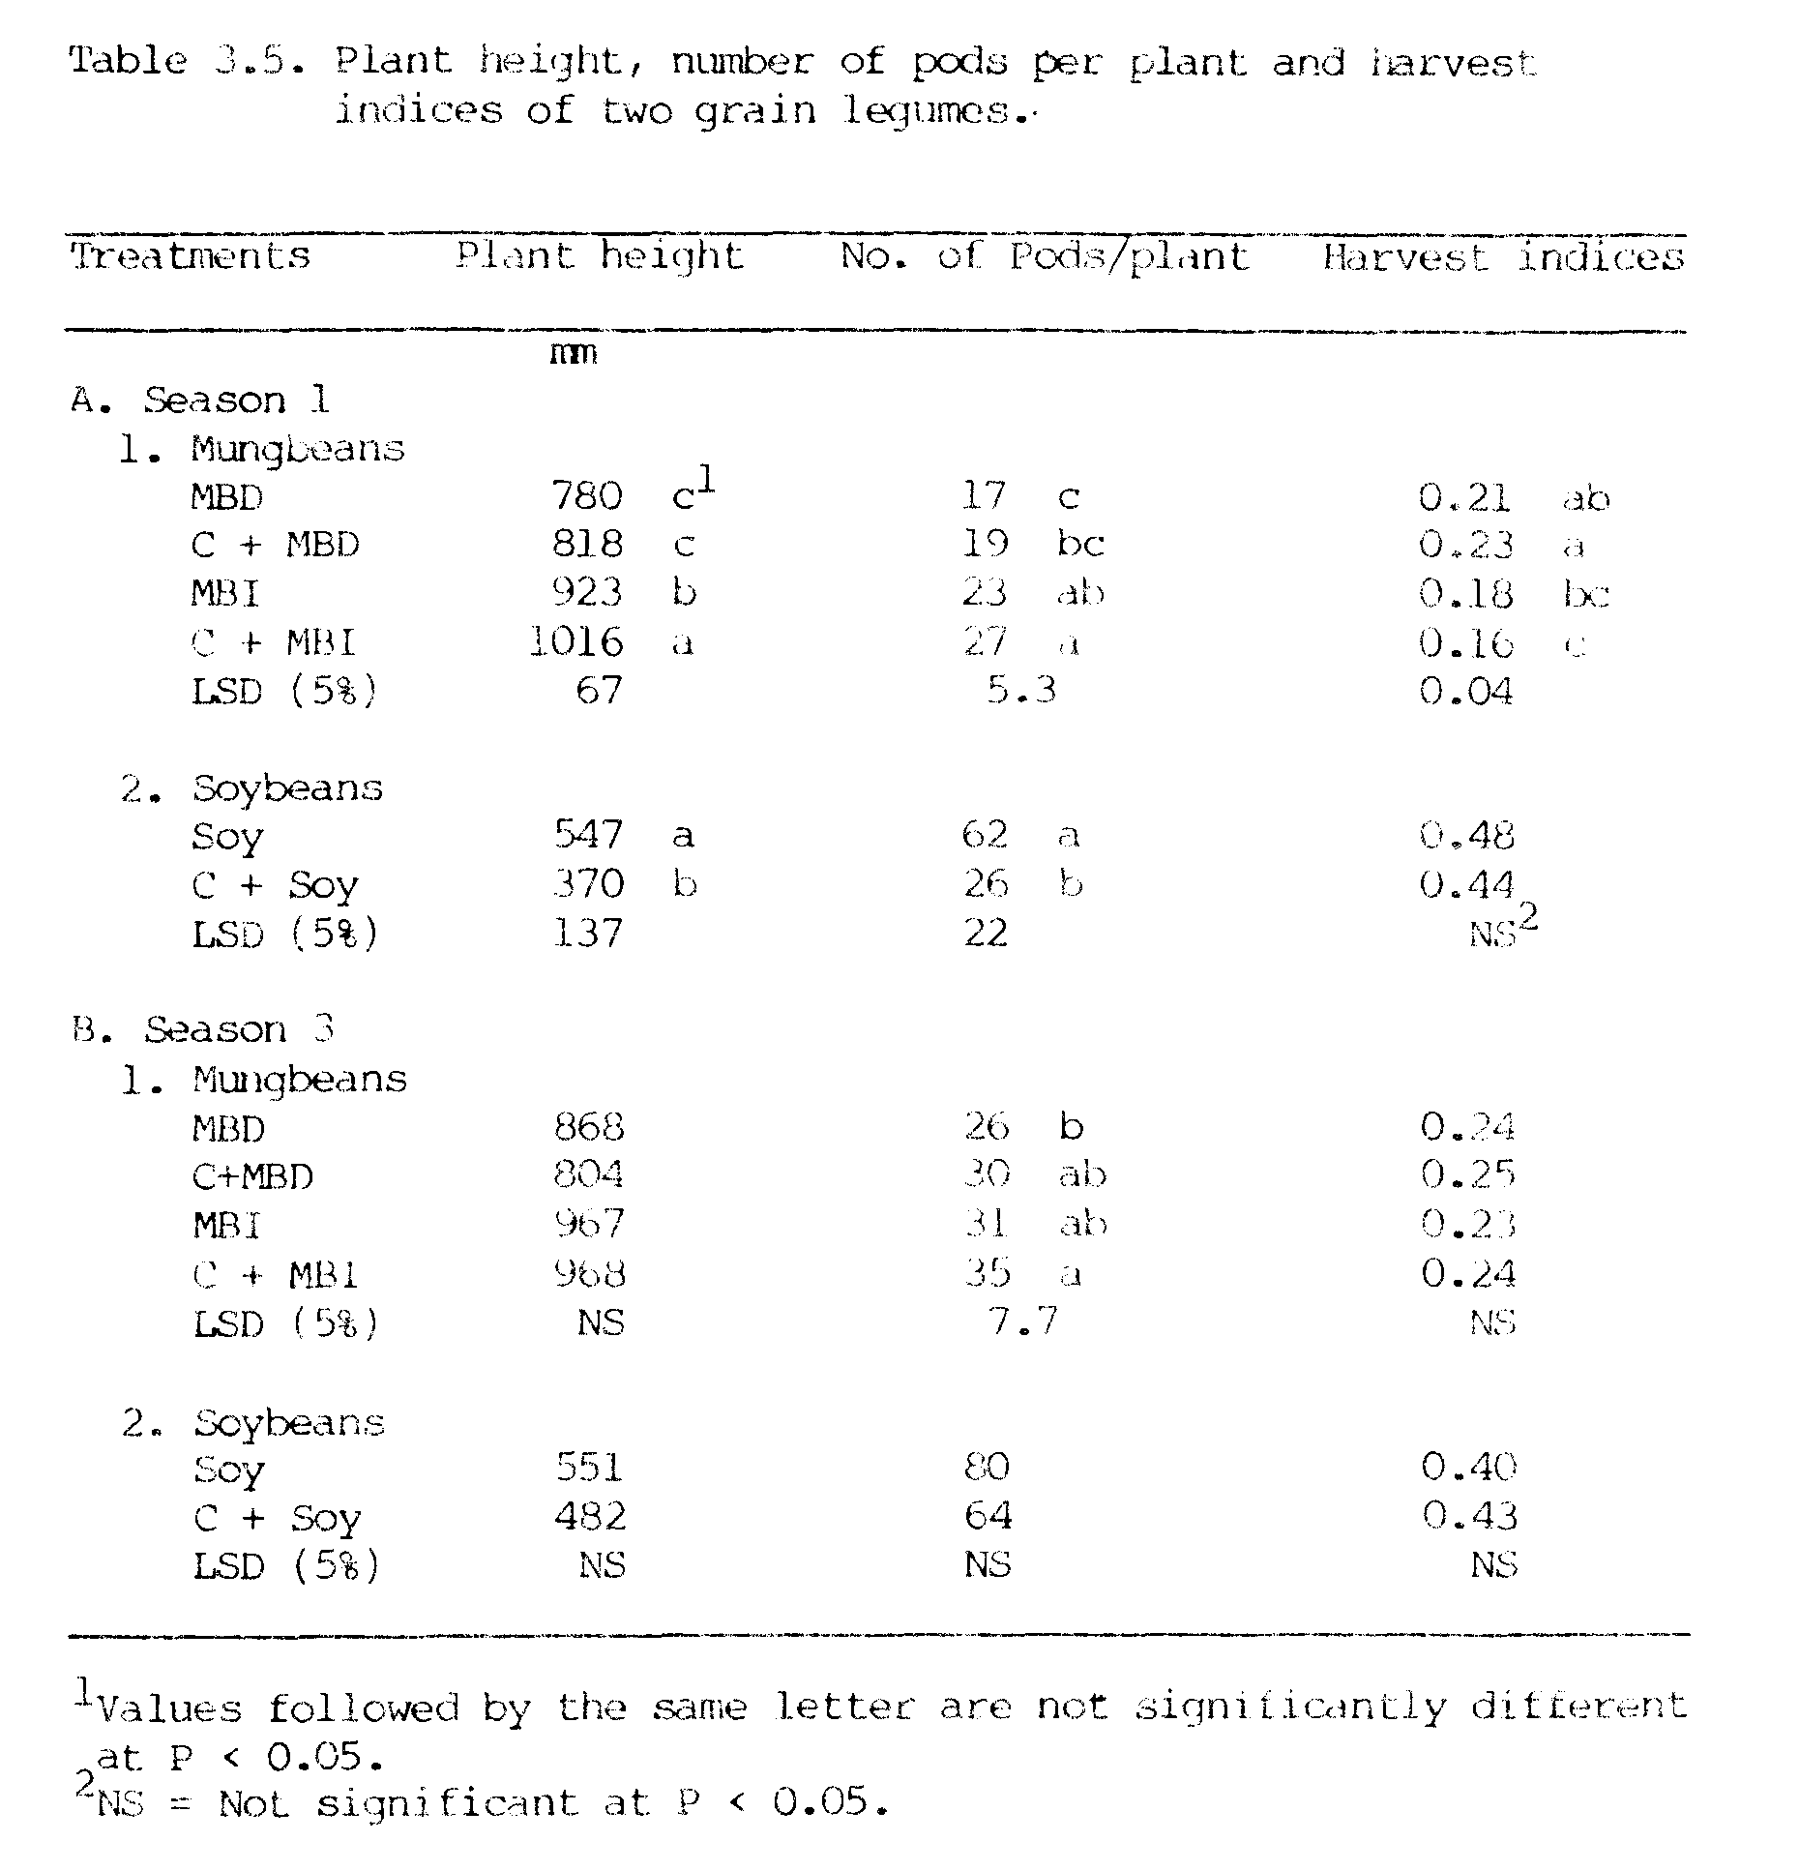
two types of mungbeans used in this experiment, indeterminate mungbeans had a greater number of pods/plant and was taller than determinate mungbeans in both season l and season 3. The grain yields of indeterminate mungbeans, however, were not significantly different than the grain yields of determinate mungbeans (Figure 3.4).
As previously discussed in this chapter, there were yield advantages for corn intercropped with grain legumes, but the above results indicate that there were yield depressions in grain legumes intercropped with corn. Therefore, in these corn/grain legume intercrops, corn was dominant over grain legumes (see also in Appendix Figure 2 and Appendix Figure 3).
These results agree with those of similar experiments where yield reductions with intercropping were observed in mungbeans (Agboola and Fayemi, 1971; Ahmed, 1976; Singh and Chand, 1980) and in soybeans (Roquib et al., 1973; Singh, 1977; Mohta and De, 1980; Chowdhury, 1981) grown with corn.

Total Performance in Intercropping
Total dry matter yields of crops in intercropping systems compared to monocropping systems in seasons 1 and 3 are presented in Figure 3.5. In season 1, intercrops of corn/grain legume produced as much total biomass as legume monocrops. The total biomass produced by these intercrops was comparable to the total biomass produced by a monocrop of corn (10.01 Mg ha⁻¹) with 100 kg ha⁻¹ of applied N. In season 3, total biomass produced by corn/legume intercrops was higher than biomass produced by legume monocrops, and was comparable to the total biomass produced by the corn monocrop (10.08 Mg ha⁻¹ ) with 67 kg ha⁻¹ of applied N. The total biomass produced by corn/legume intercrops was 3.03 to 5.70 Mg ha⁻¹ higher than biomass produced by the control plot (3.08 Mg ha⁻¹) in season 1, and 5.37 to
6.55 Mg ha⁻¹ higher than the biomass produced by the control plot (4.33 Mg
ha⁻¹) in season 3 (Appendix Table 3). These results suggest that much higher total can be produced by corn /legume intercrops then by a corn monocrop
application.
Total grain production in monocropped (control plots) and in intercropped treatments is shown in Table 3.5. Grain yields of intercropped corn in both seasons 1 and 3 were higher than those of monocropped corn without N. Moreover, the grain yields of legumes were additional yields produced in intercrops which would not have obtained in monocrops of corn without applied N. The intercropping systems used in this investigation produced total grain yields (corn + grain legumes) in the range of 1.58 to 2.05 Mg ha⁻¹ in season 1 and 2.10 to 3.45 Mg ha⁻¹ in season 3 compared to control plot (monocropped corn without N) yields of 0.39 Mg ha⁻¹ in season 1 and 0.55 Mg ha⁻¹ in season 3. The total grain produced in intercropping was much higher (about 4 to 5 times in season 1 and 4 to 6 times in season 3) than grain produced by control plots of corn. This suggests that in the areas where N fertilizers are not easily available or are expensive and food production is the prime objective one can still obtain substantially higher food production/ha by corn/legume intercropping than by monocropping corn with no N application.
Leaf areas per unit area of Land (LAI) of corn in intercrops were comparable to the LAI of monocrop of corn (1.64) at 33 kg N ha⁻¹ in season 1 (Table 3.7). LAI’s of legume intercrops were lower than LAI’s of legume monocrps. Total LAI’s in intercrops (3.25 to 3.80) were slightly higher than those in legume monocrops (2.84 to 3.29). Total LAI in corn/legume intercrops (3.25 to 3.80) were higher than the LAI of the corn monocrop (2.74) with 100 kg ha⁻¹ of applied N.
As the LAI of intercropped corn was as much as or higher than the LAI of the control plot of corn, these LAI values suggest that corn
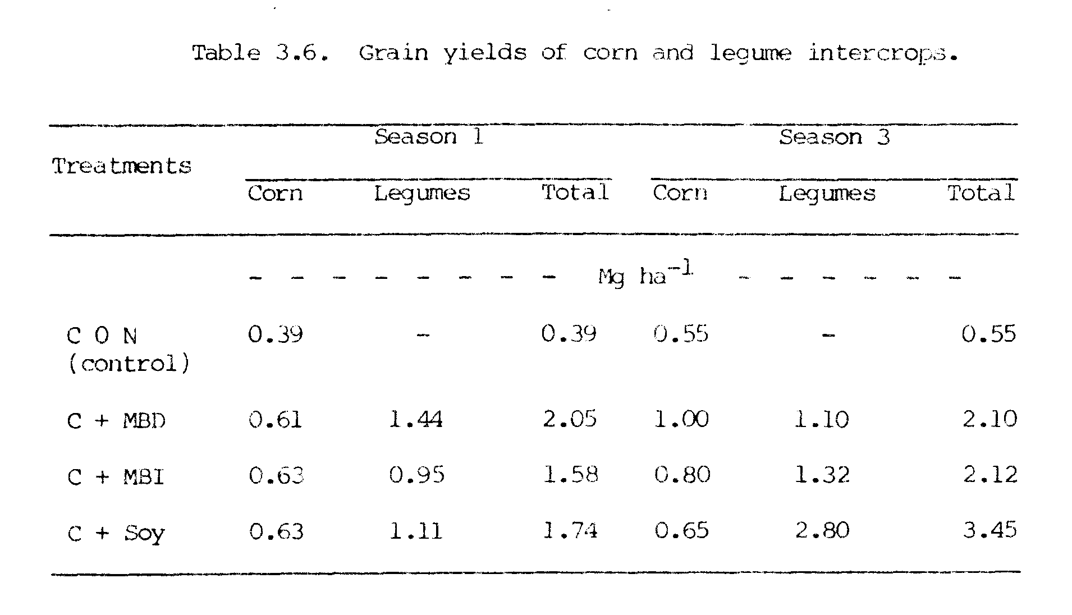
did not suffer from competition with legumes. The LAI’s of intercropped legumes were lower than LAI’s of legume monocrops, which suggests that grain legumes were dominated by corn. This may be the reason for depressed yields of intercropped legume. The higher total LAI in
corn/legume intercrops indicate a greater interception of incoming solar radiation by intercrops than by monocrops, and this may also he the reason for increased total biomass production/ha in intercropping systems.
Land equivalent ratios (LER) of corn/grain legume intercrops are presented in Table 3.8. LER of intercropped corn were 1.5 in season 1 and ranged from 0.8 to 1.1 in season 3. Values of LER greater than one indicated that there were yield advantages of corn when intercropped with grain legumes. LER of grain legumes were in the range of 0.4 to 0.7 in season 1 and 0.6 to 0.9 in season 3. LER values less than one indicate that the yield of grain legumes were depressed in intercrops. The total values of LER were in the range of 1.9 to 2.2 in season 1 and 1.6 to 1.9 in season 3. These high values of LER indicate chat one would have needed 1.9 to 2.2 hectares of land in season 1 and 1.6 to 1.9 hectares of land in season 3 under monocrops to produce as much as were produced in one hectare of land by these intercrops.
The higher LER values clearly suggest that there were yield advantages in corn/legume intercrops over corn monocrops with no N applied. In those areas where N fertilizers are in short supply and/or are too expensive for a former to use, the use of corn/legume intercropping systems seems a cheap methods of increasing food production/ha without input of inorganic N.

Corn Following Grain Legumes
Grain and total dry matter yields of corn following grain legumes
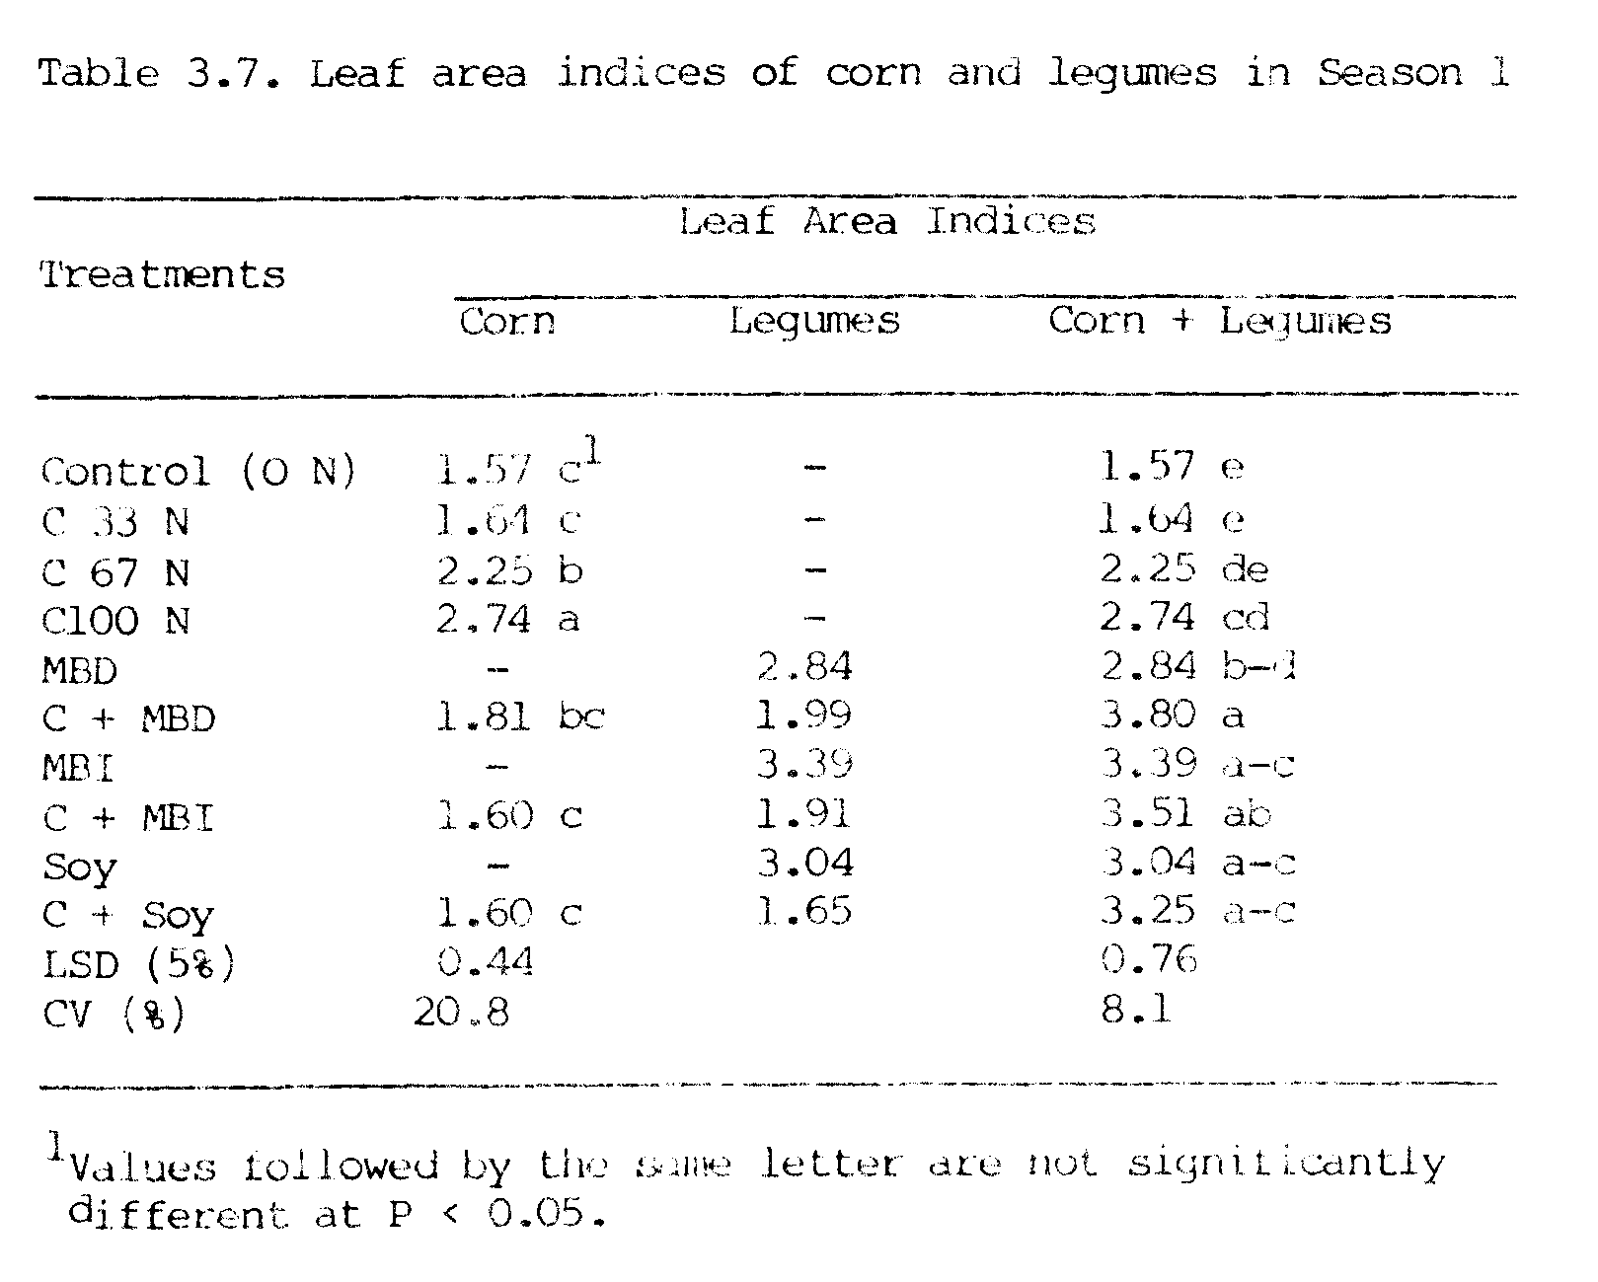
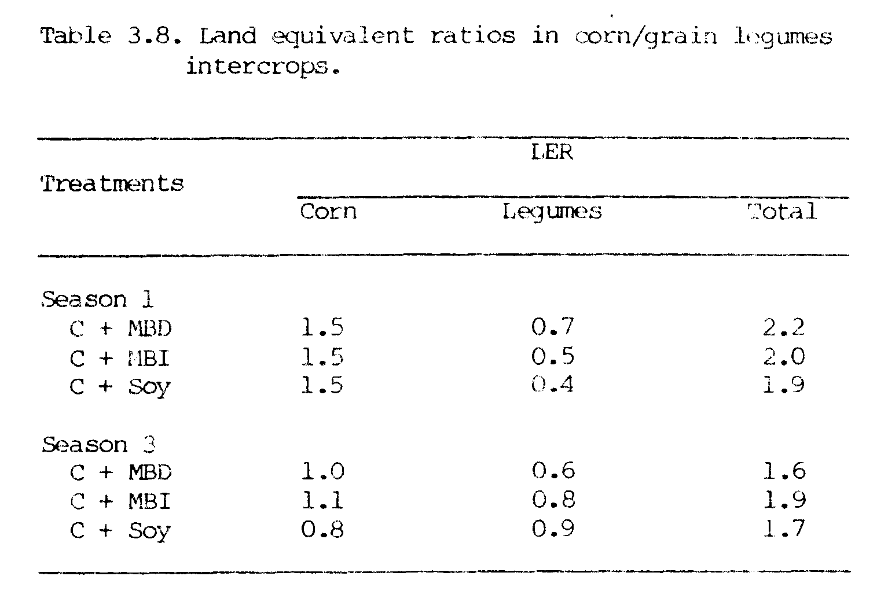
in season 2 and season 4 are presented in Table 3.9. The grain yields of corn in both season 2 and season 4 were poor. In season 2, the highest corn grain yield (0.57 Mg ha⁻¹) was at the 100 kg ha⁻¹ level of applied N and it was significantly higher than the yields of all other
treatments which were not significantly different from each other. Total dry matter yields in season 2 also did not differ in all the treatments except for those of the 0 and 33 kg ha⁻¹ rates of N which were significantly lower than those of the other treatments.
In season 4, grain yields of corn following the indeterminate
and soybean monocrops were comparable with corn at the 67 and 100 kg ha⁻¹ levels of N. Grain yields of all other treatments were comparable to that of at 33 kg ha⁻¹ level of N application. Total dry matter yields of corn following monocrops of indeterminate mungbeans and soybean were comparable to 67 kg ha⁻¹ level of N in the corn monocrop, and total dry matter yields in all other treatments were comparable with that of the 33 kg ha⁻¹ level of N. Corn yields in season 4 were a little better than yields on season 2.
Nitrogen response by corn monocrops was also found to be poor in Figure (3.6). Grain yields of corn increased from 0.38 to 0.57 Mg ha⁻¹ in season 2 and from 0.39 to 0.99 Mg ha⁻¹ in season 4 as N rates were increased from 0 to 100 kg ha⁻¹. Figure 3.6 shows that the response to N application by corn was linear, but with a poor R² of 0.35 in season 2 and a little batter R² of 0.77 in season 4. Slopes of the regression lines show that with each kg of N applied, the increases in corn grain yields were only about 2 kg in season 2 and 6 kg in season 4. These results show that the N response by corn in seasons 2 and 4 was much poorer than those of in seasons 1 and 3 (Figure 3.1 ).
There was no significant difference in harvest indices (HI) in all the treatments in seasons 2 and 4 (Table 3.10). Harvest indices were in the narrow range of 0.15 to 0.21 in season 2 and 0.20 to 0.25 in season 4. These

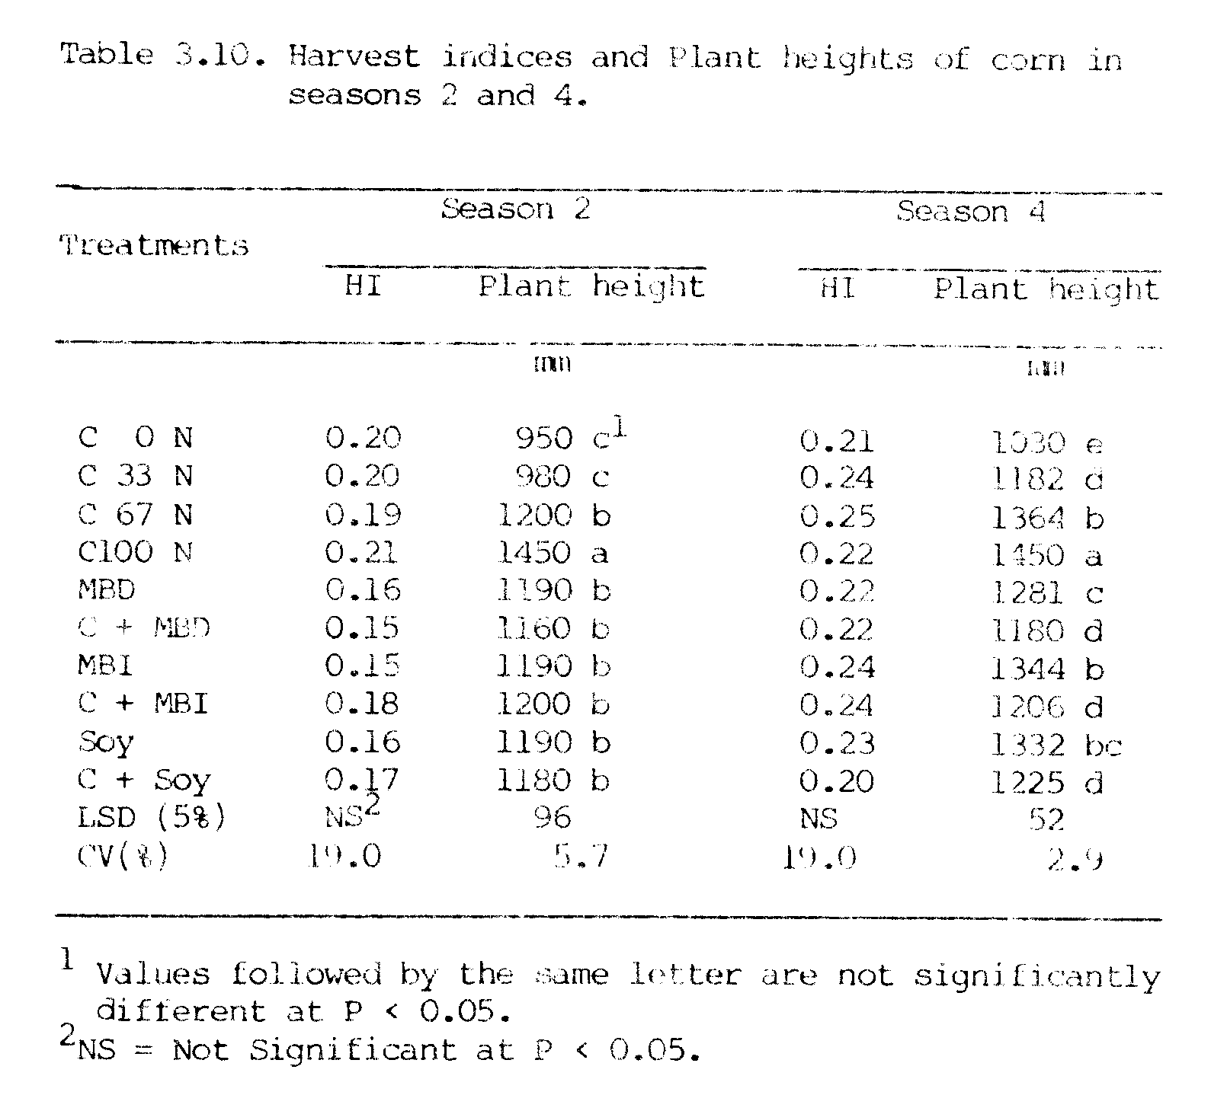
results were obvious because grain and total dry matter yields themselves were not significantly different among most of the treatments in season 2 and season 4.
Plant heights of corn in all plats having grown grain legumes in the previous season were comparable to the plant height of monocropped corn with 67 kg ha⁻¹ level of N application in season 2, and plant heights of the 33 and 67 kg N ha⁻¹ treatments in season 4 (Table 3.10).
The poor performance of corn in seasons 2 and 4 were due to the fact that these seasons were in the winter period with lower solar radiation and lower temperature, which were not favorable for the growth of corn (Appendix Table 3). Also storm with heavy rainfall occurred in January 1982 during season 2. This combination of all these environmental factors resulted in poor growth of corn. Poor growth and thereby poor yield of corn during the winter was also reported by Jong et al. (1982) in an experiment where 41 successive monthly plantings of corn was done at Waimanalo Research Station in Hawaii.

Environmental Effects
Seasonal yields of corn were affected by conditions (Figure 3.7). Corn grain yields in summer plantings of season 1 (0.39 to 4.28 Mg ha⁻¹) and season 3 (0.55 to 4.28 Mg ha⁻¹) were much higher than the yields in winter plantings of season 2 (0.38 to 0.57 Mg ha⁻¹) and season 4 (0.39 to 1.0 Mg ha⁻¹). The pattern of seasonal yields of corn followed the pattern of solar radiation. Average monthly solar radiation in MJ m⁻² day⁻¹ during the summer ranged from 6.70 to 22.10 in season 1 and 6.39 to 16.63 in season 3, and during the winter ranged from 6.30 to 10.96 in season 2 and 7.01 to 14.08 in season 4. Average monthly solar radiation (MJ m⁻² day⁻¹) for each of these seasons was in the decreasing order: 18.20 > 13.50 > 10.18 > 8.18 for seasons 1, 3, 4, and 2, respectively.
Grain yields of corn followed similar trends at four levels of applied N with increasing amounts of solar radiation, however, N response was poor in the winter (seasons 2 and 4) and was lowest in season 2. This poor response to N in season 2 could have been due to the low average solar radiation, and the very high rainfall during that season (Figure 3.7). Average monthly rainfall during the experimental period were 53, 239, 102, and 121 mm in seasons l to 4, respectively. The high average monthly rainfall (239 mm) during season 2 probably caused leaching of N into the soil and, therefore, little N was available to the growing plants.
It can be seen that lower solar radiation associated with higher rainfall (Figure 3.7). The correlation coefficient (r) between solar radiation and rainfall was -0.88 during the entire period of this experiment.
The average monthly temperatures (⁰C) during these seasons were 25.1, 22.5, 24.6, and 23.7 in seasons 1 to 4, respectively, with higher temperature occurring in summer and lower temperatures in winter.
However, the change in temperature during the entire period of the experiment was gradual and not as drastic as that observed in solar radiation and rainfall. The correlation coefficients (r) for the relationships between temperature and solar radiation, and between temperature and rainfall during the entire period of the experiment were 0.94 and -0.97, respectively. These results clearly show that the corn yields were greatly affected by changes in environmental conditions during the growing period of corn.

Nitrogen Yield and Transfer
Nitrogen yields in monocrops and in intercrops in both season 1 and season 3 are presented in Figure 3.8. N yields of corn in intercrops (18.4 to 19.9 kg ha⁻¹) were not significantly different from the N yield of corn
in the control plot (18.6 kg ha⁻¹) in season 1; however, in season 3, N yields of corn in intercrops (25.2 to 33.5 kg ha⁻¹⁾ were comparable to the N yield of monocropped corn with 33 kg N ha⁻¹ (32.64 kg ha⁻¹). These results suggest that there was no N transfer from grain legumes to corn while they were growing together in season 1, but there may have been some N transfer in season 3. These results also suggest that legumes did not compete with corn for soil N in the intercropping situation.
Nitrogen yields of grain legumes in intercrops were lower than the N yields in monocrops in both seasons 1 and 3 (Figure 3.8). Soybeans had much higher N yields (115 to 234 kg ha⁻¹ in season 1 and 290 to 334 kg ha⁻¹ in season 3) than mungbeans (110 to 166 kg ha⁻¹ in season 1 and 96 to 154 kg ha⁻¹ in season 3). Nitrogen yields in determinate mungbeans were not different from N yields in indeterminate mungbeans in both seasons 1 and 3. The decrease in N yields of grain legumes in intercrops compared to monocrops may he due to the fact that legume yields were depressed in intercrops compared to their monocrops (see Figure 3.4).
Total N yields (corn + legumes) from plots, where legumes were grown, however, were much higher than N yields obtained from monocrops of corn at all levels of N application in both seasons (Figure 3.8 and Appendix Table 4). Soybean plots had the highest total N yields. This suggests that an appreciable amount of N ha⁻¹ can be harvested if legumes are included in intercropping systems with corn.
Nitrogen yields in sequential crops of corn in season 2 and season 4 are presented in Figure 3.9. In season 2, N yields of corn following the grain legumes (22.4 to 25.0 kg ha⁻¹) were higher than the N yield (19.5 kg ha⁻¹) obtained with 33 kg ha⁻¹ urea-N and lower than the N yield (26.6 kg ha⁻¹) obtained with 67 kg ha⁻¹ urea-N applied in corn. N yields
obtained from the monocrops and intercrops of legumes were not different in season 2. In season 4, the N yields of corn following grain legumes were comparable with N yield (29.5 kg ha⁻¹) obtained with 33 kg N ha⁻¹ in corn; however, the N yields from the monocrops of indeterminate mungbeans (40.3 kg ha⁻¹) and soybeans (36.5 kg ha⁻¹) were higher than the N yield (35.9 kg ha⁻¹⁾ from monocropped corn with 67 kg ha⁻¹ of urea N applied. The monocrop of indeterminate mungbeans provided the highest N yield in both seasons. Higher N yields of corn following indeterminate mungbeans may have been due to higher % N in root and nodules of indeterminate mungbeans than of determinate mungbeans (Table 3.11).
Percent N in corn ear leaves at 50% silking are presented in Table 3.12. Percent N in corn ear leaves in intercrops were comparable with the % N (1.54) in ear leaves of monocropped corn with 67 kg N ha⁻¹ treatment in season 1 and with the % N (1.09) with 33 kg N ha⁻¹ treatment in season 3. Except in plots of monocrop of indeterminate mungbeans, % N in ear leaves of corn following grain legumes (1.92 to 1.96% in season 2 and 1.76 to 1.91% in season 4) were comparable to the % N in ear leaves of monocropped corn with 33 kg N ha⁻¹ in seasons 2 and 4. Corn following the indeterminate mungbean monocrop had the highest % N in ear leaves (2.25 and 2.17% N in seasons 2 and 4, respectively), which were comparable to % N in ear leaves of monocropped corn with 67 kg N ha⁻¹ treatment.
The % N in ear leaves at corn in summer (seasons 1 and 3) was considerably lower than ear leaf N in winter (seasons 2 and 4) at 4 levels of applied N in corn monocrops (Figure 3.10). This may result from the reduced production of carbohydrates necessary for growth in winter due to reduced solar radiation. Similar differences in % N in ear leaves of corn between winter and summer were also reported by Evensen (1983).
An estimate of amounts of N transferred from grain legumes to corn
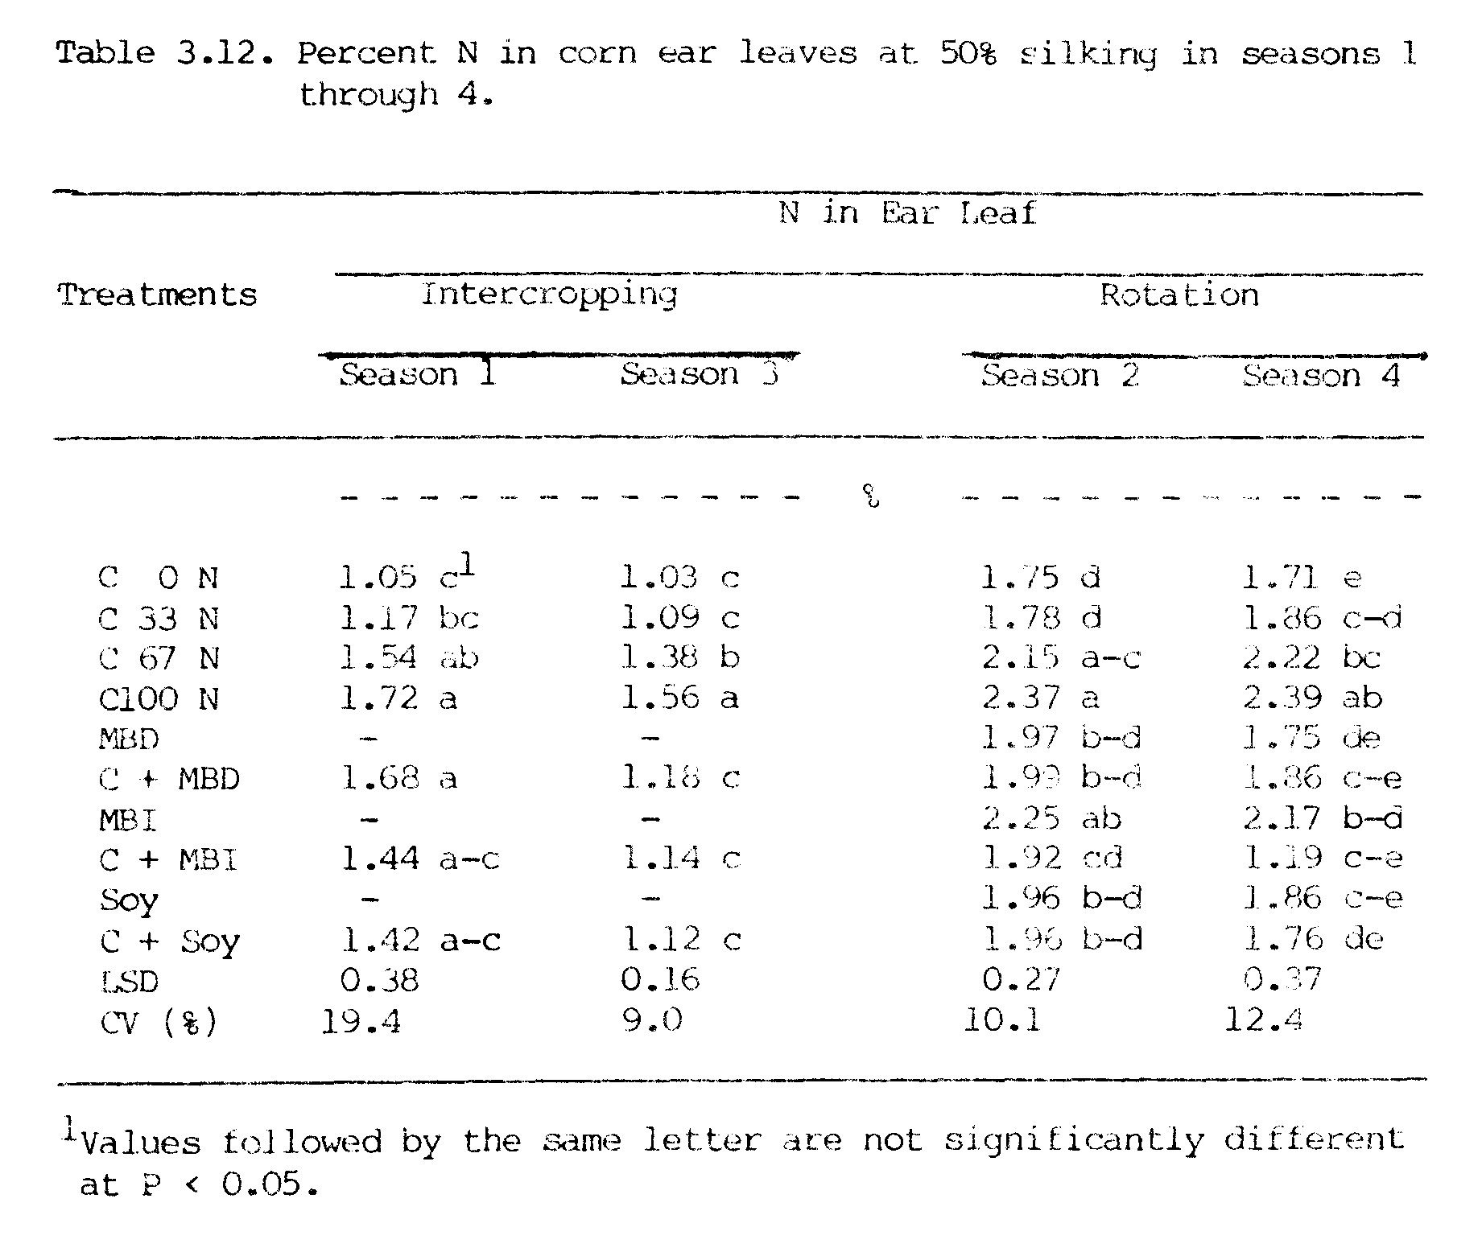
was made comparison with the uptake of N from four rates of urea-N by corn (Figure 3.11). Based on the N uptake by corn, no N was contributed to corn by legumes in season 1 and 10 to 25 kg N ha⁻¹ was contributed in season 3 (Table 3.13).
On the basis of N uptake, the N contributions from grain legumes to the following corn crop were estimated to be 40 to 58 kg N ha⁻¹ in
season 2 and 31 to 75 kg N ha⁻¹ in season 4 (Table 3.13). Residual N from legumes taken up by the following corn crop was the highest from indeterminate mungbean monocrops (58.0 and 75.0 kg N ha⁻¹) followed by soybean monocrops (40.0 and 62.5 kg N ha⁻¹) and determinate mungbean monocrops (35.0 and 47.0 kg N ha⁻¹). N contributed from legume
monocrops was higher than that from legume intercrops in both seasons 2 and 4.
These results indicate that there was very little if any N contributed to corn from grain legumes while they were growing together. These results also suggest that legumes and corn did not compete for soil N in an intercropping situation, however, the residual N from grain legumes to the following crop of corn was substantial.
These results agree with those of other studies where it was shown that mungbeans (Agboola and Fayemi, 1972; Singh and Singh, 1975) and soybeans (Shrader et al., 1966; Saxena and Tilak, 1975) were more beneficial in terms of N supply to cereal crops when grown in rotation with cereal crops than as a companion crop.

N Recovery from Urea
The percentages of N recovered by corn from Urea-N is presented in Table 3.14. The N recovered from urea in summer plantings were in the ranges of 31 to 49% and 28 to 59% in seasons 1 and 3, respectively, and in winter plantings were in the ranges of 3 to 12% and 26 to 34% in seasons 2 and 4,
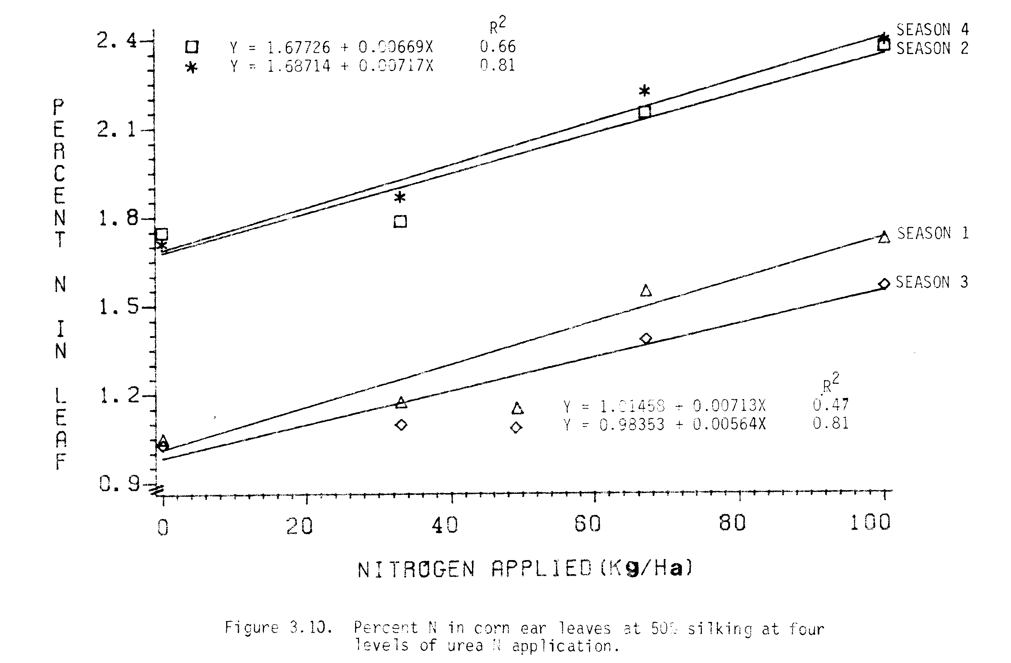
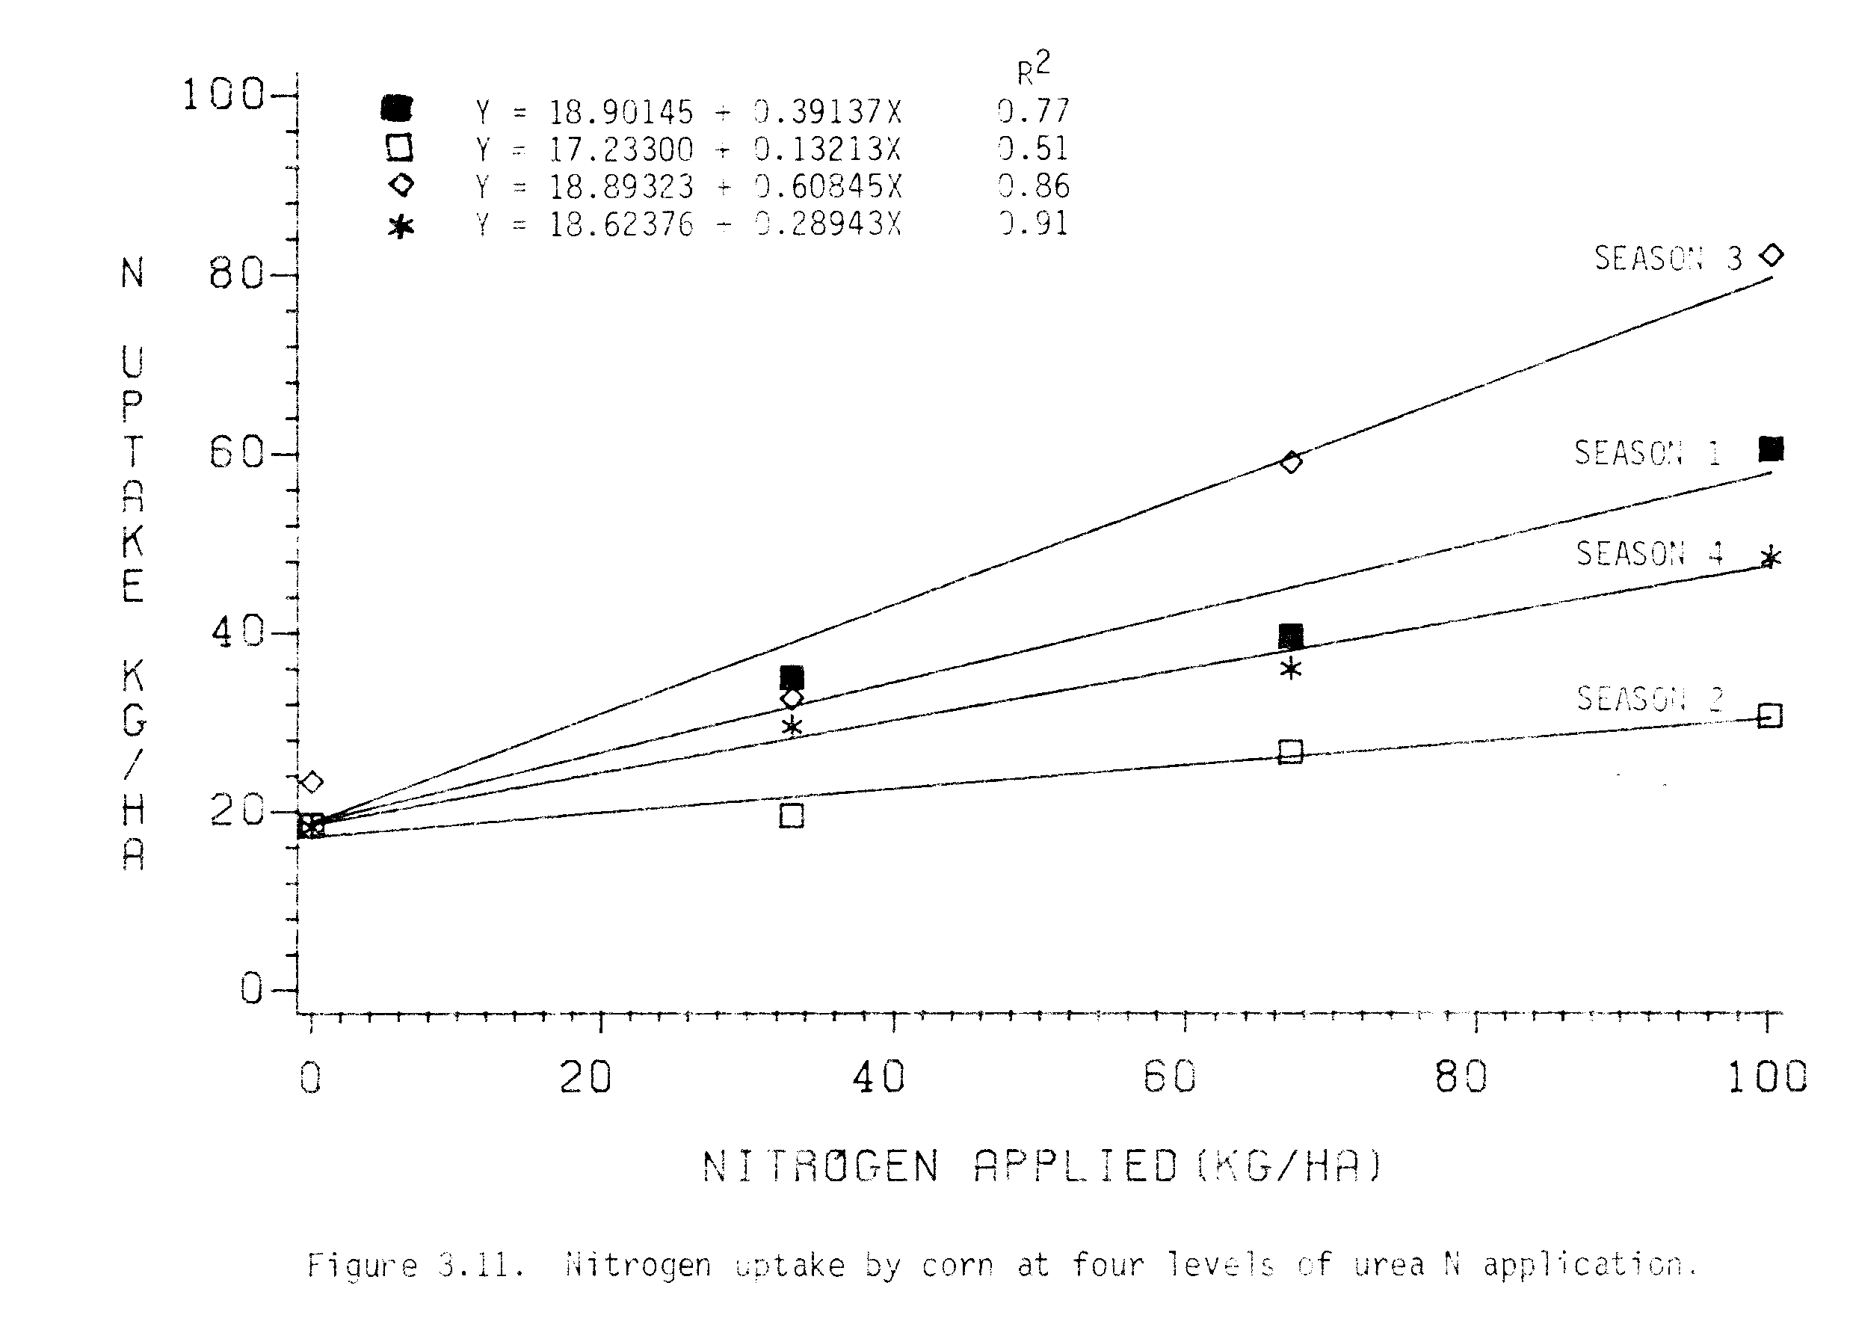
respectively. These results show that appreciably less N was recovered in winter than in summer. The N recovery from urea-N was very low in season 2 during which there was heavy rainfall and low solar radiation that probably accounted for the poor crop of corn in that season. In the summer, however, N recovery from urea was comparable to that in other studies where average N recovery was 50% (Allison, 1966; Soper et al., 1971).

Soil Nitrogen
Available NH₄-N and NO₃-N before and after each season are presented in Appendix Table 8. In the beginning of the experiment, the available NH₄-N and NO₃-N in the top 15 cm of soil were low in the ranges of 10.35 to 13.54 ppm and 7.32 to 10.19 ppm, respectively. The data show that the availability of NH₄-N and NO₃-N in the top 15 cm of soil were higher after seasons 1 and 3, and were lower after seasons 2 and 4. The higher values after seasons 1 and 3 may have been due to the fact that grain legumes were grown in seasons 1 and 3, while lower values after seasons 2 and 4 may have resulted from the upake of N by corn following legumes. Also the heavy rainfall in seasons 2 and 4 may have caused N to be lost by leaching and denitrification.

Effects on Nitrogen Fixation
Large variations in nitrogenase activity were observed from season 1 to season 3 (Table 3.15). The nitrogenase activities in mungbeans were not reduced significantly by intercropping in both seasons 1 and 3. There were no significant adverse effect on total nitrogenase activity (TNA) or specific nitrogenase activity (SNA) of intercropped soybeans compared to monocropped soybeans, except for the significant reduction in mass of nodules/plant of soybeans in season 1. The reduction in mass of nodules/plant of soybeans in season 1 may have been due to shading or soybeans by corn (see Appendix Figure 2).
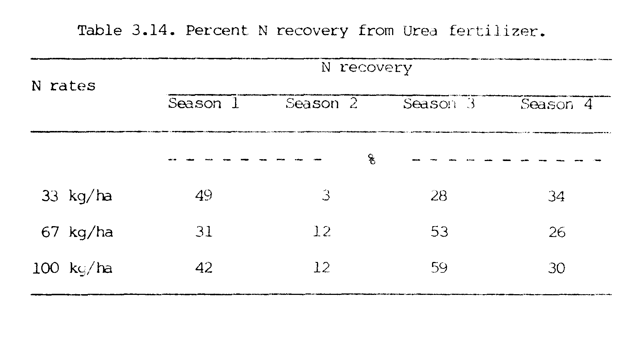
The ratios of TNA in monocropped legumes compared to those in intercropped legumes were 1.3, 1.5 and 1.4 in 1 and 1.0, 0.9 and 0.8 in season 3 for intercrops of determinate mungbeans, indeterminate mungbeans and soybeans, respectively (calculated from Table 3.15). Higher ratios in season 1 indicated that there was a slight (but non-significant) decrease in N₂ fixation by intercropping of legumes in season 1 but lower ratios in season 3 indicate that intercropping did not adversely affect nitrogenase activity of these two grain legumes in season 3.
Correlation coefficients for the relationship between several
variables related to N₂ fixation in mungbeans and soybeans presented in Table 3.16. Total nitrogenase activity was significantly correlated with number of nodules/plant (r values of 0.58 and 0.68 for mungbeans and soybeans, respectively) and nodule mass/plant (r values of 0.54 and 0.79 for mungbeans and soybeans, respectively). The relationship between number of nodules/plant and nodule was also significant with r values of 0.80 in mungbeans and 0.76 in soybeans. In both mungbeans and soybeans, the specific nitrogenase activities were negatively correlated (but not significant at the 0.05 level) with number of nodules/plant and mass of nodules/plant.
Soybeans had much higher N₂ fixing ability (μ mole ethylene/plant/-hour of 13.08 to 18.68 in season 1 and 20.93 to 26.43 in season 3) than mungbeans (μ mole ethylene/plant/hour of 2.50 to 4.40 in season 1 and 7.10 to 7.44 in season 3, Table 3.15). This higher N₂ fixation by soybeans may account for the higher N yields obtained from soybeans as than from mungbeans (Figure 3.8).
N contributions to the succeeding crops of corn from indeterminate mungbeans (58 to 75 kg ha⁻¹) were higher than those from soybeans (40.0
to 62.5 kg ha⁻¹, in spite of the difference in ability to fix N (Table
3.13). One reason for this might be that a greater portion of the fixed N may have been harvested in the above ground parts of soybeans than in mungbeans
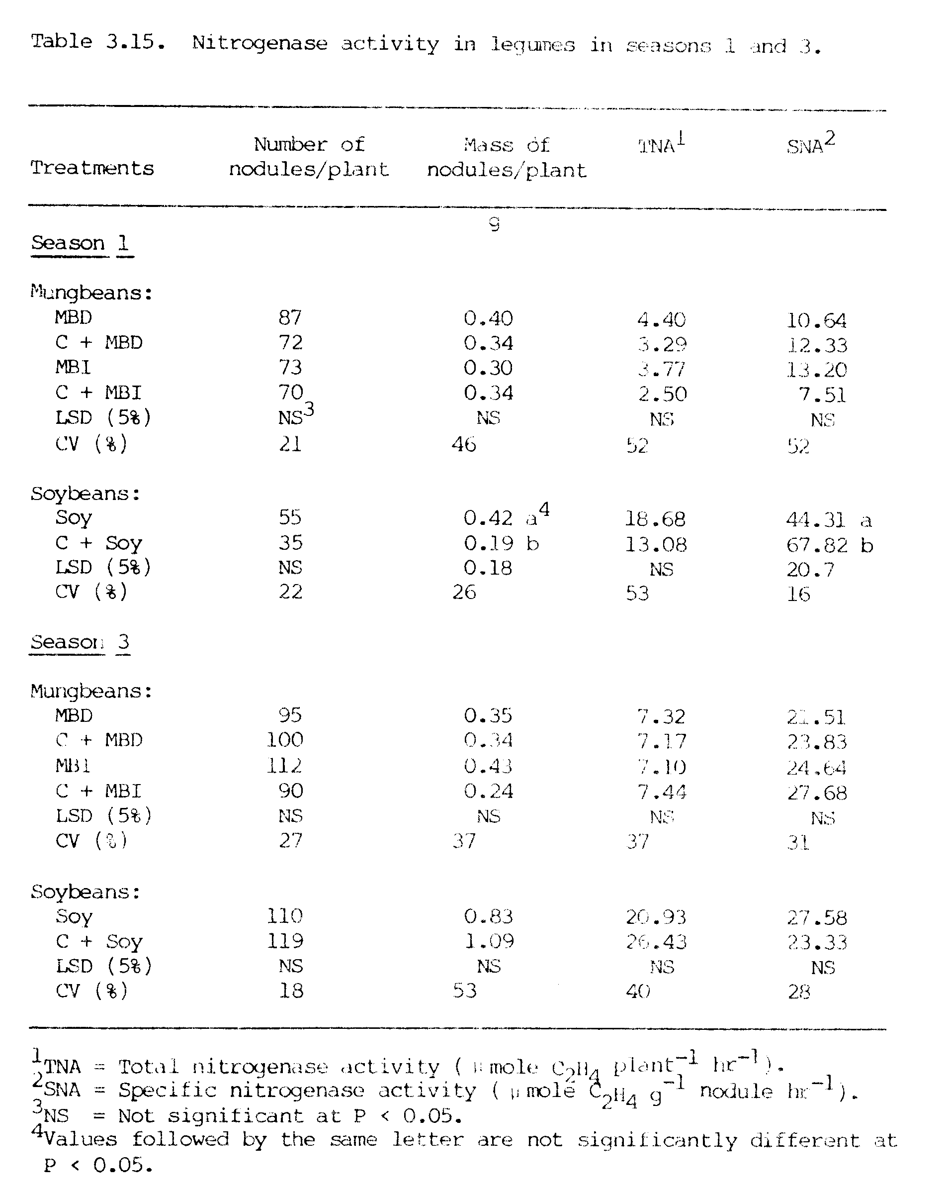

(Figure 3.8). Also, mungbeans were harvested about 7 weeks earlier than soybeans (Table 3.2), which may have allowed more time for mungbean roots and nodules in the soil to decompose and, therefore, release more N to the succeeding crop of corn.
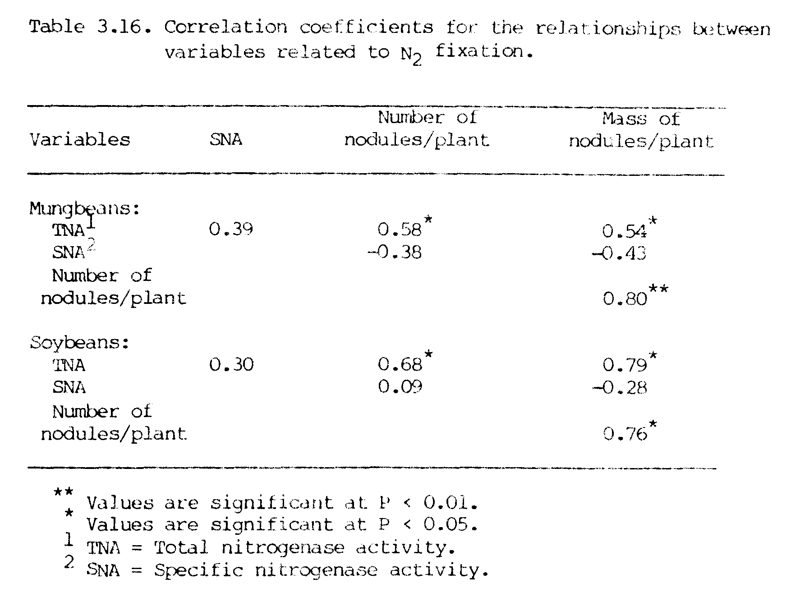
There was no significant difference in the N₂ fixation by indeterminate and by determinate mungbeans (Table 3.15). The N contributions to the succeeding crops of corn in both seasons 1 and 3, however, were higher from indeterminate hungbeans (58 to 75 kg ha⁻¹) than from determinate mungbeans (31 to 47 kg ha⁻¹, Table 3.13). Since flowering proceeded over a longer period of time in the indeterminate variety, the N₂ fixation also may have continued for a longer period of time in the indeterminate mungbeans. Thus the total N₂ fixed by indeterminate mungbeans was higher than that fixed by determinate mungbeans, which resulted in higher N contributions from indeterminate mungbeans.
The results suggest that N₂ fixation by mungbeans and soybeans generally was the same whether they were monocropped or intercropped with corn. Soybeans in season 1 were an exception due to the heavy shading by corn. The indeterminate mungbeans provided the largest amount of N to the succeeding crop of corn.

SUMMARY AND CONCLUSIONS
Field experiments involving intercropping of two grain legumes (mungbeans and soybeans) with a main crop of corn were conducted during four consecutive growing seasons (June 1981 to January 1983) at Waimanalo Research Station in Hawaii. In seasons 1 and 3, legumes were grown with or without corn, while in seasons 2 and 4, these plots of legumes were succeeded by corn. In addition, corn was also grown as a monocrop at N rates of 0, 33, 67 and 100 kg ha⁻¹ in each season. The main thrust of this investigation was to evaluate the yield potential and N economy of intercropping these two grain legumes with corn.
Grain yields of corn increased when intercropped with legumes compared to grain yields of corn monocropped without N application. The increases in intercropped corn grain yields over monocropped corn grain yields without N were 158, 163 and 163% in season l, and 181, 146 and 118% in season 3 for corn/determinate mungbeans, corn/indeterminate mungbeans and corn/soybean intercrops, respectively. There were no significant changes in total dry matter, harvest index, and plant height of corn in intercrops compared to corn monocropped without N.
The grain and total dry matter yields of mungbeans and soybeans were depressed when intercropped relative to monocropped. This indicates that the corn was dominant over legumes when they were growing together. In general, the plant heights, number of pods/plant and harvest indices of intercropped legumes were not different from those of monocropped legumes.
The total biomass produced by corn/legume intercropped treatments (6.11 to 10.88 mg ha⁻¹) were much higher than the biomass produced by control plots (3.08 to 4.33 Mg ha⁻¹) of corn. Total grain produced by corn/legume intercropping systems (1.58 to 3.45 Mg ha⁻¹) were 4 to 6 times higher than the grain produced by control plots of corn (0.39 to 0.55 Mg ha⁻¹). Total LAI obtained in corn/legume intercropping systems was higher than the LAI in monocrops of corn. LER values in these intercropping systems were 1.9 to 2.2 in season 1 and 1.6 to 1.9 in season 3, indicating the yield advantages in intercropping over monocropping systems.
In seasons 2 and 4, where corn crops followed legumes, the overall grain yields were poor due to lower solar radiation and temperature during the winter season. Grain yields and plant heights of corn following legumes were comparable with the grain yields and plant heights of corn monocrops with 33 to 67 kg ha⁻¹ of applied N. There were no significant differences in harvest indices among treatments.
Nitrogen yields of intercropped corn were not different from the N yields of monocropped corn without N in season 1. In season 3, however, the yield of intercropped corn was comparable to the N yield of monocropped corn which received 33 kg N ha⁻¹. N yields by intercropped legumes were lower than the N yields by monocropped legumes. Total N yields from corn/legume intercropped treatments, however, were much higher than N yields from monocropped corn at the maximum rate of applied N (100 kg N ha⁻¹). This suggests that appreciable amounts of N can be harvested if legumes are intercropped with corn.
In general, N yields of corn following grain legumes in seasons 2 and 4 were in between the N yields of monocropped corn fertilized with 33 and 67 kg N ha⁻¹. The N yields of corn following indeterminate mungbeans and soybeans in season 4, however, were higher than the N yields of monocropped corn fertilized with 67 kg N ha⁻¹.
Based on the N uptake by corn, the N contributions from legumes to the associated corn crop were zero in season 1 and 10 to 25 kg N ha⁻¹ in season 3. N contributions from legumes to following corn, however, were 40 to 58 kg N ha⁻¹ in season 2 and 31 to 75 kg N ha⁻¹ in season 4. The residual N contributions to following corn were highest from indeterminate mungbeans (58.0 to 75.0 kg N ha⁻¹) followed by soybeans (40.0 to 62.5 kg N ha⁻¹) and determinate mungbeans (35.0 to 47.0 kg N ha⁻¹ ).
The N₂ fixation by mungbeans and soybeans was not depressed by intercropping, except for soybeans in season 1 where soybean win shaded by corn due to narrow row spacing.
On the basis of the results obtained in this investigation, it can be concluded that corn intercropped with mungbeans or soybeans may perform better than corn monocropped without N application. Furthermore, in areas where food production is the prime objective (as in most subsistance farming systems), intercropping corn with mungbeans or soybeans can provide a substantial amount of total grain/ha which can not be obtained from monocropping corn without N.
It can also be concluded that there is no or very little transfer of N from mungbeans or soybeans to the associated corn crop. A substantial amount of residual N from mungbean or soybean residues, however, can be utilized by the following corn crop, thus reducing the amount of N input in cropping systems. In the areas where the supply at N-fertilizers is limited and/or N-fertilizers are too expensive to be used by common farmers (as in most of the developing countries), the inclusion of these legumes in cropping systems may provide a cheap alternative source of N.
CHAPTER IV
FORAGE LEGUMES WITH OR WITHOUT INTERCROPPING WITH CORN (Zea mays L.).

INTRODUCTION
Forage legumes are grown with grasses to increase yields as well as to improve the nutritional value of the forages. In addition to increased yields and nutritional value, the practice of legume/grass mixtures is based on the assumption that grasses utilize nitrogen fixed by legumes.
Forage legumes are included in cropping with food crops. One of the major food crops grown in these cropping is corn. Among the legume forage legumes, leucaena, because of its multiple uses, is popularly grown with corn. Efforts have been made to grow leucaena with corn (Mendoza et al., 1975; Guevarra, 1976; IITA, 1979; Rosa et al., 1980; Kang et al., 1981b; Mendoza et al., 1981). In a corn/leucaena intercropping experiment, no reduction in yield of either crop was observed by Guevarra (1976). At IITA (1979), corn yields were higher in the corn/leucaena intercrop (2.8 t ha⁻¹) than in the corn monocrop (2.5 t ha⁻¹). In another experiment, grain yields of corn were increased from 48.5 g plant⁻¹ in pure stand to 69.9-74.4 g plant⁻¹ in a corn/leucaena intercrop (Rosa et al., 1980).
Another forage legume of importance in the subtropics is desmodium. Most of the work has been done with desmodium/grass mixtures (Younge et al., 1974; Whitney et al., 1967; Whitney and Green, 1969; Whitney, 1970). No study has been reported where desmodium was intercropped with corn.
The amount of N contributed by a legume to an associated non-legume or to a subsequent crop basically depends on the N fixing ability and N requirement of the legume. The amount of N fixed by leucaena has been reported to range from 310 to 800 kg N ha⁻¹ yr⁻¹ (Brewbaker et al., 1972; Gomez and Zandstra, 1976). Most of the work on N contributions from leucaena to corn has been done by adding leucaena foliage to corn plots (Guevarra, 1976; Kang et al., 1981a, 1981b; Read, 1982; Evensen, 1983). No work has been reported on the transfer of N from leucaena to an associated corn crop or the residual N available from the root system of leucaena to the following crop of corn.
Desmodium has been found to fix as much as 381 kg N ha⁻¹ yr⁻¹ and was able to transfer about 5% of its N to associated grasses (Whitney et al., 1967). Transfer of N from desmodium to associated grass was also reported to be as little as 1.66% in sand culture (Henzell, 1962) to as much as 20% to pangolagrass (Whitney and Green, 1969). An accumulation of 101 to 112 kg N ha^{-l} yr⁻¹ in soil by desmodium has also been reported (Henzell et al., 1966). No work has been reported on the evaluation of N transfer from desmodium to an associated corn crop or the residual N available to a subsequent crop of corn.
Legumes differ in their N fixing abilities and N required for their growth. Since, leucaena (tree type) and desmodium (creeping type) differ in their growth patterns, the yield performance and N
contribution to corn from these legumes may be different. No effort has been made to compare the performance of these two types of forage crop with corn. Therefore, there is need to further investigate the use of these forage legumes (leucaena and desmodium) in cropping systems with corn.
The present investigation was conducted to evaluate the yield potential and N economy of intercropping two forage legumes with corn.

MATERIALS AND METHODS
A field experiment involving intercropping of two forage legumes (leucaena and desmodium) with a main crop of coin during four consecutive growing seasons and a crop of corn following the forage legumes in season 5 was conducted at Waimanalo Research Station in very fine kaolinitic, isohyperthermic, Vertic Haplustoll soil.

Planting
Two crops of sweet corn were grown in the field to remove available N from the soil before starting the experiment. Corn (Zea mays L.) var. H 763 was grown as a main crop. Leucaena (Leucaena leucocephala (Lam.) de wit) var. Hawaiian Giant (K8) and desmodium (Desmodium intortum (Mill) Urb) var. Greenleaf were grown with or without corn in four consecutive growing seasons. In season 5, leucaena and desmodium stubble were killed by spraying a 50:50 mixture of Roundup and Diesel directly over stubble. Two weeks after spraying, legume plots were tilled and corn was planted. In addition, monocrops of corn were grown at urea-N rates of 0, 33, 67 an a 100 kg ha⁻¹ in each season. The experiments were arranged in a randomized block design with 4 replications.
Leucaena seeds were scarified with sulfuric acid, and then were inoculated with TAL 582 strain of Rhizobium spp. before planting in dibble tubes on March 27, 1981. Seedlings were watered regularly and a N-free plant nutrient solution was supplied to the seedlings by drenching every two weeks for about 12 weeks before transplanting in the experimental plots. Desmodium seeds were inoculated with a mixture of TAL 569, TAL 667 and TAL 1147 strains of Rhizobium spp. before planting.
Planting of desmodium and transplanting of leucaena were done on June 15, 1981. Five crops of corn were planted on June 15, 1981, November 10, 1981, April 22, 1932, September 30, 1982 and February 15, 1983 In seasons 1 through 5, respectively. P as triple super phosphate and K as muriate of potash were applied at the rates 120 and 100 kg
ha⁻¹, respectively, for all crops in each season. N as urea was applied at four levels (0, 33, 67, and 100 kg ha⁻¹) only in monocrops of corn in each season. Treatments with monocrops of legumes and intercrops of legumes with corn were not supplied with N.
Leucaena and desmodium were planted at plant densities of 50,000 and 800,000 plants ha⁻¹, respectively, in both monocrop and intercrop. Corn was planted at a density of 53, 333 plants ha⁻¹ in the monocrop and 40,000 plants ha⁻¹ in the intercrop. Leucaena was planted in rows 100 cm apart with a within row plant spacing of 20 cm in both the monocrop and intercrop. The row spacing for desmodium was 25 cm and the plant spacing was 5 cm in both the monocrop and intercrop. Corn was planted in rows 75 cm apart in the monocrop and 100 cm apart in the intercrop, and had a plant spacing of 25 cm in both monocrop and intercrop. Planting patterns are presented in Appendix Figure l.

Weed and Insect Control
Atrazine and Lasso Preemergence herbicides were applied at the rate of 2 kg ha⁻¹ of each in plots of monocropped corn. In all other legume plots only Lasso was applied at the rate of 2 kg ha⁻¹. Weeds were also removed by hand whenever necessary.
Diazinon and Sevin (at the rate of 12 oz each in 100 gallons of water) were sprayed to control the insect, mainly Rose beetle.

Harvesting
Leucaena and desmodium were harvested at intervals of 6 to 8 weeks at heights of 50 and 5 cms, respectively. This much stubble was left for regrowth of these perennials. Leucaena and desmodium both harvested 9 times. Harvest numbers 1 and 2 were made in season 1, harvest numbers 3 and 4 in season 2, harvest 5, 6 and 7 in season 3, and harvest numbers 8 and 9 in season 4.

Plant Height and LAI
Heights of 10 plants from each treatment were measured and the mean values were used for plant height.
Leaf area index of desmodium were measured by taking leaves from 5 plants in each of the desmodium plots, and then measuring the leaf area with a Leaf Area Meter (LIOOR-CI - 3100). In leucaena, subsampling of leaves was done and the leaf areas of these subsamples were measured. Based on the total dry matter of leaves in the whole plant, the Values from subsamples of leaves were used to calculate the leaf area in the whole plant of leucaena. The leaf area index (LAI) was calculated as leaf area pet unit area of land.

Dry Matter Yield
Grain and stover yields were measured in corn. Above ground parts of leucaena and desmodium were measured for forage yields. Total dry matter yields were calculated by the addition of all components. Yields are reported in Megagrams per hectare (Mg ha⁻¹), which is a metric ton or million grams per hectare.

Nitrogen Contents
Ear-leaf samples taken from corn plants at the 50% silking stage were analyzed for N content. Grain, stover, and forage samples after each harvest were analyzed for N content by the Microkjeldahl method (Bremner, 1965a), and total N yields were calculated.
Soil samples taken from individual plots, before and after each crop season, were analyzed for available NH₄-N and NO₃-N by the
Steam-distillation method (Bremner, 1965b).

Evaluation
Productivity per hectare of land was estimated by calculating land equivalent ratios (LER) for all the intercropped plots. The calculation was done as:
Corn intercrop yield Legume intercrop yield
LER = -------------------- + -----------------------
Corn monocrop yield Legume monocrop yield
A harvest index (HI) was calculated for each crop as HI = economic yield/biological yield, where grain yield was the economic yield and above ground total dry matter was used as the biological yield.
Nitrogen contributions from legumes to corn were estimated by comparing the N uptake by intercropped corn with the N uptake by monocropped corn at four levels of N.
Statistical analysis of the data included the analysis of variance, F test, Duncan’s multiple range test, simple correlation technique and regression analysis.

RESULTS AND DISCUSSION

Performance of Corn in Intercropping
Corn responded well to increased rates of N application in seasons 1 and 3, which happened to be summer (Figure 4.1). Increases in grain yields of corn were from 0.39 to 4.28 Mg ha⁻¹ in season 1 and from 0.55 to 4.82 Mg ha⁻¹ in season 3 with increased rates of N application iron 0 to 100 kg ha⁻¹, respectively. Response to increased rates of N by corn was poor in seasons 2 and 4, which were the winter period. Grain yields of corn increased from 0.38 to 0.57 Mg ha⁻¹ in season 2 and from 0.39 to 0.99 Mg ha⁻¹ in season 4 as applied N increased from 0 to 100 kg ha⁻¹, respectively. The poor performance of corn during the winter (seasons 2 and 4) compared to summer (seasons 1 and 3) was due to lower solar radiation and temperature during the winter (Appendix Table 3).
Grain yields of corn intercropped with leucaena and desmodium were not significantly different from the grain yields of monocropped corn without N in seasons 1, 3 and 4 (Figure 4.2 and Appendix Table 5); however, grain yield of corn was significantly depressed in the Leucaena plot in season 2. Percentages of corn grain yields obtained with intercropping compared to monocropping (control plots) were 128 and 72% in season 1, 60 and 71% in season 2, 122 and 91% in season 3, and 102 and 118% in season 4 in leucaena and respectively (Table 4.1). Corn with leucaena seemed to do a little better than with desmodium in seasons 1 and 3 (summer), while corn with desmodium seemed to do a little better than corn with leucaena in seasons 2 and 4 (winter). However, these differences were not significant. Except in season 2, there seemed to be a slight yield advantage to corn grown with leucaena over monocropped corn without N, while except in season 4, there seemed to be no yield advantage to corn grown with desmodium over monocropped corn without N. Again, these differences were not significant.
Total dry matter yields (grain + stover) of corn in leucaena and desmodium plots were not depressed in seasons l, 3 and 4, however, total dry matter yield of corn was depressed by leucaena in season 2 (Figure 4.2).
Harvest indices of corn intercropped with leucaena and desmodium were not different from those of the control plots of corn (Table 4.2). Plant heights of corn intercropped with leucaena and desmodium were not significantly different from the plant height of monocropped corn without N in seasons 1 and 3, but were significantly higher in seasons 2 and 4 (Table 4.2).
The reduction in grain yield and total dry matter of corn grown with
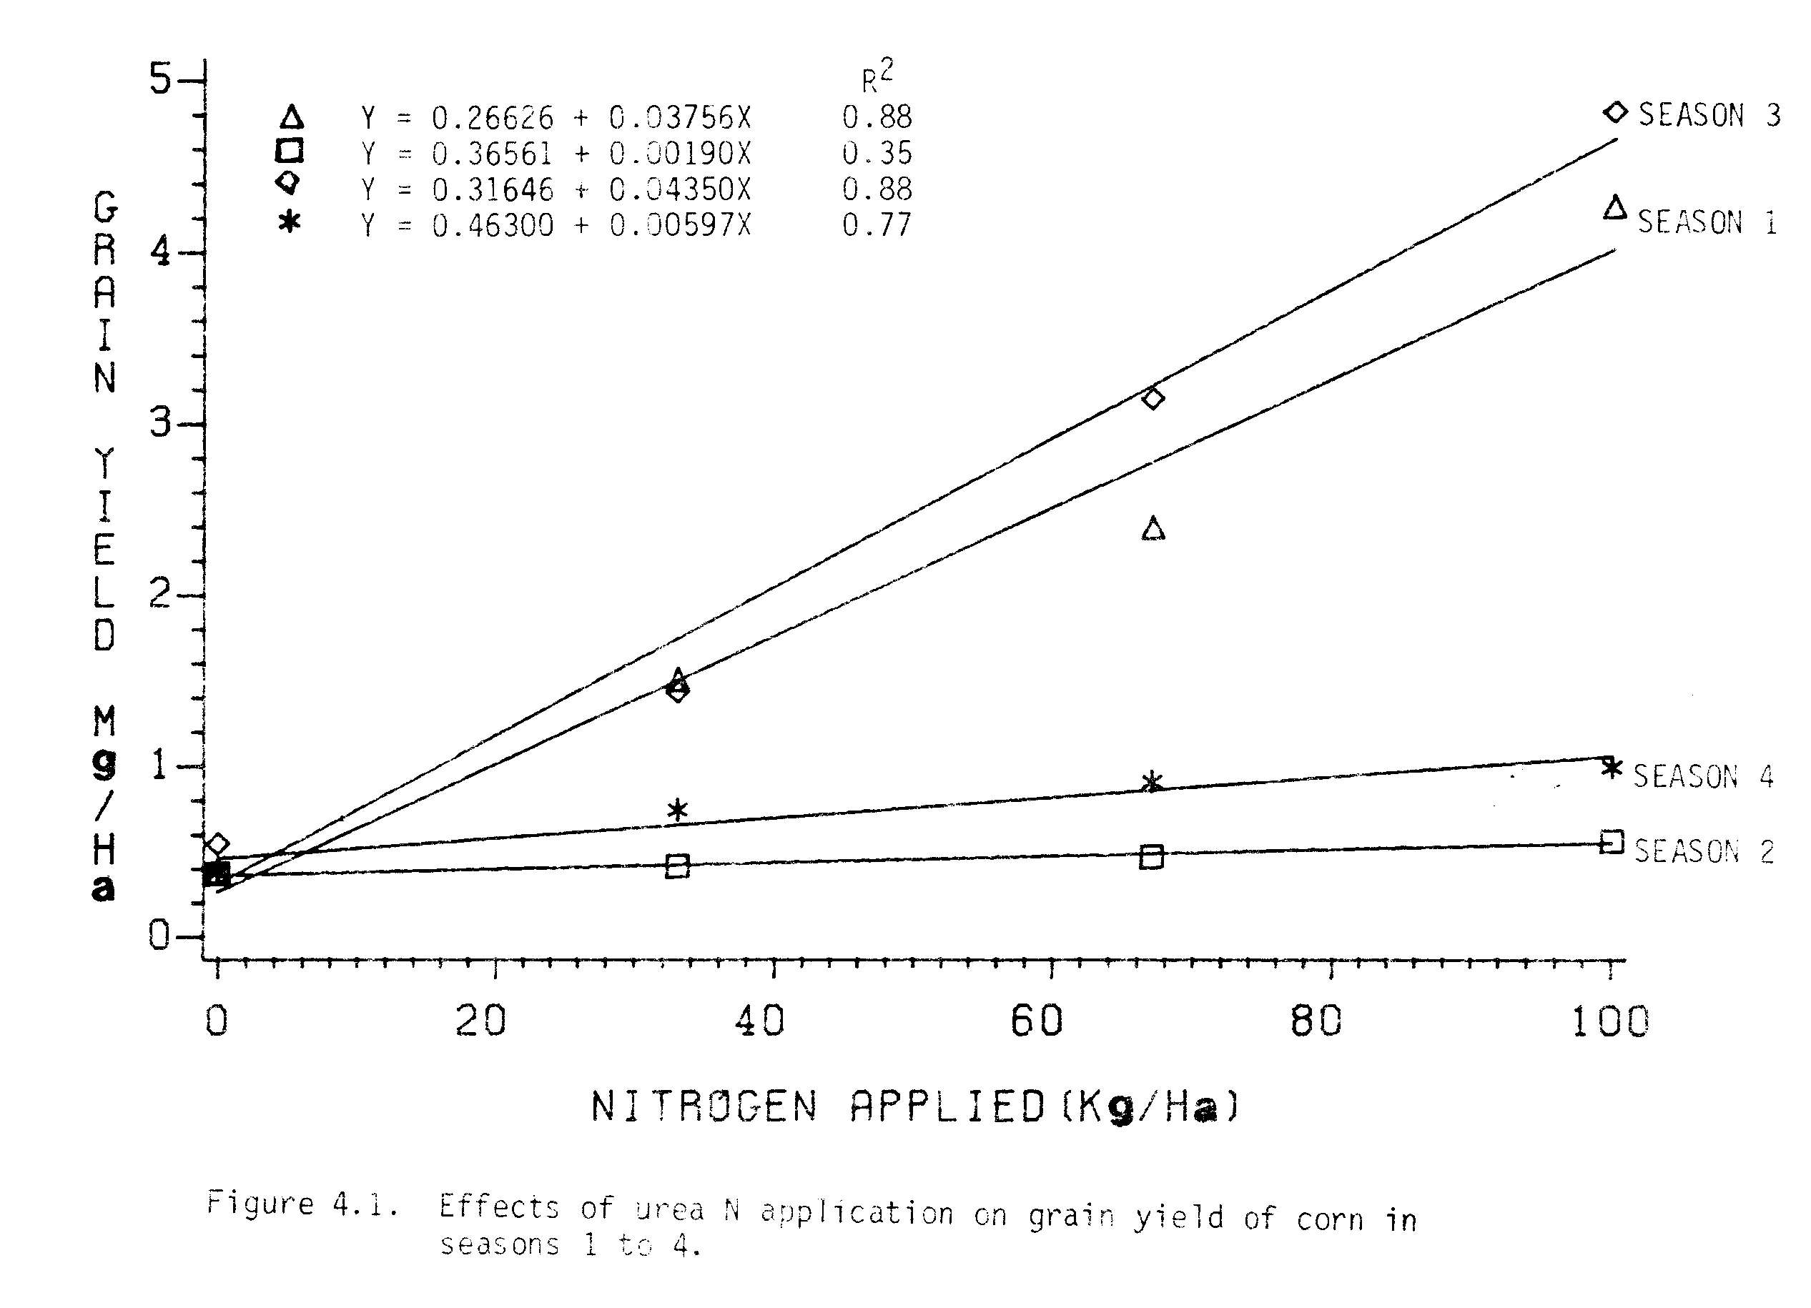

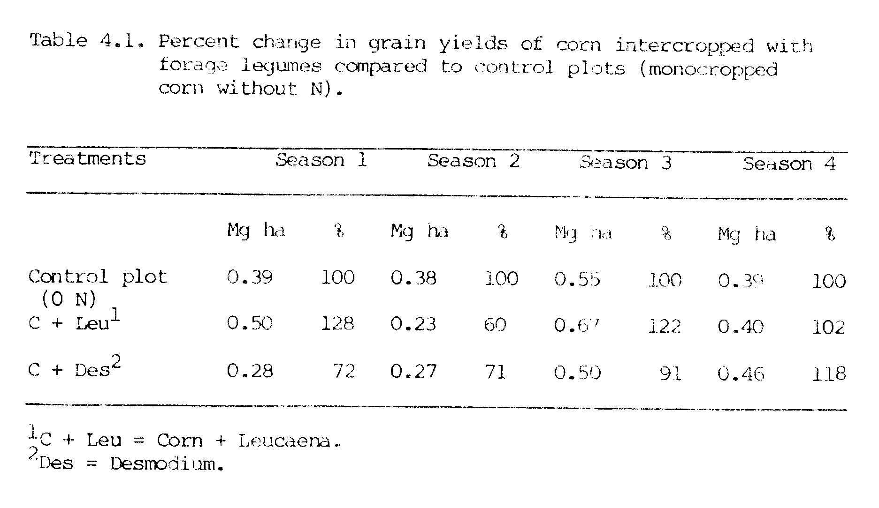
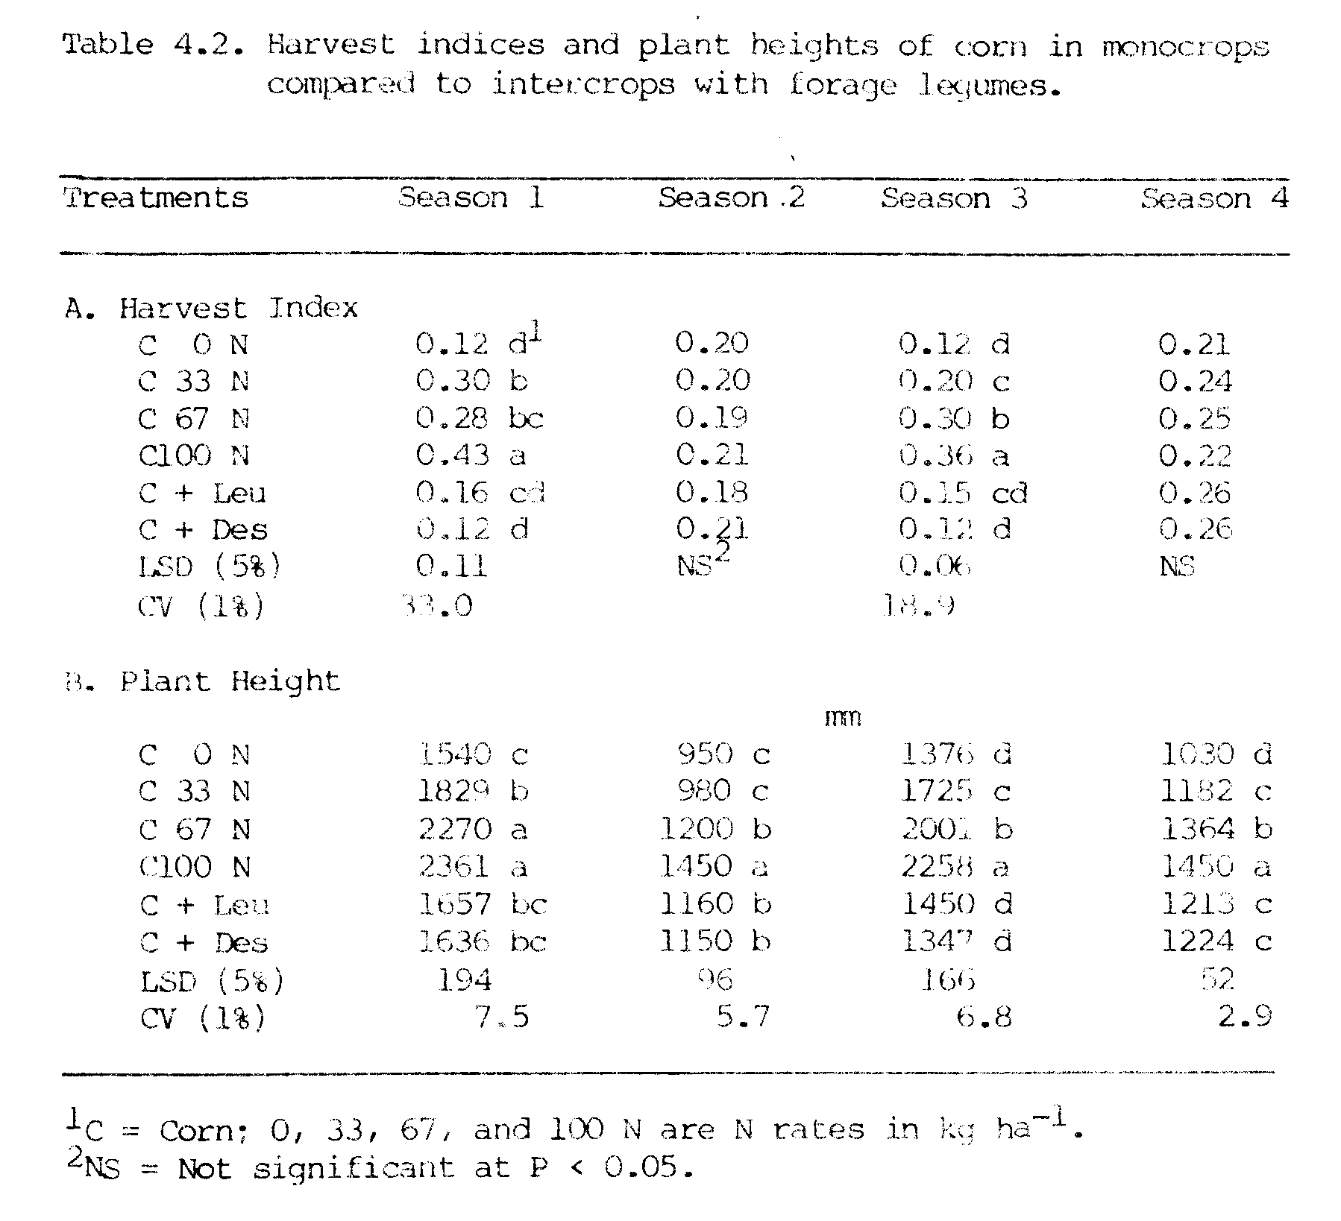
leucaena in season 2 was probably the result of the corn being shaded by leucaena as it was observed that leucaena overgrew the coal (Appendix Figure 4). Yield depression in corn in leucaena plot in season 2 suggests that shading effects can be minimized by better scheduling of intervals for cutting leucaena.
In general, comparable grain yields can be obtained when corn is intercropped with leucaena or desmodium to when it is monocropped without N application. These results agree with those of Guevarra (1976) who found no reduction in corn yield when corn was intercropped with leucaena.

Performance of Forage Legumes
Seasonal dry matter yields of leucaena and desmodium are presented in Figure 4.3. Forage yields of leucaena intercrops were slightly reduced in seasons 1 and 2, and were slightly increased in seasons 3 and 4 compared to leucaena monocrops in the respective seasons. Forage yields of leucaena intercrops were not significantly different from forage yields of leucaena monocrops in all four seasons. In desmodium, slight depressions in intercrop yields were observed compared to their monocrop yields in all four seasons; however, these yield depressions were not statistically significant (Figure 4.3 and Appendix Table 6). These results indicated that leucaena seemed to do little better as an intercrop than as a monocrop towards the end of the experiment, while the opposite was true with desmodium.
Both crops had higher yields in seasons 1 and 3 (summer) than in seasons 2 and 4 (winter), with the highest yields in season 3 (Figure 4.3). In season 1, since leucaena and desmodium both took about 2 to 4 weeks for establishment in the field before making real growth, the yields were lower than in season 3.
Over a growing period of 590 days leucaena accumulated 26.16 and 25.07 Mg ha⁻¹ dry matter when monocropped and intercropped, respectively (Table 4.3). While, desmodium in a growing period of 591 days
accumulated 32.81 and 28.64 Mg ha⁻¹ dry matter when monocropped and intercropped, respectively. Total dry matter accumulated by the end of this experiment by intercropped and monocropped leucaena were significantly different; however, there was a reduction of about 4 Mg ha⁻¹ dry matter by desmodium intercropped compared to monocropped during this experimental period. Leucaena had equally good growth in the intercrop as in the monocrop (Appendix Figure 5). The reduction in dry matter accumulation by desmodium during the last part of the experiment may have been due to the death of some of the desmodium plants during this period.
Annual dry matter yields of leucaena were 18.14 and 17.82 Mg ha⁻¹ yr⁻¹ in the monocrop and intercrop, respectively (Appendix Table 7).
The monocrop and intercrop of desmodium produced 22.46 and 19.70 Mg ha⁻¹ yr⁻¹ respectively. These results suggest that both forage legumes are capable of producing high amounts of biomass ha⁻¹ yr⁻¹.
Solar radiation, temperature, dry matter yield for each harvest and dry matter accumulation per day by leucaena and desmodium are presented in Figure 4.4. Changes in dry matter yields of leucaena and desmodium in each harvest coincided with changes in solar radiation. From June to September in 1981, average monthly solar radiation was in the range of 20 to 22 MJ m⁻² day⁻¹ and so were yields of first harvest of leucaena and desmodium in September 1981. Solar radiation declined to a value of 6.7 MJ m⁻² day⁻¹ in October 1981 and remained low until April 1982 and as a consequence the yields of the second, third, and fourth harvests of leucaena and desmodium were low. After April 1982, solar radiation increased and remained high until September 1982 in the
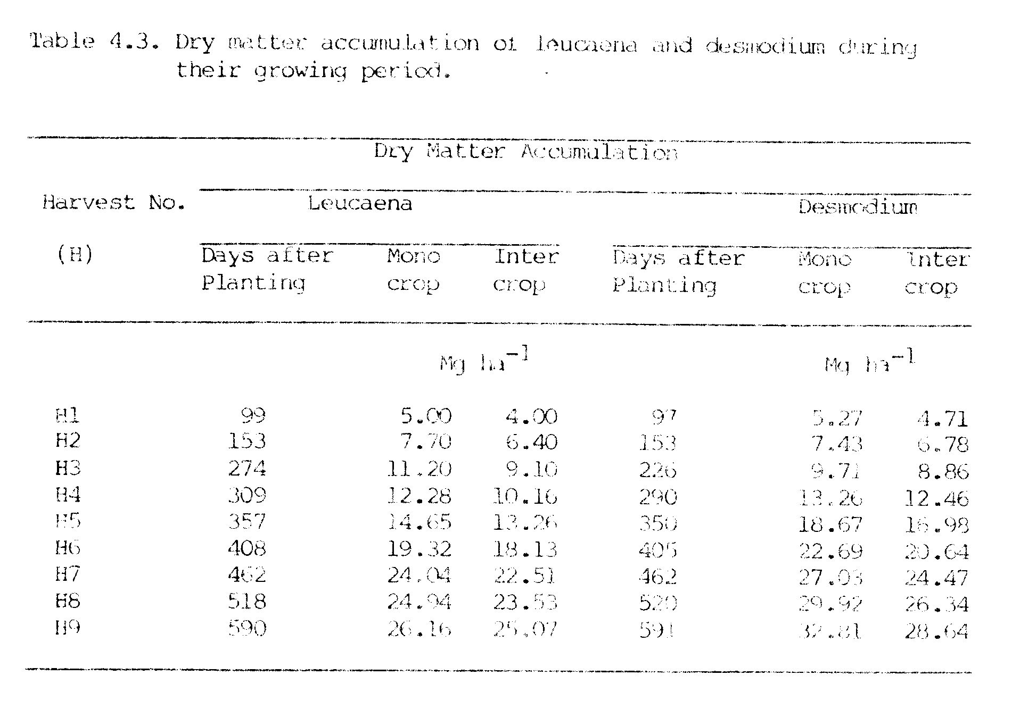
range of 14.0 to 16.6 MJ m⁻² day⁻¹ and yields of leucaena and desmodium were high during that period. After September 1982, solar radiation declined and so did yields of the last two harvests of leucaena and desmodium.
Dry matter accumulation (g m⁻² day⁻¹) by leucaena and desmodium were affected by changes in solar radiation (Figure 4.4). Rates of dry matter accumulation were higher during periods of higher solar radiation (summer) and were lower during periods of lower solar radiation (winter) in both crops. Rates of dry matter accumulation by monocrops and intercrops of leucaena were very similar during the entire growing period. In desmodium, rates of dry matter accumulation by monocrops and intercrops were very similar up to harvest number 4, but after that dry matter accumulation was higher in the monocrops. In leucaena, the similar dry matter accumulation could have been due to the fact that the growth of leucaena in the intercrop was as good as in monocrop, since leucaena was able to compete successfully with corn. While in desmodium, the reduced dry matter accumulation could have been due to the death of some of the original plants and thereby a reduced plant population towards the end of the experiment.
Changes in monthly average temperature wore similar to the changes in solar radiation during the period of this experiment. The correlation coefficient between solar radiation and temperature during the entire period of 4 seasons was 0.82. The correlation between solar radiation and yields of leucaena and desmodium was found to have r values of 0.71 and 0.88, respectively. At the same site in another experiment, the correlation between solar radiation and temperature, and correlation between solar radiation and yield of leucaena were reported
to be 0.79 and 0.73, respectively, by Hedge (1983). These results show
that environmental conditions have profound effects on the forage yields of leucaena and desmodium.

Total Performance in Intercropping
Total dry matter yields of corn/forage legume intercrops compared to dry matter of monocrops of corn are presented in Figure 4.5 and Appendix Table 2. Total dry matter produced in season 1 in corn/forage legume intercrops were comparable to total dry matter produced by corn at an N rate of 100 kg ha⁻¹. In general, total dry matter produced by corn/forage legume intercrops in seasons 2, 3 and 4 were higher than dry matter produced by monocrops of corn fertilized with 100 kg N ha⁻¹. These results suggest that much higher total biomass can be produced by a corn/forage legume intercropping system than by a monocrop of corn with no N application grown under similar environmental conditions.
LAI’s of corn in corn/desmodium intercrops were lower than the LAI’s in control plots, while the LAI’s of corn in corn/leucaena intercrops were higher than in the control plots (Table 4.4). The total LAI’s in corn/forage legume intercrops were 11.83 and 9.61 for monocropped and intercropped leucaena, respectively, and 3.15 and 3.58 for monocropped and intercropped desmodium, respectively. Leucaena had much higher LAI than any other crop. Higher LAI in corn/legume intercrops compared to control plots of corn may have resulted in higher interception of the incoming solar radiation in intercropping systems than in monocropping, and this was the reason for higher biomass production/ha in intercropping systems.
Land equivalent ratios (LER) in corn/forage legume intercrops are presented in Table 4.5. Values of LER for corn grown with leucaena were more than one in all seasons, except season 2, indicating a yield advantage for corn in all seasons but season 2, when corn was shaded leucaena. Values of LER for corn grown with desmodium were lower than one
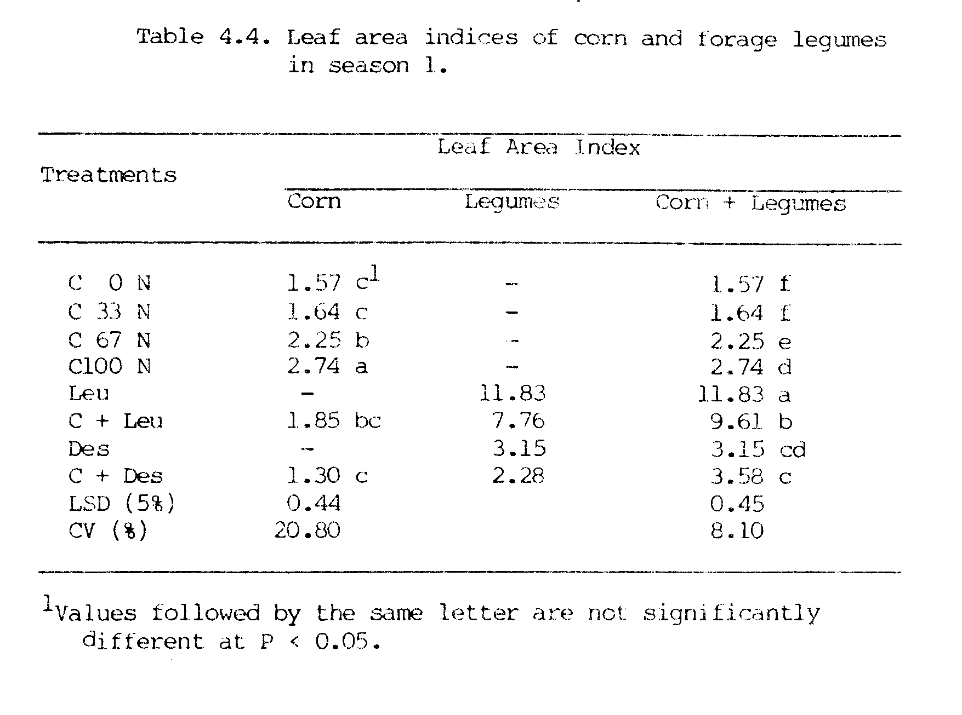
in all seasons except season 4, which indicated a yield depression of corn in seasons 1 through 3. The total LER in corn/leucaena and corn/desmodium intercrops, however, were in the ranges of 1.40 to 2.10 and 1.60 to 1.81, respectively. Except in season 2, LER values from corn/Leucaena intercrops were higher than from corn/desmodium intercrops in all other seasons. These values of LER indicated that one would have needed 1.40 to 2.10 hectares and 1.60 to 1.81 hectares of land of monocrops to produce as much as was produced in one hectare of the corn/leucaena and corn/desmodium intercrops, respectively.
These results indicated that much higher production/ha could be achieved by corn/forage legume intercrops than by monocrops of corn with no N application. In those areas where N fertilizers are in short
supply and/or are too expensive for a common farmer to use, the use of corn/forage legume intercropping systems may be a reasonable and inexpensive alternative to obtain food as well as forage yields without inputs of inorganic N.

N Yield and Transfer
Total N yields by monocrops of corn and corn/forage legume intercrops in all 4 seasons are presented in Figure 4.6 and Appendix Table 4. N yields of corn intercropped with leucaena and desmodium were not significantly different from the N yields obtained from monocropped of corn without N application in all 4 seasons.
Based on the N uptake by corn (Figure 3.11), N contributions from legumes to corn were nil in seasons 1 and 2, while N contributions to corn were 30 and 17 kg N ha⁻¹ in season 3, and 19 and 9 kg N ha⁻¹ in season 4 from leucaena and desmodium respectively. These result suggest that practically no N was transferred from forage legumes to corn in seasons 1 and 2 but there was N transfer in season 3 and 4. These N
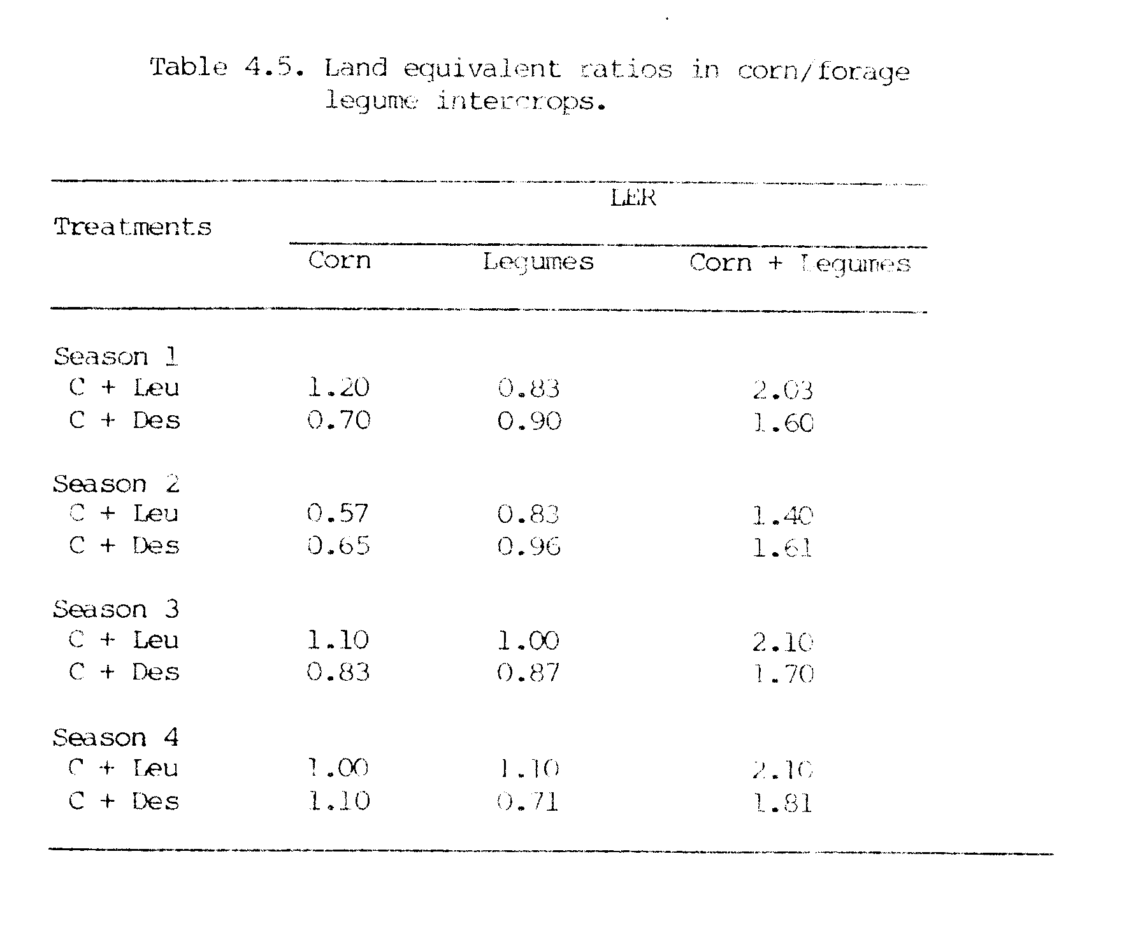
contributions in seasons 3 and 4 may have been due to N accumulations over a period of time in corn/legume plots.
Soil nitrogen analysis indicates that NH₄-N and NO₃-N in the forage legume plots at the beginning of the experiment were low in the ranges of 11.47 to 13.06 and 8.60 to 10.35 ppm, respectively (Appendix Table 8). After season 4, however, the available N as NH₄ and NO₃ in forage legume plots increased 2 to 3 times in the ranges of 31.59 to 38.22 and 15.29 to 25.48 ppm, respectively. The increase in NH₄-N and NO₃-N was probably due to the accumulation of N over a period in these forage legume plots.
Based on N accumulation during several periods, average N yields from leucaena were 653 and 630 kg ha⁻¹ yr⁻¹ in monocrops and intercrops, respectively (Appendix Table 7). From desmodium average N yields were 608 and 508 kg ha⁻¹ yr⁻¹ in monocrops and intercrops respectively. Other studies reported N yields of 310-800 kg ha⁻¹ yr⁻¹ in leucaena (Brewbaker et al., 1973; Gomez and Zandstra, 1976) and 381 kg ha⁻¹ yr⁻¹ in desmodium (Whitney et al., 1967). These results suggest that N production/ha can be greatly increased, if these forage legumes are included in cropping systems.
Total N yields obtained in corn/legume plots were considerably higher than in control plots or even in monocrops of corn at 100 kg ha⁻¹ of applied N. During the period of this investigation, total N yields obtained from corn/leucaena intercrops were 7 to 21 times higher than the N yields obtained from control plots of corn, and that from corn/desmodium intercrops were 7 to 14 times higher than the N yields obtained from the control plots of corn (Appendix Table 4).
These high N yields from intercropping are likely due to the high content in leucaena and desmodium leaves (Appendix Table 6). The N content in leucaena and desmodium foliage ranged from 3.84 to 4.39% and 2.38 to 2.85%, respectively. The % N in foliage in both forage legumes was slightly higher in winter (seasons 2 and 4) than in the summer (seasons 1 and 3). Similar higher % N in leucaena in winter than in summer was reported by Hegde (1983).
The dry matter and N yields were highly correlated in both leucaena (r = 0.89 to 0.99) and desmodium (r = 0.79 to 0.98) crops in all 4 seasons (Table 4.6). Since there were higher dry matter yields during the summer, more N was incorporated with carbon to make other compounds, and, therefore, the % N was lower in summer than in winter. This may also be the reason for the negative (but non-significant) r values
between dry matter and % N in foliage during the summer. The opposite may occur during the winter.

Performance of Corn Following Forage Legumes
In season 5, grain yields of corn (monocrops) increased linearly from 0.55 to 3.03 Mg ha⁻¹ as N rates were increased from 0 to 100 kg N ha⁻¹ (Figure 4.7). The slope of the regression line shows that with each additional kg of N, the predicted increase in corn grain yield would be about 26 kg.
The performance of corn following forage legumes in season 5 is presented in Table 4.7. Plant heights of corn following forage legumes were higher than in the control plot (1286 mm) and were comparable to the plant height (1710 mm) of corn obtained with 33 kg ha⁻¹ applied N.
Grain yields of corn obtained in legume plots (1.22 to 1.43 Mg ha⁻¹ in leucaena plots and 1.29 to 1.52 Mg ha⁻¹ in desmodium plots) were higher than grain yield in the control plot (0.55 Mg ha⁻¹) and were comparable to grain yield of corn obtained with 33 kg ha⁻¹ of applied N (1.32 Mg ha⁻¹). Total dry matter yields showed similar trends as those of corn grain yields. Only the harvest index of the control plot was
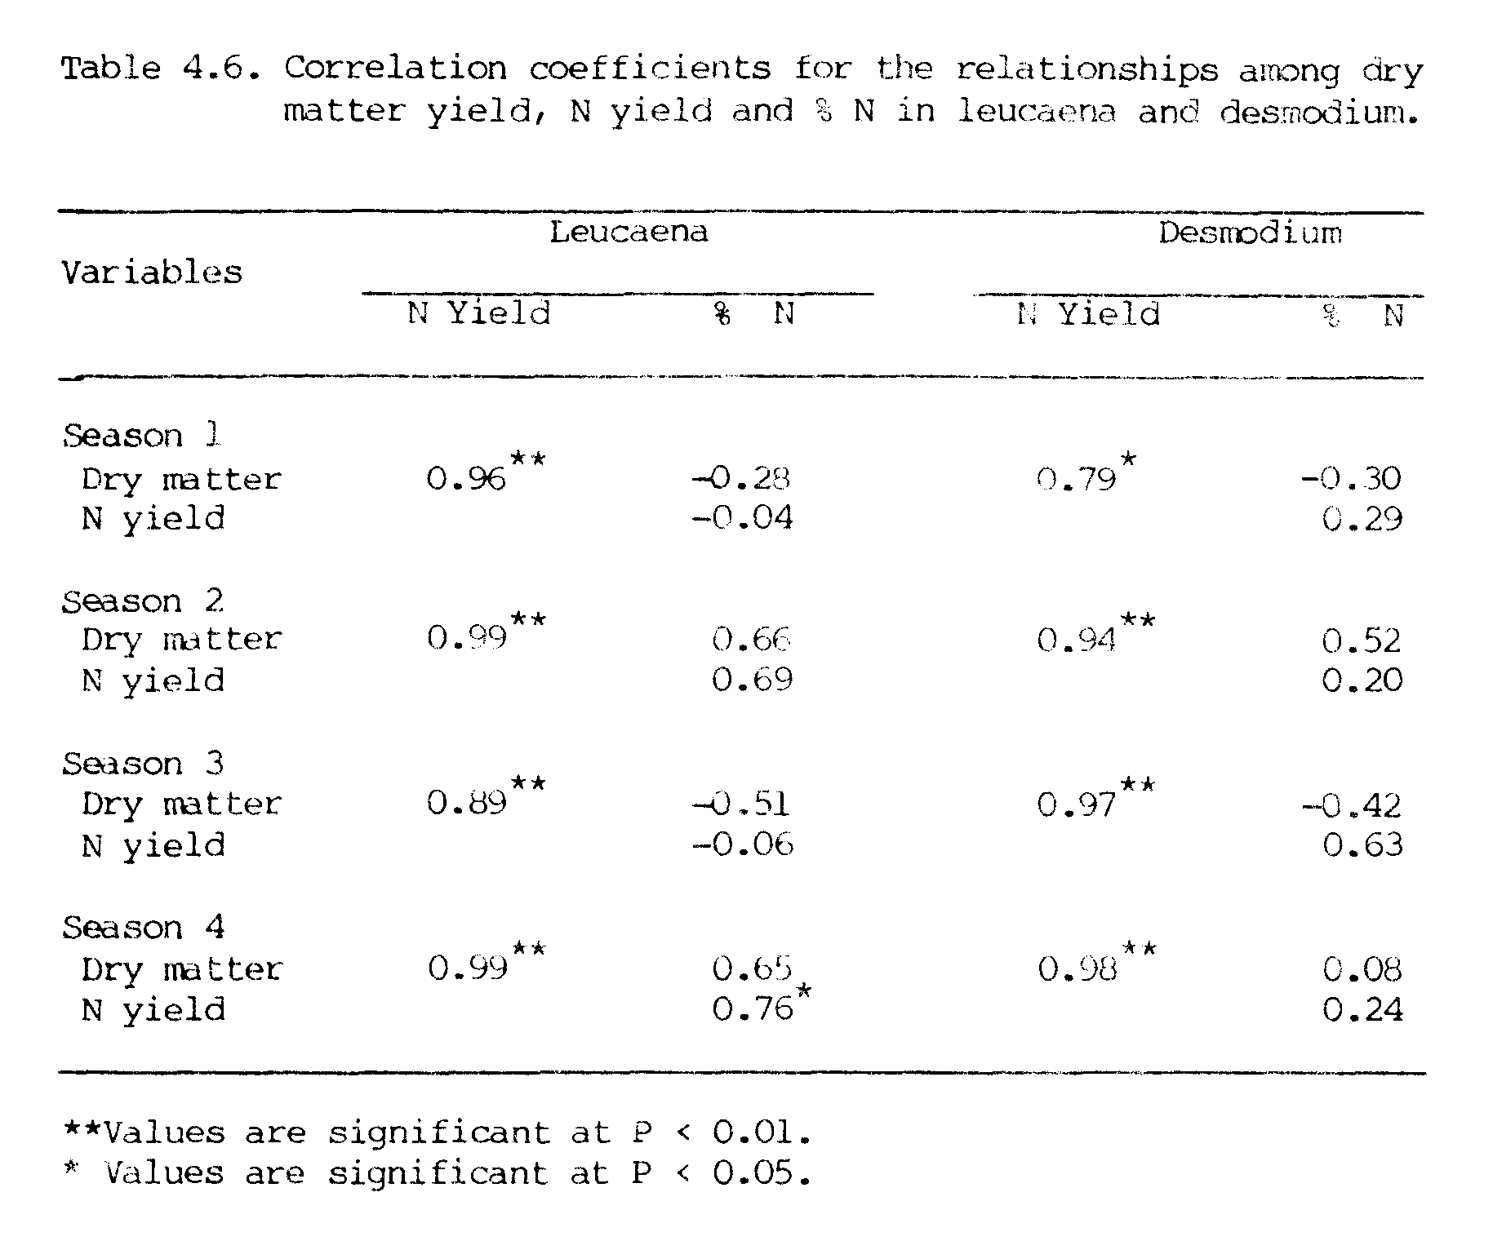

significantly different from those of other treatments (Table 4..7).
Percent N in corn leaves at 50% silking and N yields of corn following forage legumes were also comparable with % N in corn leaves (1.10%) and N yield (19.5 kg ha⁻¹) obtained with N application of 33 kg ha⁻¹ (Table 4.7).
The N uptake by corn increased linearly with increased rates of N, with an R² of 0.82 (Figure 4.8). The regression coefficient predicts that with each additional kg of N about 0.42 kg of N uptake by corn may be expected, which also means that the efficiency of applied urea-N was 42%.
Based on this regression (Figure 4.8), the N contributions from forage legumes to the succeeding crop of corn were estimated to be 21 to 31 kg ha⁻¹ from leucaena and 23 to 30 kg ha⁻¹ from desmodium.
These results suggested that in season 5, where desmodium stubble was killed and all the roots and stubble were incorporated into the soil, the crop of corn received 23 to 30 kg N ha⁻¹ from decomposition of stubble and roots. In leucaena plots, where leucaena stubble was killed (but not incorporated into the soil and the roots were not disturbed), the succeeding crop of corn received 21 to 31 kg ha⁻¹. It is possible that the leucaena roots being thick and woody may have not decomposed fast enough to supply most of their N to succeeding crop; therefore, only a part of the N from leucaena roots may have been available to the succeeding corn crop and still more N may have been released into soil with further decomposition of roots after the corn was harvested.

SUMMARY AND CONCLUSIONS
A field experiment involving intercropping of two forage legumes (leucaena and desmodium) with a crop of corn was conducted during four
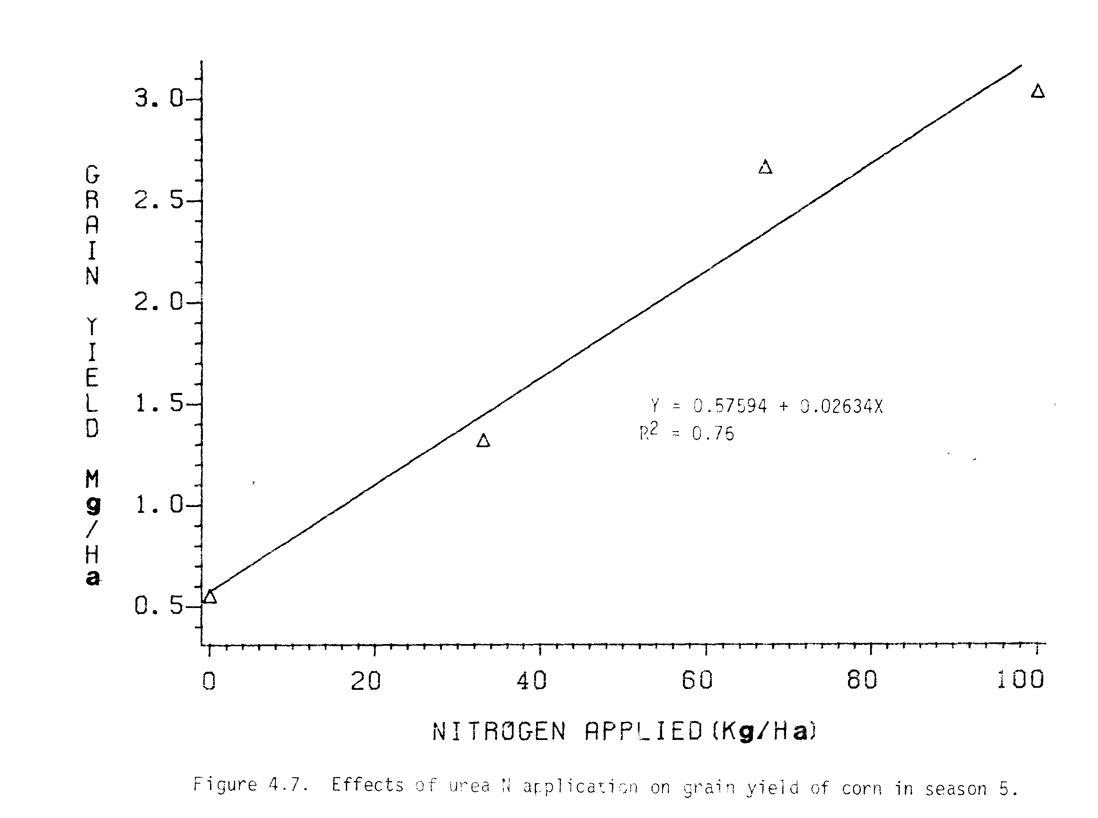
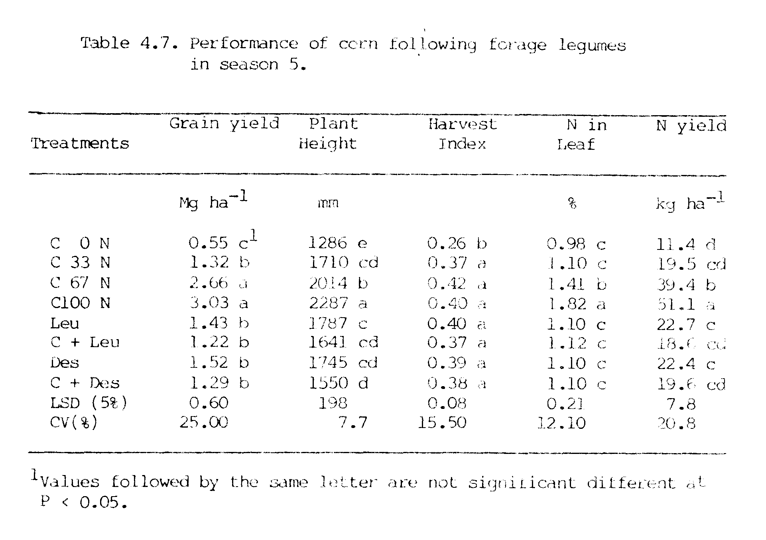
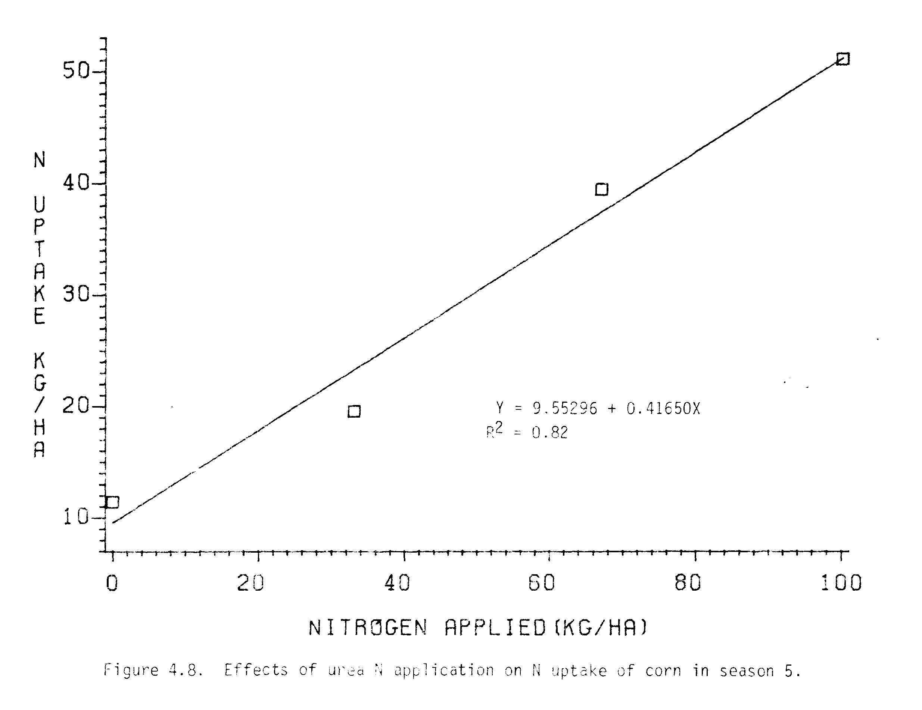

consecutive growing seasons beginning in June 1981 at Waimanalo Research Station in Hawaii. In season 5, leucaena and desmodium were followed by corn. The main objective of this investigation was to evaluate the
yield potential and N economy of intercropping these two forage legumes with corn.
Grain yields of corn intercropped with leucaena were slightly higher than in control plots in all seasons except season 2, where corn was shaded by leucaena. Grain yields of corn intercropped with leucaena were 128, 60, 122, and 102% of control plots in seasons 1 to 4, respectively. While grain yields of corn with desmodium were slightly lower than the control plots in all seasons except season 4. Grain yields of corn intercropped with desmodium were 72, 71, 91, and 118% of control plots in seasons 1 to 4, respectively. In general, corn did better with leucaena than with desmodium. However, corn seemed to perform better with leucaena than with desmodium during summer and better with desmodium than with leucaena during winter times.
Seasonal forage yields of leucaena and desmodium were not significantly different in intercrops as compared to monocrops. Leucaena did somewhat better as intercrop than as monocrop towards the end of the experiment while the opposite was true in case of desmodium. On an annual basis forage yields produced by desmodium (19.7 to 22.5 Mg ha⁻¹ yr⁻¹) were higher than forage yields of leucaena (17.6 to 18.1 Mg ha⁻¹ yr⁻¹). The environment had large effects on the seasonal yields of forages.
The total biomass produced by corn/forage legume intercropped plots (4.5 to 17.0 Mg ha⁻¹) were much higher than the biomass produced by control plots (3.08 to 4.33 Mg ha⁻¹)of corn. Total Leal Area Index in corn/legume intercropping systems (9.61 in corn/leucaena and 3.58 in corn/desmodium) were much higher than the LAI in control plots at corn (1.57). Total Land Equivalent Ratios in corn/leucaena and corn/desmodium intercrops were in the range of 1.40 to 2.10 and 1.60 to 1.81, respectively. LER values greater than one clearly indicated the yield advantages in intercropping over monocropping systems.
Nitrogen yields of corn intercropped with leucaena and desmodium were not different from the N obtained in control plots in all 4 seasons. On an average, N produced by leucaena were from 630 to 653 kg ha⁻¹ yr⁻¹ and by desmodium were from 508 to 608 kg ha⁻¹ yr⁻¹. Total N yields obtained from corn/leucaena intercroppings were 7 to 21 times and from corn/desmodium intercroppings were 7 to 14 times as much the N yields obtained from control plots of corn. This suggest that an appreciable amount of N ha⁻¹ can be harvested if these legumes are included in the cropping systems.
Based on the N uptake by corn, there was no N contributions from legumes to associated corn in seasons 1 and 2; however, there was some N contribution from legumes to associated corn in seasons 3 and 4 (19 to
30 kg N ha⁻¹ from leucaena and 9 to 17 kg N ha⁻¹ from desmodium). Corn
following forage legumes in season 5 received residual N of 21 to 31 kg
ha⁻¹ from leucaena plots and 23 to 30 kg ha⁻¹ from desmodium plots.
On the basis of the results obtained in this investigation, it can he concluded that in general corn intercropped with leucaena performed better than monocropped corn with no N application. There was a slight reduction in corn yield when intercropped with desmodium. Total productivity/ha in corn/forage legume intercropping, however, was much higher than in monocropped corn.
It can be concluded that there is no or very little N transfer from leucaena or desmodium to the associated corn crop, however, a substantial amount of residual N from leucaena and desmodium residues can be utilized by the following crop of corn, thus reducing the proportionate amount of N input required in cropping systems. In those areas where land size is small and the supply of N-fertilizers is limited (as in most developing countries), the inclusion of these forage legumes in cropping systems may provide an alternative source of N and at the same time may provide both food and forage from the same piece of land.
CHAPTER V
EVALUATION OF LEUCAENA (Leucaena leucocephala (Lam.) de wit)
AS A GREEN LEAF MANURE FOR CORN (Zea mays L.)

INTRODUCTION

Green manuring has been in practice from ancient times and at the present is becoming of increasing importance due to the increasing costs and unavailability of nitrogenous fertilizers in many parts of the world.
Leucaena with its capacity for fixing high amounts of atmospheric nitrogen (310 to 800 kg N ha⁻¹ yr⁻¹) and high N content (3 - 4%) in its foliage (Brewbaker et al., 1972; Gomez and Zandstra, 1976) is becoming popular for its use as green-leaf manure. Two basic types of systems involving leucaena use as a green manure are being practiced. In the first, hedgerows of leucaena are intercropped with food crops, also known as “alley cropping”, where leucaena foliage are periodically pruned and mulched or incorporated into the soil for use by the companion food crop. The second system involves sole cropping of leucaena, where leucaena foliage is cut and carried to another field where it is mulched or incorporated into the soil for use by another food crop. The latter one is also known as a “cut and carry” system.
In a corn/leucaena intercropping experiment, where leucaena foliage was incorporated into the soil, the yield of intercropped corn with leucaena incorporation was comparable to yield of corn where urea was applied at the rate of 75 kg N ha⁻¹ (Guevarra, 1976). In a corn/leucaena alley cropping experiment, application of 100 kg ha⁻¹ of fertilizer N, 10 t ha⁻¹ of leucaena prunings, or 50 kg ha⁻¹ of fertilizer N plus 5 t ha⁻¹ of leucaena pruning treatments produced 4.5, 3.7, and 3.5 t grain ha-¹, respectively, in contrast to 2.6 t ha⁻¹ for the no N control (Kang et al., 1981a). Increased corn grain yields with application of leucaena pruning over control plot (no N applied) were also reported in other experiments (Kang et al., 1981b; Mendoza et al., 1981).
In cut and carry system, Read (1982) studied several important leucaena green-leaf manure management alternatives and reported that fresh-leaf application was better than dry-leaf application, incorporation of leucaena was better than mulching, and there was no difference in applying the leucaena at planting and splitting the application over time. In Hawaii, Evensen (1983) reported that incorporation of leucaena leaves was superior to mulching.
In chapter IV, where leucaena was intercropped with corn for forage purpose and leucaena prunings were not applied into the soil, N contribution from leucaena to companion corn crop was not significant. Therefore, further investigation on the use of leucaena forage as a green manure to corn crop is needed to understand the full potential of leucaena as a N source.
The main objectives of the present investigation were to : 1) evaluate the use of leucaena as a green-leaf manure in corn production, 2) compare the efficiency of leucaena green-leaf manure with urea as N sources, and 3) determine residual effects of leucaena green-leaf manure on the following crop of corn.

MATERIALS AND METHODS

A field experiment involving green manuring of leucaena to corn was conducted during two consecutive growing seasons begining June 1982 at Waimanalo Research Station in a very fine, kaolinitic, isohyperthermic Vertic Haplustoll soil.

Treatments
The experiment was arranged in a randomized complete block design with 7 treatments and 4 replications. Treatments applied were a control plot (no N applied), three levels of urea-N application (33, 67, and 100 kg N ha⁻¹) and three levels of leucaena-N application (47, 94, and 141 kg N ha⁻¹).

Planting
Two plantings of corn (var. H 763) were made in this investigation. The first planting was made on June 3, 1982 to evaluate the potential of leucaena forage as a green manure to the corn crop and the second
planting was made on September 30, 1982 to evaluate the residual effects of leucaena green manure. Spacing of 75 cm between rows and 25 cm between plants were used to give a planting density of 53,333 plants ha⁻¹ in both seasons.
Leucaena var. Hawaiin Giant (k8) was used as a green manure to corn. Succulent leaf and stem portions of leucaena forage were cut and carried from another field to the corn plots. Leucaena forage was chopped and then 5.78, 11.56, and 17.25 kg of chopped leucaena (air dried to 15% moisture and 2.84% N) were applied per 30 m² plot in the field for 47, 94, and 141 kg leucaena-N ha⁻¹, respectively. Leucaena forage was incorporated into the top 15 cm of the soil by rotary tiller one week before planting of the first crop of corn. No leucaena forage was applied to the second crop of corn.
Urea-N was applied at three levels (33, 67, and 100 kg N ha⁻¹) in both seasons. P as triple super phosphate, and K, as muriate of potash were applied at the rates of 120 and 100 kg ha⁻¹, respectively, in all plots in both seasons.
The first and the second crops of corn were harvested on September 23, 1982 and January 24, 1983, respectively. Sampling area at the time of harvest was 6.75 m² in both corn crop.

Observations
Plant heights of 10 plants from each treatment were measured after silking and mean values were used.
Grain and stover yields were measured. Total dry matter production was calculated by addition of all the components. Yields are reported in Megagrams per hectare (Mg ha⁻¹), which is a metric ton or a million grams per hectare.
Harvest index (HI) was calculated as:
HI = economic yield/biological yield,
where grain yield was the economic yield and the above ground total dry matter was used as the biological yield.
Ear leaf samples taken from corn plants at the 50% silking stage in each season were analyzed for N content. Grain and stover samples taken after each harvest were analyzed for N content by Microkjeldahl method (Bremner, 1965a), and total N yields was calculated. Soil samples taken from individual plots before and after each crop season were analyzed for available NH₄-N and NO₃-N by steam-distillation method (Bremner, 1965b).
Nitrogen recoveries from the applied urea-N and leucaena-N were calculated in both seasons as:
N uptake by plants N uptake by plants
with added N ---- with no N added
% N recovery= -------------------------------------------
Rate of N applied

Evaluation
Two methods were used to evaluate the potential of leucaena forage as green manure to corn: 1) by comparing corn grain yields in leucaena-N vs urea-N treatments, and 2) by comparing N uptake by corn plants in leucaena-N vs urea-N.
For statistical analysis an analysis of variance of the data was conducted. F tests, Duncan’s multiple range tests, simple correlation techniques and regression analysis were used wherever necessary.

RESULTS AND DISCUSSION

Performance of Corn in Season 1
Plant heights of corn increased with increasing rates of urea-N and leucaena-N (Table 5.1). Plant height of corn at leucaena-N application of 47 kg ha⁻¹ was comparable with plant height obtained at urea-N application of 33 kg ha⁻¹, and plant heights of corn at leucaena-N rates of 94 and 141 kg ha⁻¹ were comparable with plant height obtained at urea-N rate of 67 kg ha⁻¹.
Corn grain yields increased from 0.51 to 3.72 Mg ha⁻¹ as urea-N rates were increased from 0 to 100 kg N ha⁻¹ (Table 5.1). Corn grain yield (1.03 Mg ha⁻¹) obtained at leucaena-N rate of 47 kg N ha⁻¹ was higher than that of control plot (0.51 Mg ha⁻¹). Corn grain yields obtained at leucaena-N rates of 94 and 141 kg N ha⁻¹ were comparable with grain yields obtained at urea-N rates of 33 and 67 kg ha⁻¹, respectively. Total dry matter of corn had the same trend as observed for corn grain yield. Harvest indices of corn increased with increasing rates of urea-N. Harvest indices of corn from leucaena incorporated plots (0.20 - 0.27) were comparable with the harvest index (0.26) of corn from the plot where urea-N was applied at the rate of 33 kg N ha⁻¹.
Leucaena green manuring at the rates of 47, 94, and 141 kg N ha⁻¹ produced corn grain yields equivalent to urea-N application rates of 18, 35, and 58 kg N ha⁻¹, respectively (Table 5.1 and Figure 5.1). The efficiency of leucaena green manures to produce corn grain as compared to urea-N applications were found to be 37 to 41% in season 1. In other words, corn with application of 100 kg of leucaena-N might be able to produce grain
yields as much as produced by application of 37 to 41 kg of urea-N. These values agree with the results of Guevarra (1976) who reported that the efficiency of leucaena-N applied to corn was about 38% of that of urea. The results of this investigation suggested that 37 to 41 kg of urea-N could be saved by green manuring corn with 100 kg of leucaena-N.
Nitrogen yields and percent N in plant tissues of corn in season 1 are presented in Table 5.2. Nitrogen yields of corn increased from 19.7 to 65.2 kg ha⁻¹ as the urea-N rates were increased from 0 to 100 kg N ha⁻¹. N yields of corn also increased from 34.0 to 58.4 kg N ha⁻¹ with increasing rates of leucaena-N from 47 to 141 kg N ha⁻¹. N yields obtained at the leucaena-N rates of 47, 94, and 141 kg N ha⁻¹ were comparable with N yields obtained at the urea-N rates of 33, 67, and 100 kg N ha⁻¹, respectively.
Percent N in corn ear leaves at 50% silking stage increased from 0.92 to 1.75% as the urea-N rates were increased from 0 to 100 kg N ha⁻¹ (Table 5.2). Percent N in corn ear leaves of leucaena green manure plots at the rates of 47, 94, and 141 kg N ha⁻¹ were comparable with % N in corn ear leaves of urea applied plots at the rates of 0, 33, and 67 kg N ha⁻¹, respectively. In general, the % N in corn grain decreased with increasing rates of N application, which may have been due to the dilution factor.
Based on the Figure 5.2, the leucaena green manuring at the rates of 47, 94, and 141 kg N ha⁻¹ produced N yields equivalent to urea-N rates of 34, 54, and 90 kg N ha⁻¹, respectively. The efficiency of leucaena green manures to increase N yields of corn compared to urea-N applications were found to be 57 to 72%. In other words, corn with application of 100 kg of leucaena-N might be able to produce N yields as much as produced by the application of 57 to 72 kg of urea-N.

Performance of Corn in Season 2
Plant height of corn increased with increasing rates of urea-N from 0
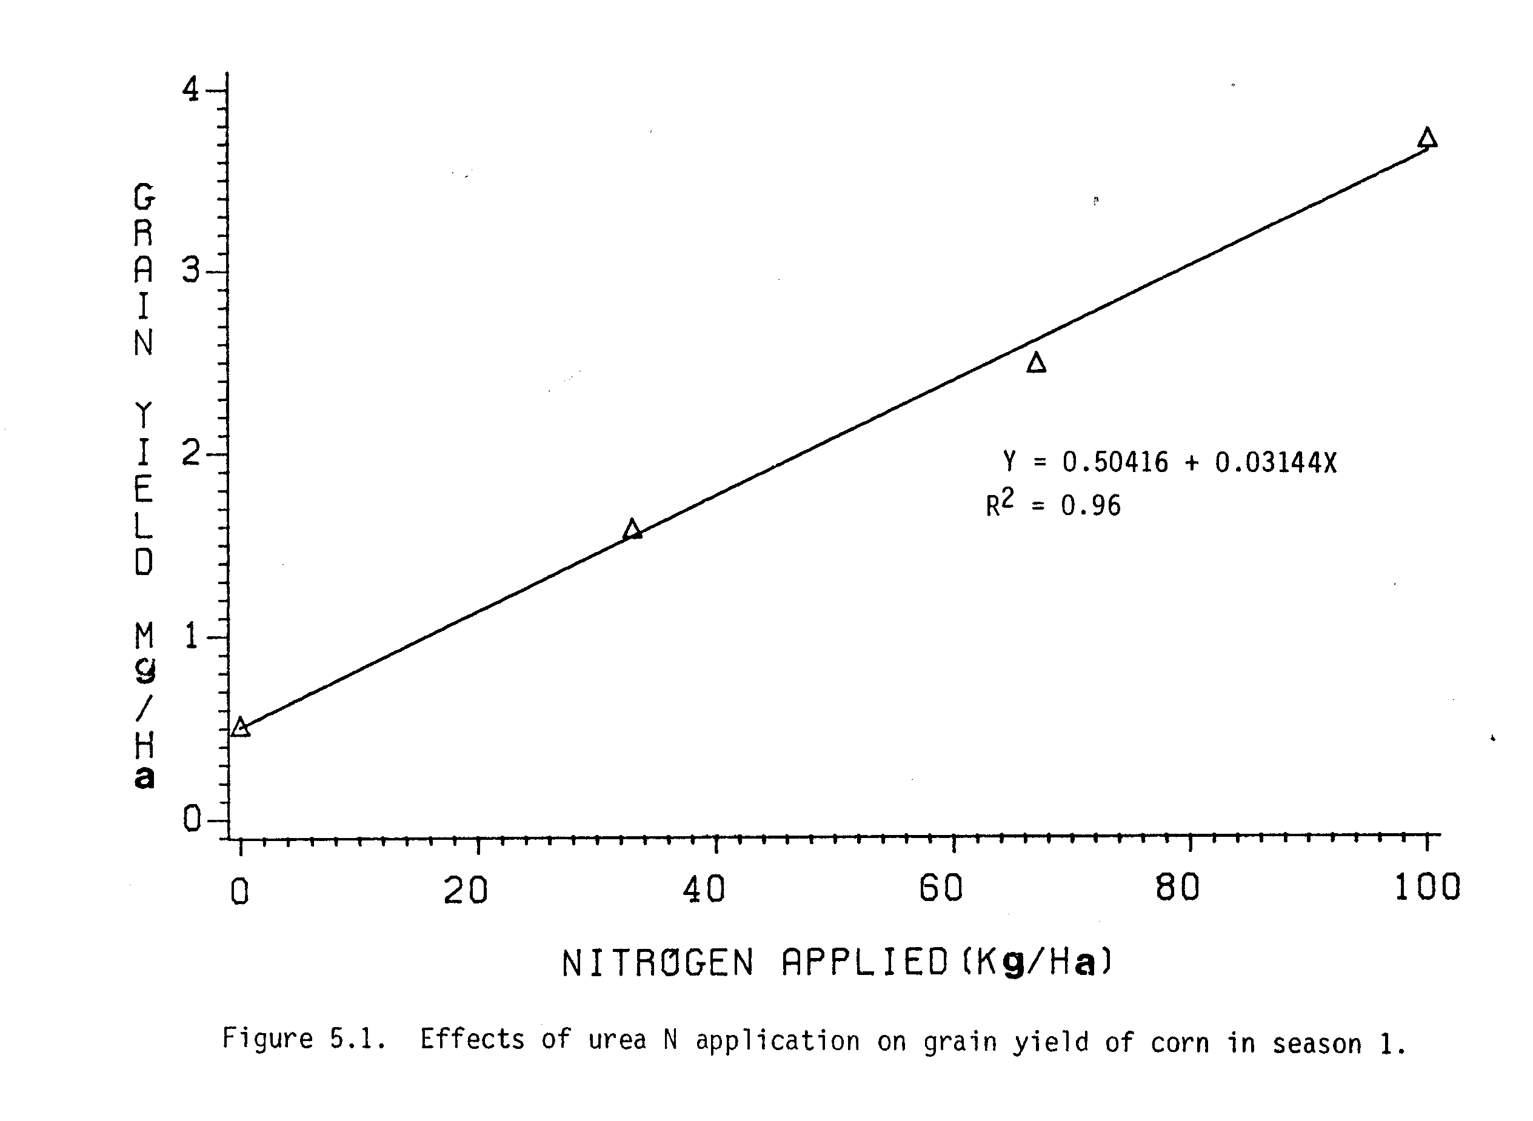

to 100 kg N ha⁻¹ (Table 5.3). Plant heights of corn from the plots, where leucaena green manures were applied in the previous season (season 1), were slightly higher than the plant height of corn in control plot but were not significant.
Corn grain yield increased from 0.34 to 1.24 Mg ha⁻¹ as urea-N rates were increased from 0 to 100 kg N ha⁻¹ (Table 5.3). Corn grain yield (0.46 Mg ha^{-l} from the plot where leucaena green manure was applied at the rate of 47 kg N ha⁻¹ in the previous season was higher than the corn yield (0.34 Mg ha⁻¹) from the control plot. Corn grain yields from the plots of previously green manured plots at the rates of 94 kg N ha⁻¹ (0.56 Mg ha⁻¹) and 141 kg N ha⁻¹ (0.63 Mg ha⁻¹) were comparable with grain yield obtained urea-N rate of 33 kg N ha⁻¹ (0.61 Mg ha⁻¹). Total dry matter of corn obtained from the previously green manured plots were in between the total dry matter obtained from the control plot and from the plot of urea-N rate of 33 kg N ha⁻¹. Harvest indices of corn obtained from previously green manured plots were comparable with the harvest index of corn at urea-N rate of 33 kg N ha⁻¹.
In season 2, the response of corn to N application was poor (Figure 5.3). The slope of the regression line showed that with addition of every kg of N the expected increase in corn grain yield was only 9 kg in season 2 (Figure 5.3), while it was 31 kg in season 1 (Figure 5.1). The poor response of corn in season 2 was due to the fact that this was the winter and lower solar radiation and lower temperature were available to corn as compared to season 1 which happened to be summer season.
Based on the Figure 5.3, the corn grain yields obtained in season 2 from the leucaena green manured plots in season 1 at the rates of 47, 94, and 141 kg N ha⁻¹ were equivalent to urea-N application rates of 13.0, 24.5, and 30.5 kg N ha⁻¹, respectively. These results indicated that the residual effects of leucaena green manures from season 1 were equivalent to 13.0 to 30.5 kg ha⁻¹ of urea-N in season 2.
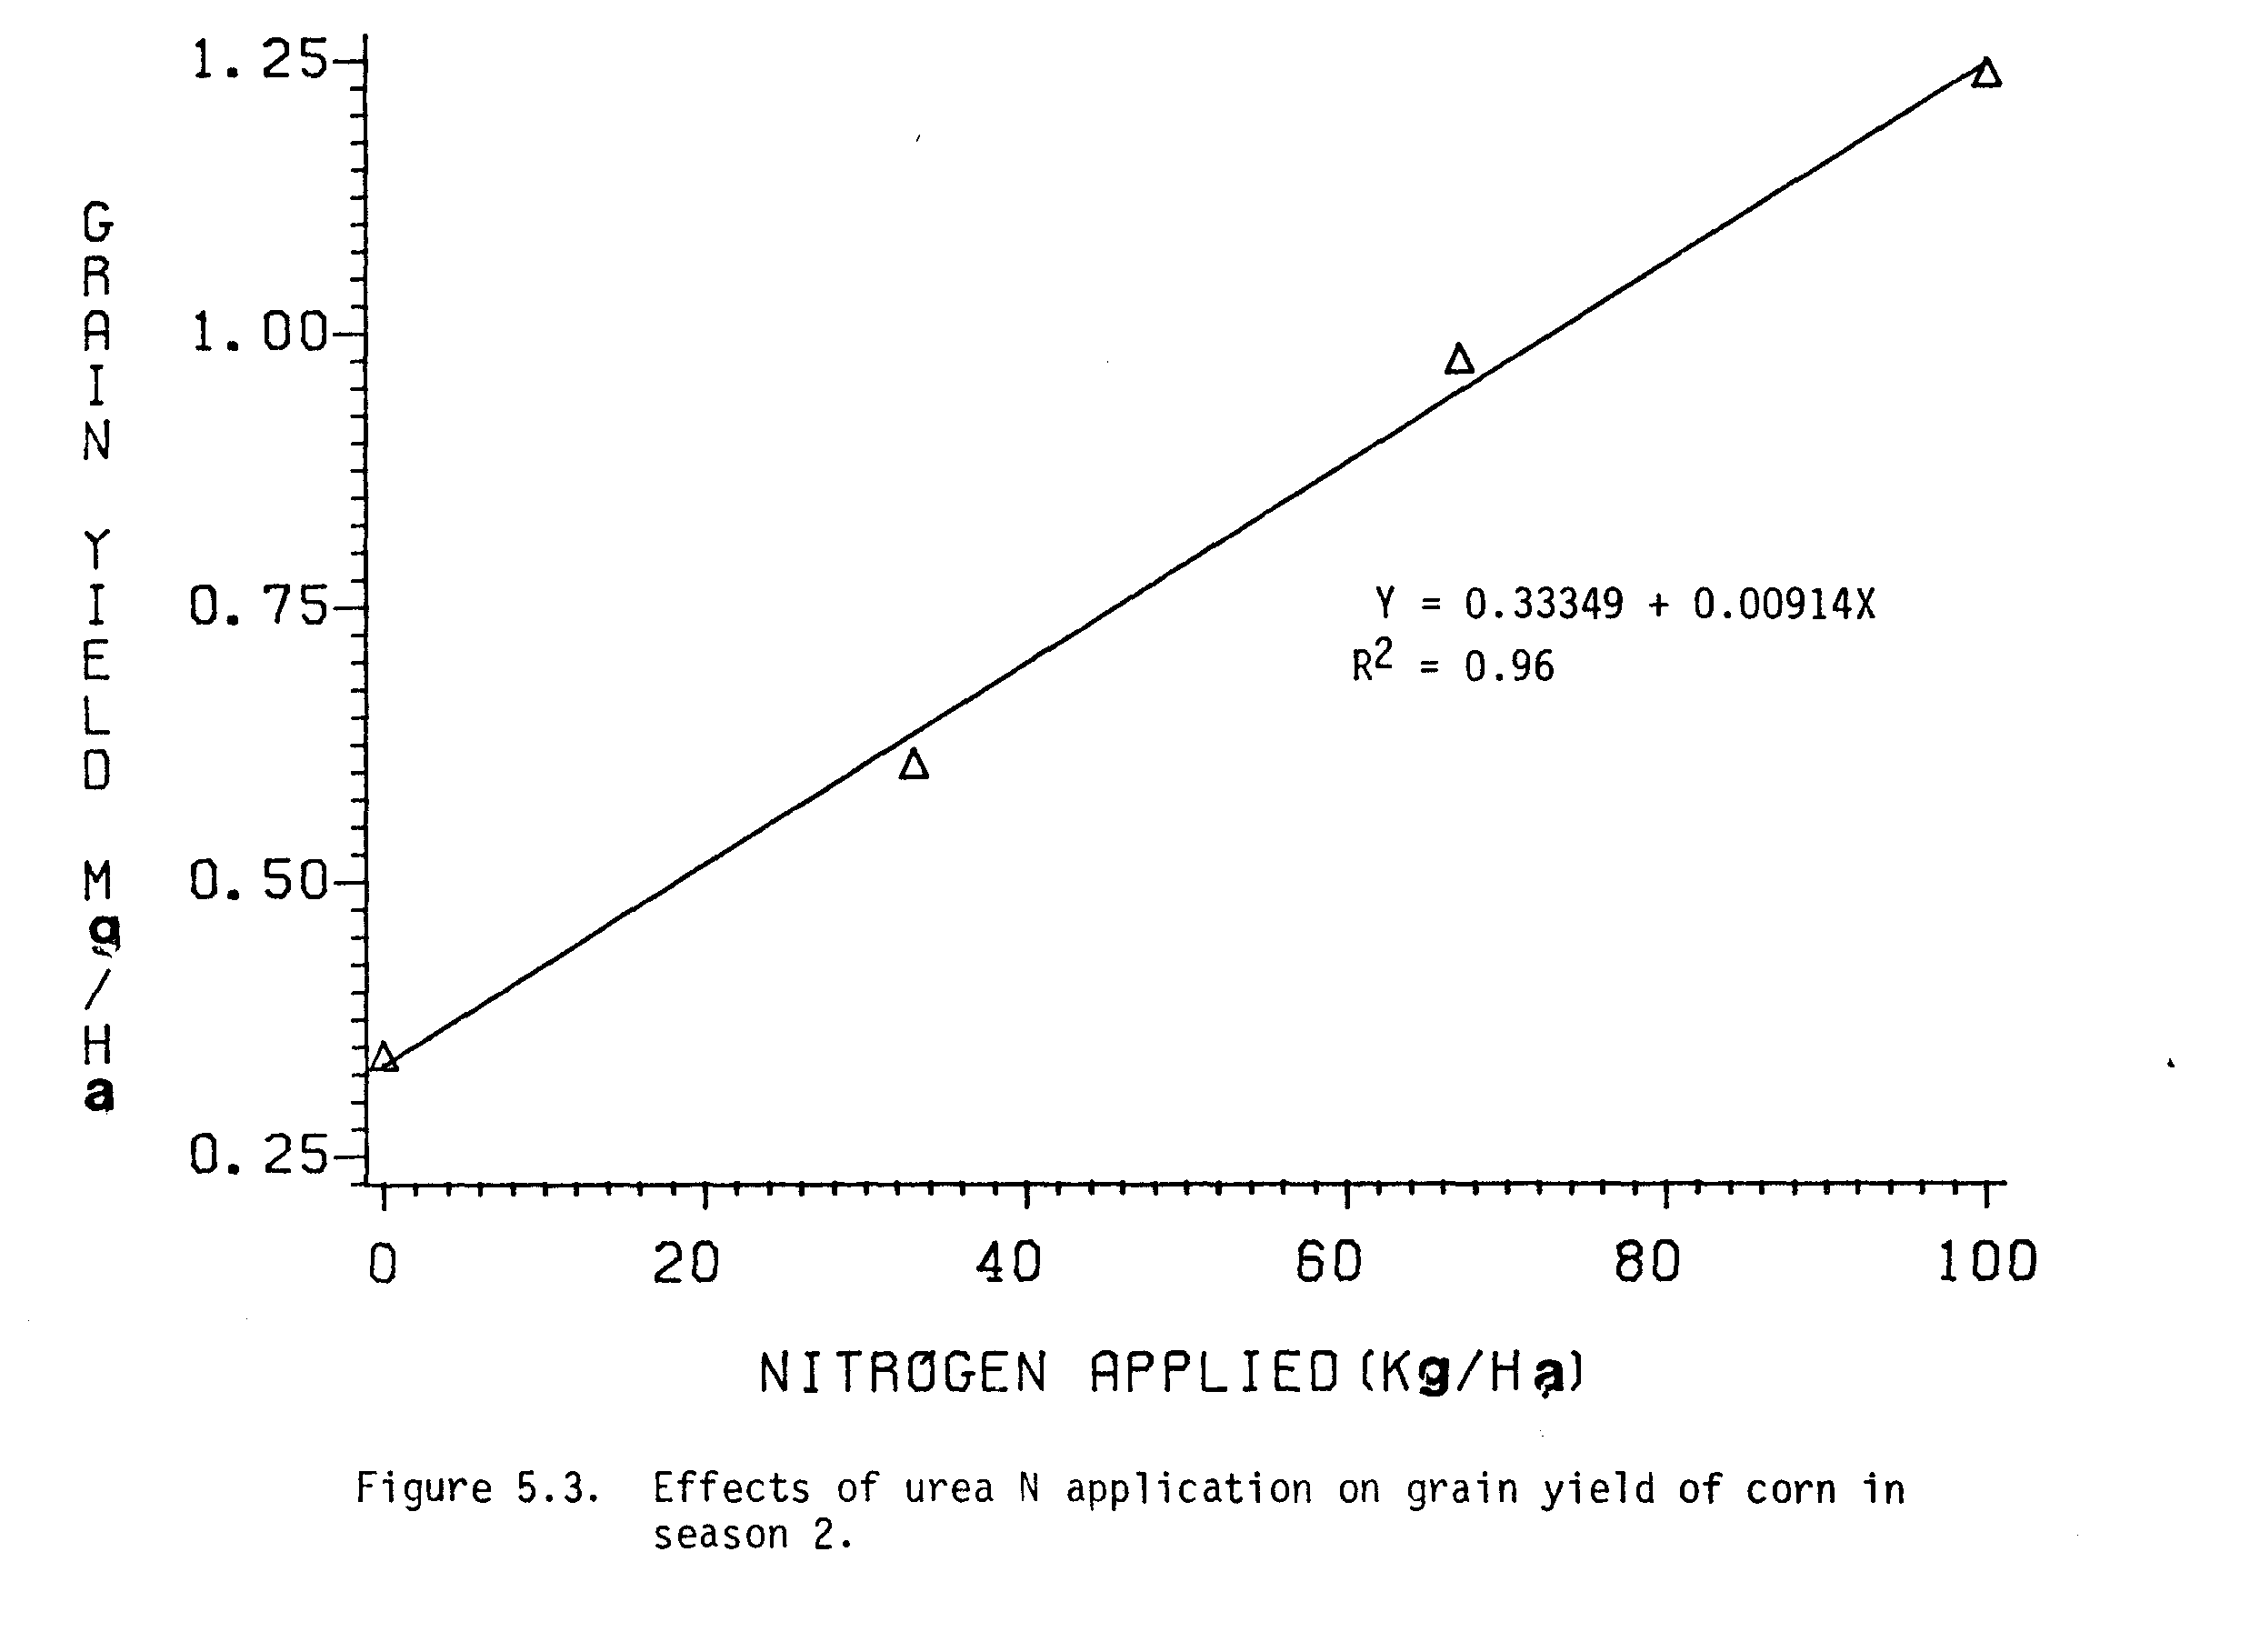
Nitrogen yields of corn increased from 16.9 to 40.9 kg ha^{-l} with increasing rates of urea-N from 0 to 100 kg N ha⁻¹ in season 2. N yields obtained in season 2 (20.2 to 23.9 kg N ha⁻¹) from the previously green manured plots were comparable with the N yield (24.1 kg ha^{-l}) obtained at the urea-N rate of 33 kg N ha^{-l}. Percent N in corn ear leaves at 50% silking from previously green manured plots were in between the % N in corn ear leaves at urea-N rates of 33 and 67 kg N ha^{-l}. In general, the % N in corn grain decreased with increasing rates of urea-N. Percent N in corn grain from previously green manured plots were in between the % N in corn grain at urea-N rates of 67 and 100 kg N ha⁻¹.
The N uptake by corn was poor with increasing rates of urea-N in season 2 (Figure 5.4). The slope of the regression line showed that with addition of every kg of N the expected increase in N uptake by corn was only 0.24 kg in season 2 (Figure 5.4), while it was 0.44 kg in season 1 (Figure 5.2). The poor uptake of N by corn in season 2 was due to poor growth of plant during the winter time as compared to better growth of plant during season 1 (summer time).
The N uptake by corn in season 2 from the leucaena green manured plots in season 1 at the rates of 47, 94, and 141 kg N ha^{-l} were equivalent to urea-N rates of 13.5, 22.0, and 30.0, respectively (Table 5.4 and Figure 5.4). These results of N uptake by corn indicated that residual effects of leucaena green manures from season 1 were equivalent to 13.5 to 30.0 kg N ha⁻¹ of urea-N in season 2. Based on the corn grain yields, the similar residual effects of leucaena green manures were found to be equivalent to urea-N rates of 13.0 to 30.5 kg ha⁻¹ (Figure 5.3).

Nitrogen Recovery
Recovery of N from urea-N applied to corn varied from 39.4 to 47% in season 1 and 22 to 24.3% in season 2 (Table 5.5). Better plant growth during

summer (season 1) compared to winter (season 2) may have been the reason for higher N recovery by corn in season 1 as compared to season 2. Also, the higher rainfall during season 2 as compared to season 1 may have caused leaching of N into soil, thus making N partly unavailable to corn plants (Appendix Table 3).
Recoveries of N from leucaena-N applied to corn were 26.3 to 30.5% in season 1 (Table 5.5). Recoveries of residual leucaena-N in season 2 were 5.0 to 7.1%. Thus, the total N recovered from the leucaena-N applied were 31.7 to 37.6% by two crops of corn. These results of recovery of leucaena-N agree with the leucaena-N recovery (31.7%) reported by Evensen (1983).

Correlations
The correlation matrix of different variables affecting grain yield and N yield of corn are presented in Table 5.6. All components of corn yield were positively and significantly correlated among themselves in both season 1 and season 2. All the components of corn yield were positively correlated with N yield and % N in corn ear leaves but were negatively correlated with % N in corn grain in both seasons. As discussed earlier, the grain yield and the N yield of corn increased with increasing rates of urea-N, while the % N in grain decreased with increasing rates of N application (Table 5.2 and Table 5.4). This negative correlation between % N in grain and yield components clearly explains the above mentioned trend.

SUMMARY AND CONCLUSIONS
A field experiment involving green manuring of leucaena to corn was conducted during two consecutive growing seasons at Waimanalo Research Station. The first planting of corn was made to evaluate the potential of leucaena forage as a green manure to corn crop and the second planting was
made to evaluate the residual effects of leucaena green manure. Treatments applied were a control plot (no N applied), three levels of urea-N application (33, 67, and 100 kg N ha⁻¹) and three levels of leucaena-N application (47, 94, and 141 kg N ha⁻¹).
Plant heights of corn increased with increasing levels of Leucaena-N application in season 1. Corn grain yields obtained from the leucaena green manuring at the rates of 47, 94, and 141 kg N ha⁻¹ were equivalent to corn grain yields obtained from urea-N rates of 18, 35, and 58 kg N ha⁻¹, respectively. The efficiency of leucaena green manures to increase corn grain yield as compared to urea-N applications were found to be 37 to 41%.
Nitrogen yields of corn from the leucaena green manure at the rates of 47, 94, and 141 kg N ha⁻¹ were equvalent to those of at urea-N application rates of 34, 54, and 90 kg N ha⁻¹, respectively. The efficiency of leucaena green manure to increase N yields of corn as compared to urea-N applications were 57 to 72% in season 1.
In season 2, where residual effects of leucaena green-leaf manure were evaluated, plant heights of corn from the previously green manured plots were not significantly different from that of the control plot. Corn grain yields in season 2 from the previously green manured plots at the rates of 47, 94, and 141 kg N ha⁻¹ were equivalent to those of urea-N application rates of 13.0, 24.5, and 30.5 kg N ha⁻¹, respectively. N yields of corn in season 2 from the previously green manured plots at the rates of 47, 94, and 141 kg N ha⁻¹ were equivalent to those of urea-N application rates of 13.5, 22.0, and 30.0 kg N ha⁻¹, respectively.
Recoveries of N from urea-N were 39.4 to 47% and from leucaena-N were 26.3 to 30.5% in season 1. Recoveries of residual leucaena-N in season 2 were 5.0 to 7.1%. The total N recovered from the applied leucaena green manure were 31.7 to 37.6% by two crops of corn.
On the basis of the results obtained in this investigation, it can be concluded that leucaena forage was 37 to 41% as efficient in increasing corn grain yield as was urea. The residual effects of leucaena green manure to the following crop of corn were equivalent to urea-N application rates of 13 to 30 kg N ha⁻¹. A total of 31.7 to 37.6% of N from the leucaena green manure was recovered by two crops of corn.
It can be concluded that leucaena can very well be used as a green manure in cropping systems involving food production. In the areas where the supply of N-fertilizers is limited (as in most developing countries), the use of leucaena as a green manure may provide an alternative source of N and thereby reduce the dependency on costly commercial N-fertilizers.
CHAPTER VI
NITROGEN UPTAKE BY WHEAT CROPS FROM ¹⁵N-LABELED
LEGUME PLANT MATERIALS

INTRODUCTION

The increasing cost of nitrogenous fertilizers has increased the importance and accelerated the use of legume crops in various cropping systems. Legumes crops may contribute N to associated non-legumes, to succeeding non-legumes, or when used as green manure crops for non-legumes. The N contribution from legume to non-legumes, however, seems more likely to succeeding non-legumes or when legume residues are recycled into the soil rather than direct transfer from legumes to companion crops of non-legumes (Whitney and Kanehiro, 1967; Misra and Misra, 1975; Simpson, 1976; Henzell and Vallis, 1977).
Not all the organic N added into the soil is mineralized or is readily available to the companion or succeeding crops. A range of 30-60% of the N in legume residues has been reported to mineralize and become available for the succeeding crops and the remainder may be lost or may be incorporated in the soil organic matter (Bartholomew, 1965; Henzell and Vallis, 1977). The recovery of N by crops as affected by plant species, soil, climate, and management practices has been reviewed by Allison (1965; 1966).
Recovery of N by crops can be estimated by difference and isotopic tracer methods. The difference method assumes that mineralization, immobilization, and other N transformations are the same for both fertilized and unfertilized soils. Obviously, this is an erroneous assumption which can result in large discrepancies between recoveries calculated by non isotopic and isotopic techniques. On the other hand, the isotopic tracer method assumes that: 1) the isotope composition of the tracer is constant; 2) living organisms can distinguish one isotope from another of the same element only with difficulty; and 3) the chemical identity of isotopes is maintained in biochemical systems. Although these assumptions are not entirely valid for all experimental conditions, they may be considered valid for most studies in which ¹⁵N compounds are used as tracers (Hauck and Bremner, 1976).
The use of ¹⁵N-tracers has made it possible to study the proportion of N derived from different sources. ¹⁵N-tracer techniques have also been used in studies dealing with evaluation of uptake of N from plant residues (Yaacob and Blair, 1980; Herridge, 1982). Yaacob and Blair (1980) using ¹⁵N-labeled soybeans and siratro residues reported that rhodesgrass recovered 14.6 to 16.8% of N from soybeans and 13.7 to 55.5% of N from siratro. Herridge (1982) reported that only 11 to 17% of the ¹⁵N-labeled medicago residues added to the soil were utilized by a succeeding wheat crop, while 72-78% remained in the soil organic pool.
In a recent study, Ladd et al. (1983) using ¹⁵N-labeled Medicago littoralis reported the N recoveries of 20.2 to 27.8% of the legume N applied by the first crop of wheat and only 4.8% by the second crop of wheat. The proportion of wheat N derived from added legume N was 52-65% for grain and 5-6% for roots.
In chapter III, among the legumes tested, the indeterminate mungbeans had the highest N contribution to the succeeding crop of corn. No report has been found to show the N recovery by non-legumes from mungbean residues with the use of ¹⁵N-tracers.
The experiment reported here was an attempt to evaluate the N recovery by two crops of wheat from ¹⁵N-labeled mungbean plant materials applied into the soil.

MATERIALS AND METHODS

Tagging of Mungbeans
An indeterminate mungbean crop (Vigna radiata) cultivar v 2013 was grown on October 29, 1982 in 3-gallon pots having a 50:50 mixture of soil and vermiculite in the greenhouse. A total of 152.10 g of ¹⁵N-labeled ammonium sulfate (60-85% enrichment) containing 23 g of ¹⁵N was applied equally in 100 pots (1.521 g of ammonium sulfate in each pot) in solution form. Pots were watered regularly and water leached from the pots was recycled into the pots.
Initially 12 mungbean plants were grown in each pot and two weeks later they were thinned to 6 plants per pot. Removed plants were returned into the pots. Mungbean plants were harvested 60 days after planting at the late flowering and early pod formation stage.
Shoot and root portions of mungbeans were separated, dried and ground. Ground samples of shoot and root were analyzed for % N by the Microkjeldhal method. (Bremner, 1965a) and for atom % ¹⁵N by the mass spectrometer.

Treatments
This greenhouse experiment was arranged in a randomized complete block design with 17 treatments in 6 replications. Treatments were control (0 N), 4 levels of urea-N (33, 67, 100, and 200 kg N ha⁻¹), 6 levels of mungbean shoot -N (33, 67, 100, 200, 300, and 400 kg N ha⁻¹), 3 levels of mungbean root-N (33, 67, and 100 kg N ha⁻¹) and 3 levels of mungbean shoot + root-N (33, 67, and 100 kg N ha⁻¹). Based on the N content of the mungbean shoot (2.5%) and mungbean root (1.5%), the amounts of plant materials applied for these treatments are presented in Table 6.1. In addition, P as triple super phosphate, and K, as muriate of potash were applied at the rates of 100 and 80 kg ha⁻¹, respectively, to all the treatments.
The soil used in this pot experiment was a very fine, kaolinitic, isohyperthermic family of Vertic Haplustoll. On the dry weight basis, 7.5 kg of soil per 3-gallon pot and 2.5 kg of soil per 1-gallon pot.
Treatments of mungbean shoot and shoot + root were applied in 3-gallon pots, but, because of the limited supply of root materials from mungbeans, root treatments were applied in 1-gallon pots. The rates of N applied (kg N ha⁻¹) were kept the same for the root treatments, but the size of pot, amount of soil pot⁻¹ and the number of plants pot⁻¹ were reduced to one third of the other treatments applied in 3-gallon pots. Assumptions were made that there was no effect of pot size as the amount of soil, nutrients, and water applied per plant were the same in all pots.

Planting of Wheat
The first crop of wheat (Triticum aestivum), cultivar Pavon 76, was planted on January 23, 1983. Initially 12 plants were planted in each of the 3-gallon pots and 4 plants in each of the 1-gallon pots. Two weeks later plants were thinned to 6 plants in each 3-gallon pot and 2 plants in each 1-gallon pot.
The second crop of wheat was planted on May 16, 1983 to evaluate the residual effect of mungbean plant materials applied for the first crop of wheat. Plants per pot and all other managements were kept the same as for the first crop of wheat.

Harvesting
The first and the second crops of wheat were harvested at the maturity stage on April 25, 1983 and August 9, 1984, respectively.
Grain and straw portions of wheat were separated, dried, and then grain, straw and total dry matter yields per pot were recorded. Data from root-N treatments were multiplied by three to make comparisons with other shoot-N and shoot + root-N treatments.
Grain and straw samples were ground and then analyzed for % N by Microkjeldahl method (Bremner, 1965a) and for atom % ¹⁵N by mass spectrometer.
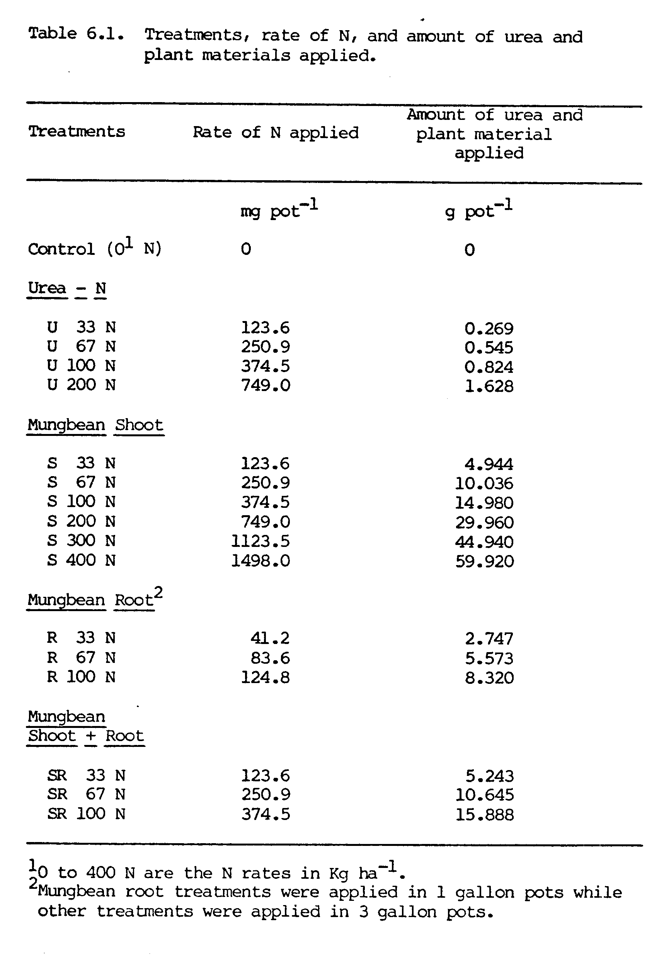
Evaluation
Using regression analysis, two methods were used to evaluate the N supply from mungbean-N to wheat: 1) by comparing wheat dry matter yields in mungbean-N vs. urea-N treatments, and 2) by comparing N uptake by
wheat plants in mungbean-N vs. urea-N treatments.
Percentage recovery of mungbean-N by wheat crops was calculated by the following methods:
1. Difference method
(N_{f} = N_{c})
% N recovery = --------------- X 100,
R
where,
N_{f} = total N in the plant from N applied pots,
N_{c} = total N in the plant from control pots, and
R = amount of N applied per pot.
2. Isotopic ¹⁵N method
N_{f} (A-B)
% N recovery = -------------- X 100,
(C-B) R
where,
N_{f} = total N in the plant from mungbean-N applied pots,
A = atom % ¹⁵N in the plant from mungbean-N applied pots,
B = atom % ¹⁵N in the plant from control pots,
C = atom % ¹⁵N in mungbeans applied,
R = rate of mungbeans-N applied, and
(A-B)
------ x 100 = % of N uptake by wheat derived from mungbean.
(C-B)
The data from the pot experiment were analyzed using analysis of variance suited to randomized complete block design. Specific treatment comparisons were made by Duncan’s Multiple Range test at the 5% significance level. Regression analysis were used wherever necessary.

RESULTS AND DISCUSSION

Yield of Wheat Crop 1
Grain, straw, and total dry matter yields of the first crop of wheat increased with increasing rates of urea-N and mungbean-N (Figure 6.1). Straw yields of wheat were higher than grain yields at all levels and from all sources of N applications. Increases in grain and straw yields of wheat were almost parallel as N rates were increased from 0 to 100 kg N ha^{-l} of urea-N, root-N and shoot + root-N, and from 0 to 200 kg N ha⁻¹ of shoot-N. When urea-N rates were increased from 100 to 200 kg N ha⁻¹ and shoot-N from 200 to 400 Kg ha⁻¹, the increases in straw yields were much higher than the increases in grain yields.
The above results suggested that at the lower levels of N application, there were almost proportional increases in grain and straw yields, however, at the higher levels of N application (in this case urea-N beyond 100 kg N ha⁻¹ and shoot-N beyond 200 kg N ha⁻¹), the increase in grain yield was at slower rate than that of straw, indicating the utilization of major proportion of photosynthates by straw.
Grain yield of wheat from the highest rate (400 kg N ha⁻¹) of shoot-N treatment (15.43 g pot⁻¹) was comparable with urea-N rate of 200 kg N ha⁻¹ (14.02 g pot⁻¹) (Figure 6.1 and Appendix Table 9). Grain yields from N rates of 100 kg N ha⁻¹ of shoot-N (8.59 g pot⁻¹), of root-N (7.65 g pot⁻¹) and of shoot + root-N (8.13 g pot⁻¹) were comparable with each other and were in between the grain yields obtained from urea-N rates of 33 and 67 kg N ha⁻¹.
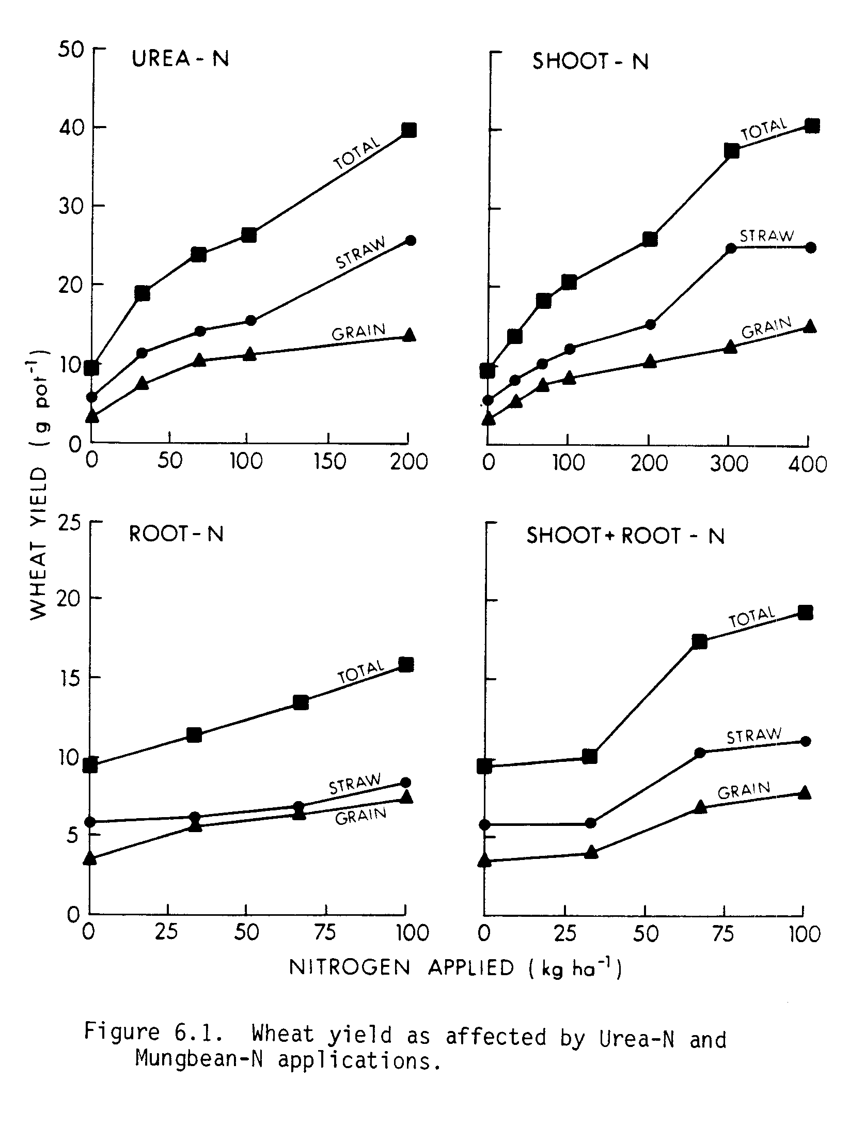
Total dry matter yields of wheat increased linearly with increasing rates of urea-N (Figure 6.2). Using this regression line, the dry matter yields from shoot-N rates of 300 and 400 Kg N ha⁻¹ were comparable with dry matter yield (39.9 g pot⁻¹) obtained from urea-N rate of 200 kg N ha⁻¹. Dry matter yields from 100 kg N ha⁻¹ rates of shoot-N, root-N, and shoot + root-N were comparable with each other (Appendix Table 9) and all these yields were comparable to yield (19.1 g pot⁻¹) obtained from 33 kg N ha⁻¹ rate of urea-N (Figure 6.2).
All these results indicated that in terms of dry matter yield of wheat, incorporation of shoot-N was little better than root-N. The performance of wheat from various sources of N applications can also be seen in Appendix Figure 6.

Nitrogen Uptake by Wheat Crop 1
Nitrogen uptake by wheat increased with increasing rates of N applications from all sources (Figure 6.3). Unlike the dry matter yields, where straw yields were higher than grain yields (Figure 6.1), the N uptake by grain was higher than that of straw at all levels and from all sources of N (Figure 6.3). This higher N uptake by grain was as a result of higher % N in grain as compared to straw (Appendix Table 10).
Total N uptake by wheat increased linearly as the urea-N rates were increased from 0 to 200 kg N ha⁻¹ (Figure 6.4). Using this regression line, the N uptake by wheat from 100 kg N ha⁻¹ rates of shoot-N, root-N, and shoot + root-N were equivalent to N uptake by wheat from 33 kg N ha⁻¹ rate of urea-N (0.178 g N pot⁻¹). As discussed earlier on the basis of dry matter yields (Figure 6.2), the results from 100 kg N ha⁻¹ rates of shoot N, root-N, and shoot + root-N were also found to be equivalent to urea-N rate of 33 kg N ha⁻¹. A highly significant correlation (r = 0.95) was found between the total dry matter and total N uptake by the first crop of wheat.
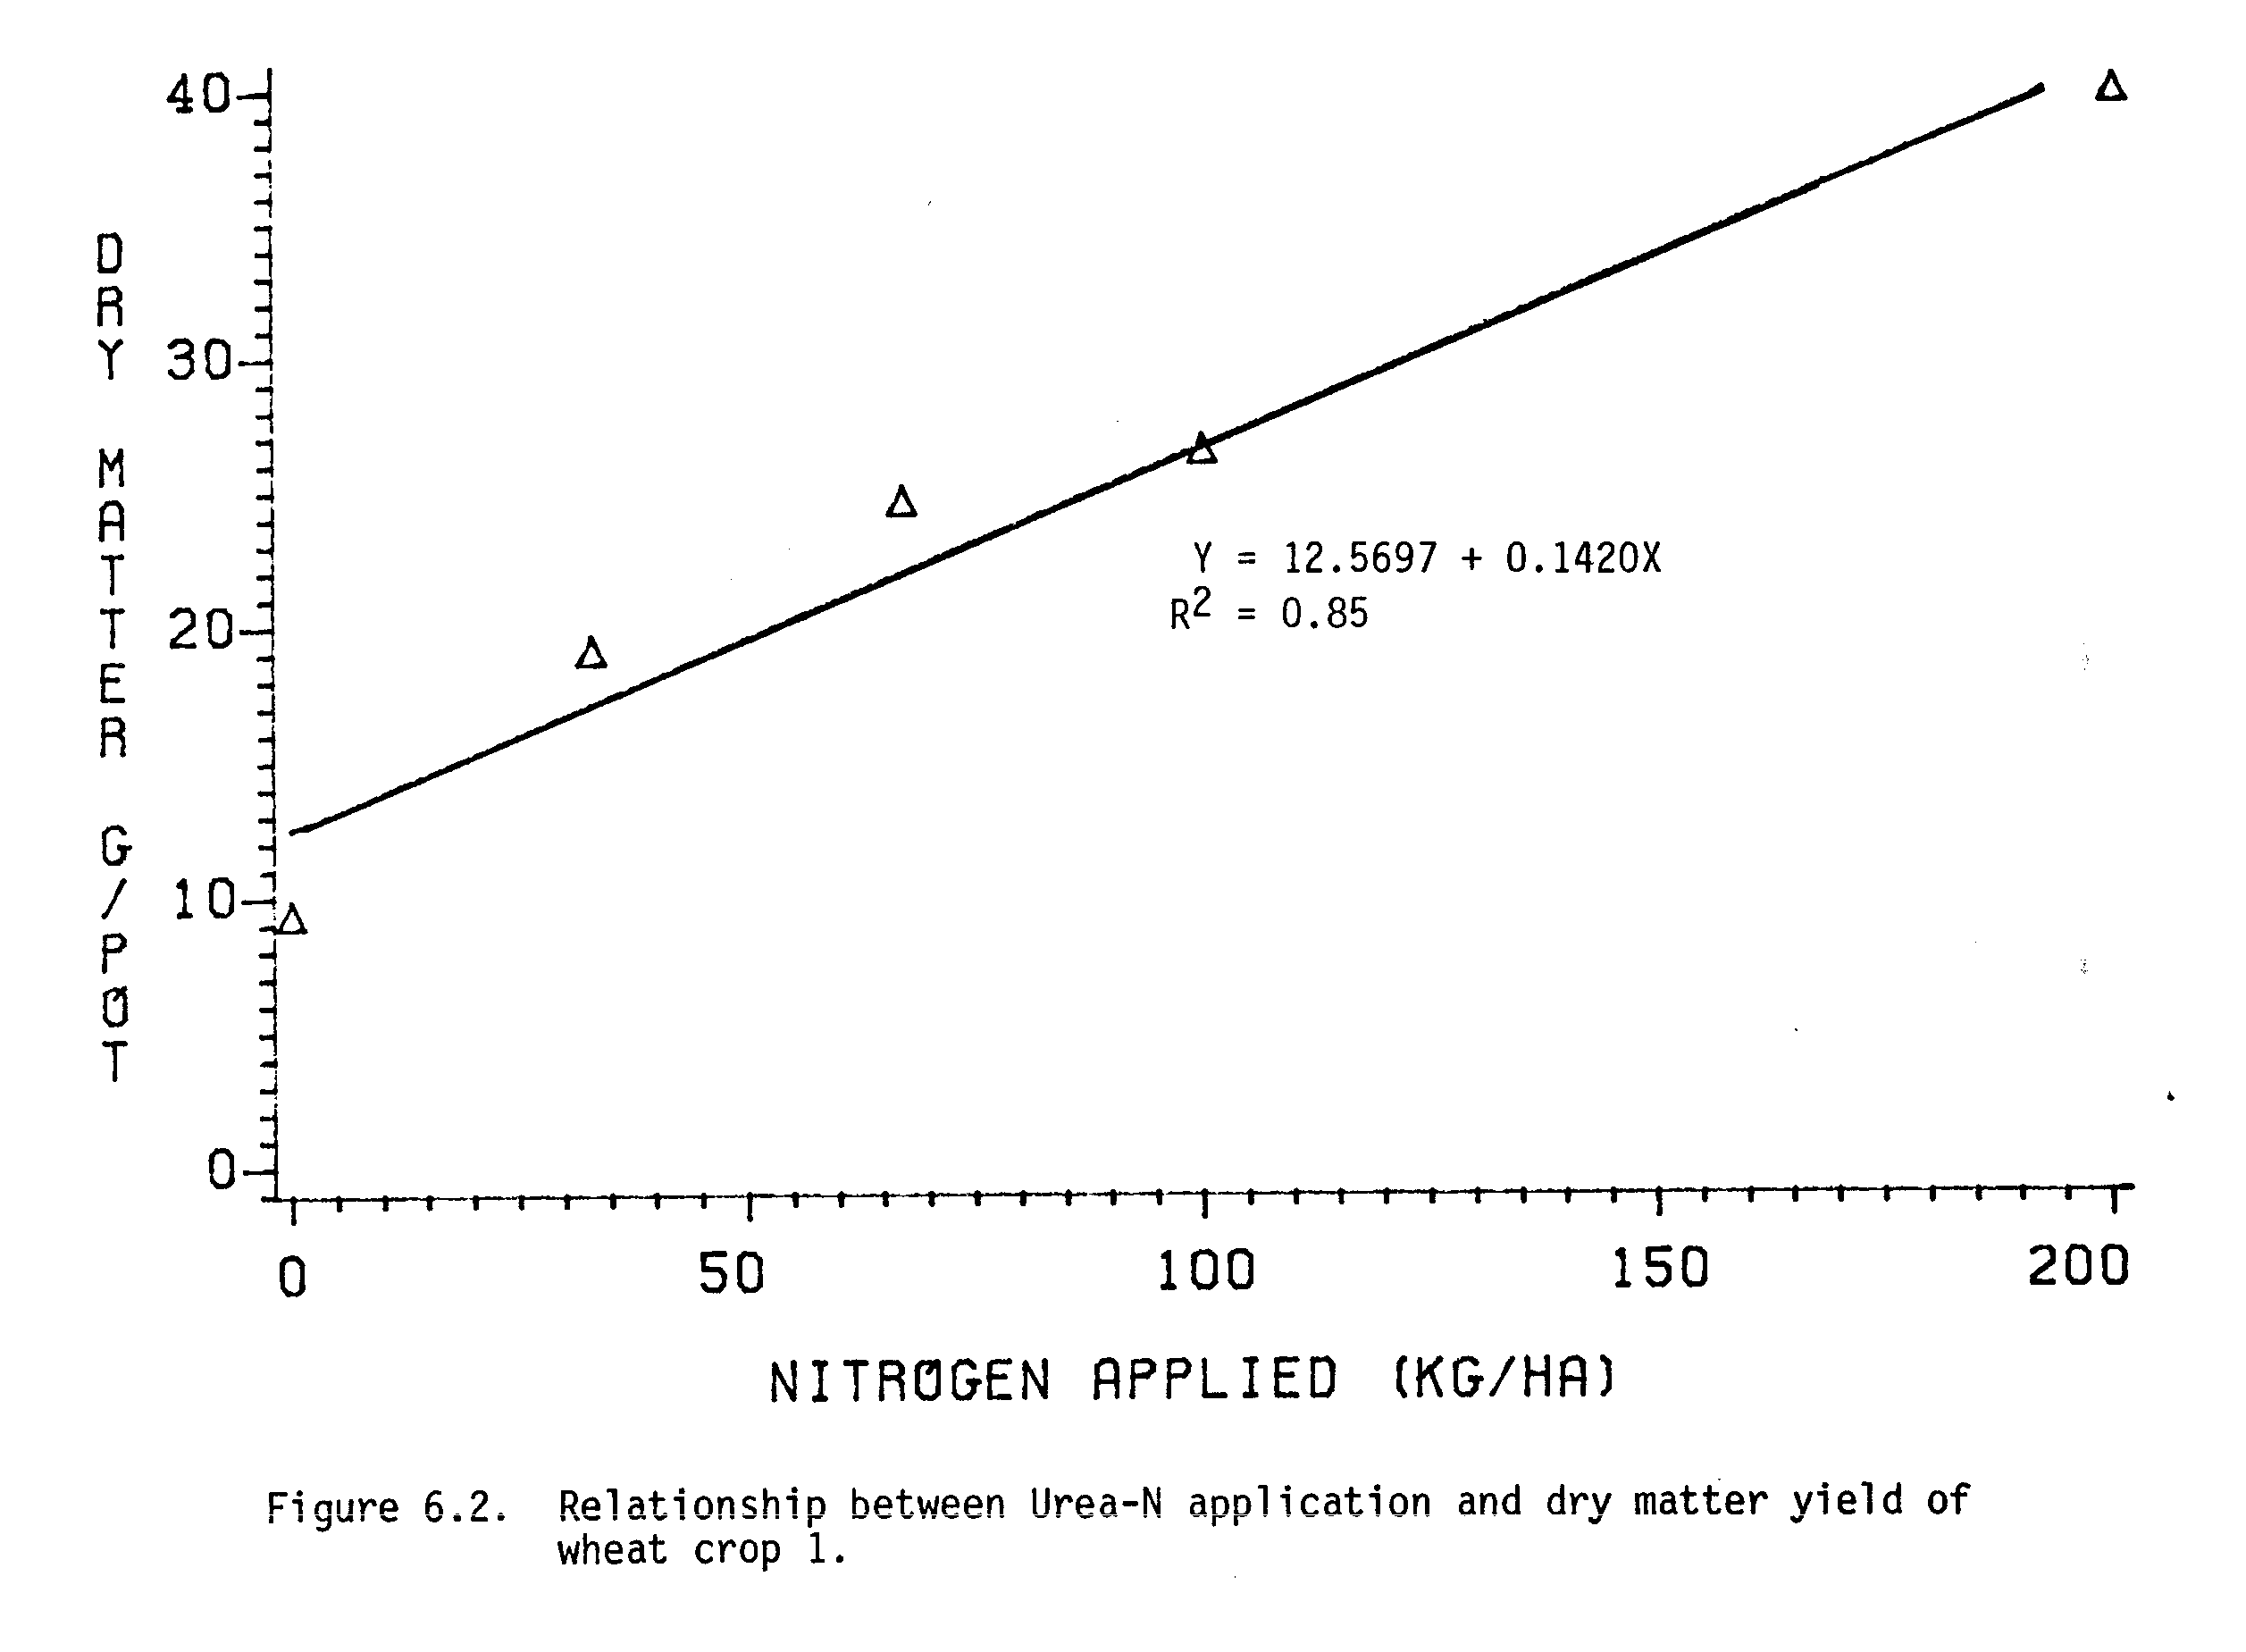
Although not significantly different, in general, the N uptake by wheat from shoot-N treatments were higher than that of root-N treatments (Appendix Table 10). At the same rate of N application (kg N ha⁻¹), the decomposition and availability of N from shoot may have been higher than from root, and therefore, wheat from shoot-N treatments may have performed better than from root-N treatments.

Yields of Wheat Crop 2
Residual effects of mungbean-N on the second crop of wheat are presented in Table 6.2. In general, grain, straw, and total dry matter yields of wheat crop 2 were much lower than those of wheat crop 1. As observed in the first crop of wheat, the grain yields of the second crop of wheat were also lower than the straw yields at all levels and from all sources of N. Except the dry matter yields from shoot-N rates of 300 and 400 kg N ha⁻¹, the dry matter yields obtained from all other mungbean-N treatments were not different among themselves. Only the yields obtained from 100 to 400 kg N ha⁻¹ rates of shoot-N and 100 kg N ha⁻¹ rates of root-N and shoot + root-N were higher than that of control plot.
Dry matter yield of wheat crop 2 increased linearly as the urea-N rates were increased from 0 to 200 kg N ha⁻¹ (Figure 6.5). Using this regression line, the residual effects from 300-400 kg N ha⁻¹ of shoot-N treatments were equivalent to urea-N rates of 67 kg N ha⁻¹ and the residual effects from all other mungbean-N treatments were lower than urea-N rate of 33 kg N ha⁻¹.

Nitrogen Uptake by Wheat Crop 2
The N uptake and % N in grain of the second crop of wheat were higher than in straw at all levels and from all sources of N (Table 6.3). Total N uptake by the second crop of wheat was also much lower than the N uptake by the first crop of wheat. N uptake by the second crop of wheat were similar
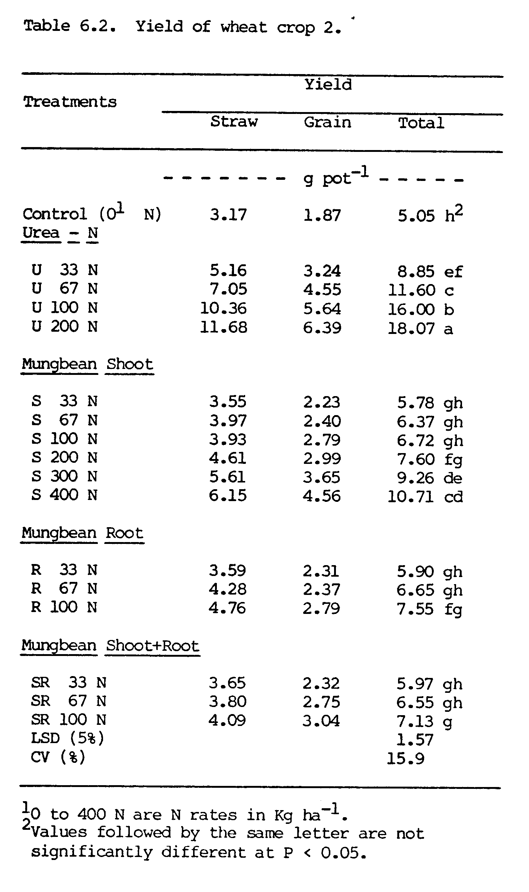
from 100 kg N ha⁻¹ rates of all there sources of mungbean-N treatments. Except the N uptake by wheat from shoot-N rates of 100 to 400 kg N ha⁻¹ and 100 kg N ha⁻¹ rates of root-N and shoot + root-N, the N uptake from all other residual mungbean-N treatments were not different among themselves and were not higher than that of control plot. This suggests that the residual effects of N were observed only at and above 100 kg N ha⁻¹ rate of mungbean-N application.
N uptake by the second crop of wheat increased linearly as the urea-N rates were increased from 0 to 200 kg N ha⁻¹ (Figure 6.6). Using this regression line, the residual effect from 400 kg N ha⁻¹ rate of shoot-N was equivalent to urea-N rate of 67 kg N ha⁻¹. Except the 300 and 400 kg N ha^{-l} rates of shoot-N, the residual effects from all other mungbean-N treatments were lower than urea-N rate of 33 kg N ha⁻¹.
These results of residual effects based on N uptake (Figure 6.6) agree with the results based on dry matter yield (Figure 6.5). Also a highly significant correlation (r = 0.96) was found between the total dry matter and total N uptake by the second crop of wheat.

Nitrogen Recovery by Wheat
Atom % ¹⁵N in grain and straw of wheat increased with increasing rates of shoot, root, and shoot + root-N (Appendix Table 11). As expected, atom % ¹⁵N in plant tissues of the first crop of wheat was higher than that of in the second crop of wheat. Atom % ¹⁵N in shoot, root, and shoot + root of mungbean applied were 19.9129, 17.1152, and 18.5140%, respectively.
Based on the atom % ¹⁵N in plant tissues of wheat, the calculated values of wheat N derived from decomposing mungbean plant materials by crop 1 and crop 2 are presented in Figure 6.7. Wheat N derived from decomposing mungbean-N by crop 1 increased with increasing rates of mungbean-N, reaching 70.4% at 400 kg N ha⁻¹ rate of shoot-N, 22.1.% at 100 kg N ha⁻¹ rate of root-N,
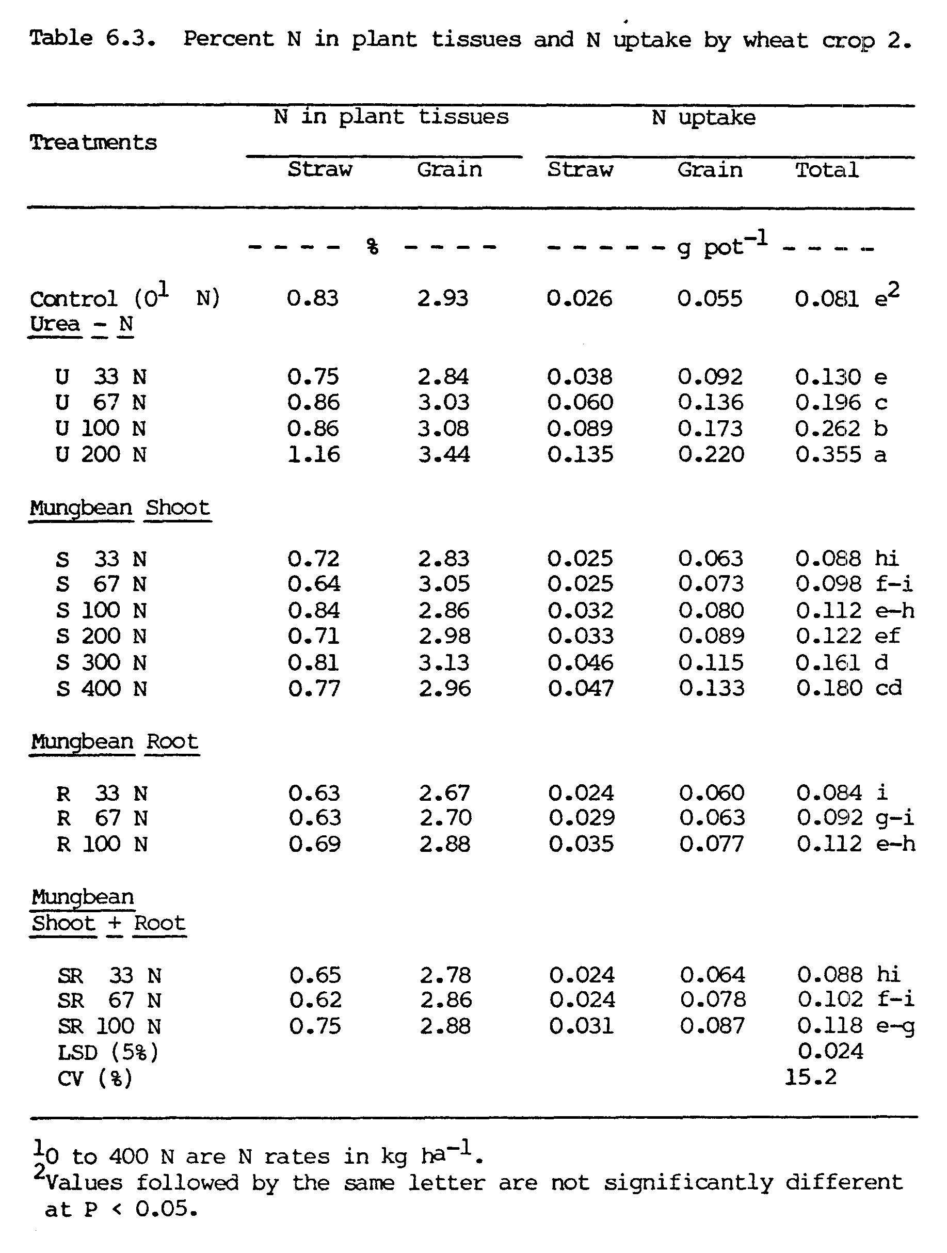
and 38.0% at 100 kg N ha⁻¹ rate of shoot + root-N. Except the shoot-N treatments beyond the rate of 200 kg N ha⁻¹, the increase in wheat N derived from mungbean applied was proportionate to the increasing rates of mungbean-N. This suggest that wheat crop could use the mungbean-N applied proportionately at lower rates below 200 kg N ha⁻¹, however, at the higher rate beyond the 200 kg N ha⁻¹ of mungbean-N, the first crop of wheat was not able to use N proportionately as the supply of N was far beyond the need of wheat crop.
At a given rate of mungbean-N applied, the N derived by the first crop of wheat was always higher from shoot-N than from root-N treatments (Figure 6.7). As discussed earlier, at the same given rate of mungbean-N, the N uptake by the first crop of wheat from shoot-N treatments were also higher than that of from root-N (Appendix Table 10). The decomposition of shoot may have been faster than roots, and therefore, may have been readily available to the first crop of wheat.
In general, the N derived from decomposing mungbean residues by the second crop of wheat was lower than the first crop of wheat (Figure 6.7). Wheat N derived from residual mungbean-N was highest (43.5%) from the highest shoot-N rate of 400 kg N ha⁻¹. At a given rate of 100 kg N ha⁻¹, the residual N derived by the second crop of wheat were similar for shoot-N (13.7%), root-N (13.7%) and shoot + root-N (14.9%). These results suggested that the residual N available to the second crop of wheat was lower from lower rates of all sources of N, however, the residual N was still high at the high rates of N (200-400 kg N ha⁻¹).
N recoveries by the first and the second crops of wheat estimated by isotopic method and difference method are presented in Table 6.4. By isotopic method, the N recoveries by the first crop of wheat were in the range of 15.1-33.9, 11.1-12.0, and 13.8-18.9% from shoot-N (33 to 400 kg N ha⁻¹), root-N (33 to 100 kg N ha⁻¹) and shoot + root-N (33 to 100 kg N ha⁻¹),

Figure 6.7. Nitrogen derived by two crops of wheat from mungbean
plant materials and soils.
respectively. These results indicated that the N recovery by the first crop of wheat increased as the shoot-N and shoot + root-N rates were increased; however, there was not much change in N recovery as root-N was increased from 33 to 100 kg N ha⁻¹, and also the N recovery from root-N was the lowest.
As estimated by the isotopic method, the N recoveries by the second crop of wheat from residual N of shoot (3.9-5.2%), root (2.9-4.1%) and shoot + root (4.3-4.7%) were much lower than the N recoveries by the first crop of wheat (Table 6.4). The N recoveries by the second crop of wheat were not much different from the all levels and all sources of residual mungbean-N.
Based on the isotopic method, total N recoveries by two crops of wheat were in the ranges of 19.0-39.2, 14.8-15.3, and 18.4-23.6% from shoot-N, root-N, and shoot + root-N treatments, respectively (Table 6.4). At a given N rate, the total N recovery from shoot-N was higher than from root-N.
As estimated by difference method, the N recoveries by the first crop of wheat from shoot-N (25.5-44.8%), root-N (24.4-26.0%), and shoot + root-N (24.2-32.7%) were higher than those estimated by the isotopic method (Table 6.4). N recoveries by the second crop of wheat (2.4-9.9%) were also lower than the first crop as estimated by the difference method, however, these values again were higher than the values obtained by the isotopic method (2.9-5.2%). Total N recoveries by the two crops of wheat as estimated by the difference method from shoot-N (31.1-51.6%), root-N (26.8-33.6%), and shoot + root-N (32.8-41.0%) were also higher than the values estimated by the isotopic method. In all the cases, the N recoveries estimated by the difference method were higher than those by the isotopic method. These results agree with the other works (Legg and Allison, 1959; Westerman and Kurtz, 1974), where also the difference method overestimated the N recovery as compared to isotopic method.

SUMMARY AND CONCLUSIONS
A greenhouse experiment was conducted where ¹⁵N-tagged mungbean plant materials as shoot, root and shoot + root were applied to a wheat crop at the N rates of 0 to 400, 0 to 100, and 0 to 100 kg N ha⁻¹, respectively. In addition, pots with 5 levels of urea-N (0, 33, 67, 100 and 200 kg N ha⁻¹) were also grown with wheat crop. A second crop of wheat was grown to estimate the residual effects of mungbean-N applied.
Total dry matter yields and total N uptake by the first crop of wheat increased with increasing rates of mungbean-N. Total dry matter yields and total N uptake by wheat crop 1 obtained from 100 kg N ha⁻¹ rates of shoot-N, root-N, and shoot + root-N were comparable with those of from urea-N rate of 33 kg N ha⁻¹.
Total dry matter yields and total N uptake by the second crop of wheat were much lower than those of the first crop of wheat. Except the higher rates of mungbean-N applied (at and above 100 kg N ha⁻¹), the residual effects from all other mungbean-N treatments were not different from the control plot. The residual effects from 100 kg N ha⁻¹ rates of all sources of mungbean-N were equivalent to lower than urea-N rate of 33 kg N ha⁻¹.
In both the wheat crops, straw overyielded the grain at all levels and from all sources of N applied. In contrast, N uptake by grain was higher than by straw in both wheat crops.
Wheat N derived from mungbean-N increased with increasing rates of mungbean-N applied and were higher (10.9-70.4%) by the first crop of wheat and lower (5.4-43.5%) by the second crop of wheat.
Most of the mungbean-N applied was recovered by the first crop of wheat (11.1-33.9%) and only less than 6% of the N was recovered by the second crop of wheat.
These results also indicated that recovery of N was higher from shoots than from roots. Out of the two methods used to estimate N recovery, the difference method overestimated the N recovery over the isotopic method.
On the basis of the above results, it can be concluded that mungbean plant residues can very well be used as N source to reduce N input for non-legume. The results indicate that mungbean shoot may be slightly better than root in terms of immediate N supply to non-legumes; however, in a practical situation, where mungbeans are harvested for grain and only root portions are left in the soil, the mungbean root can still reduce the substantial amount of N input for non-legumes.
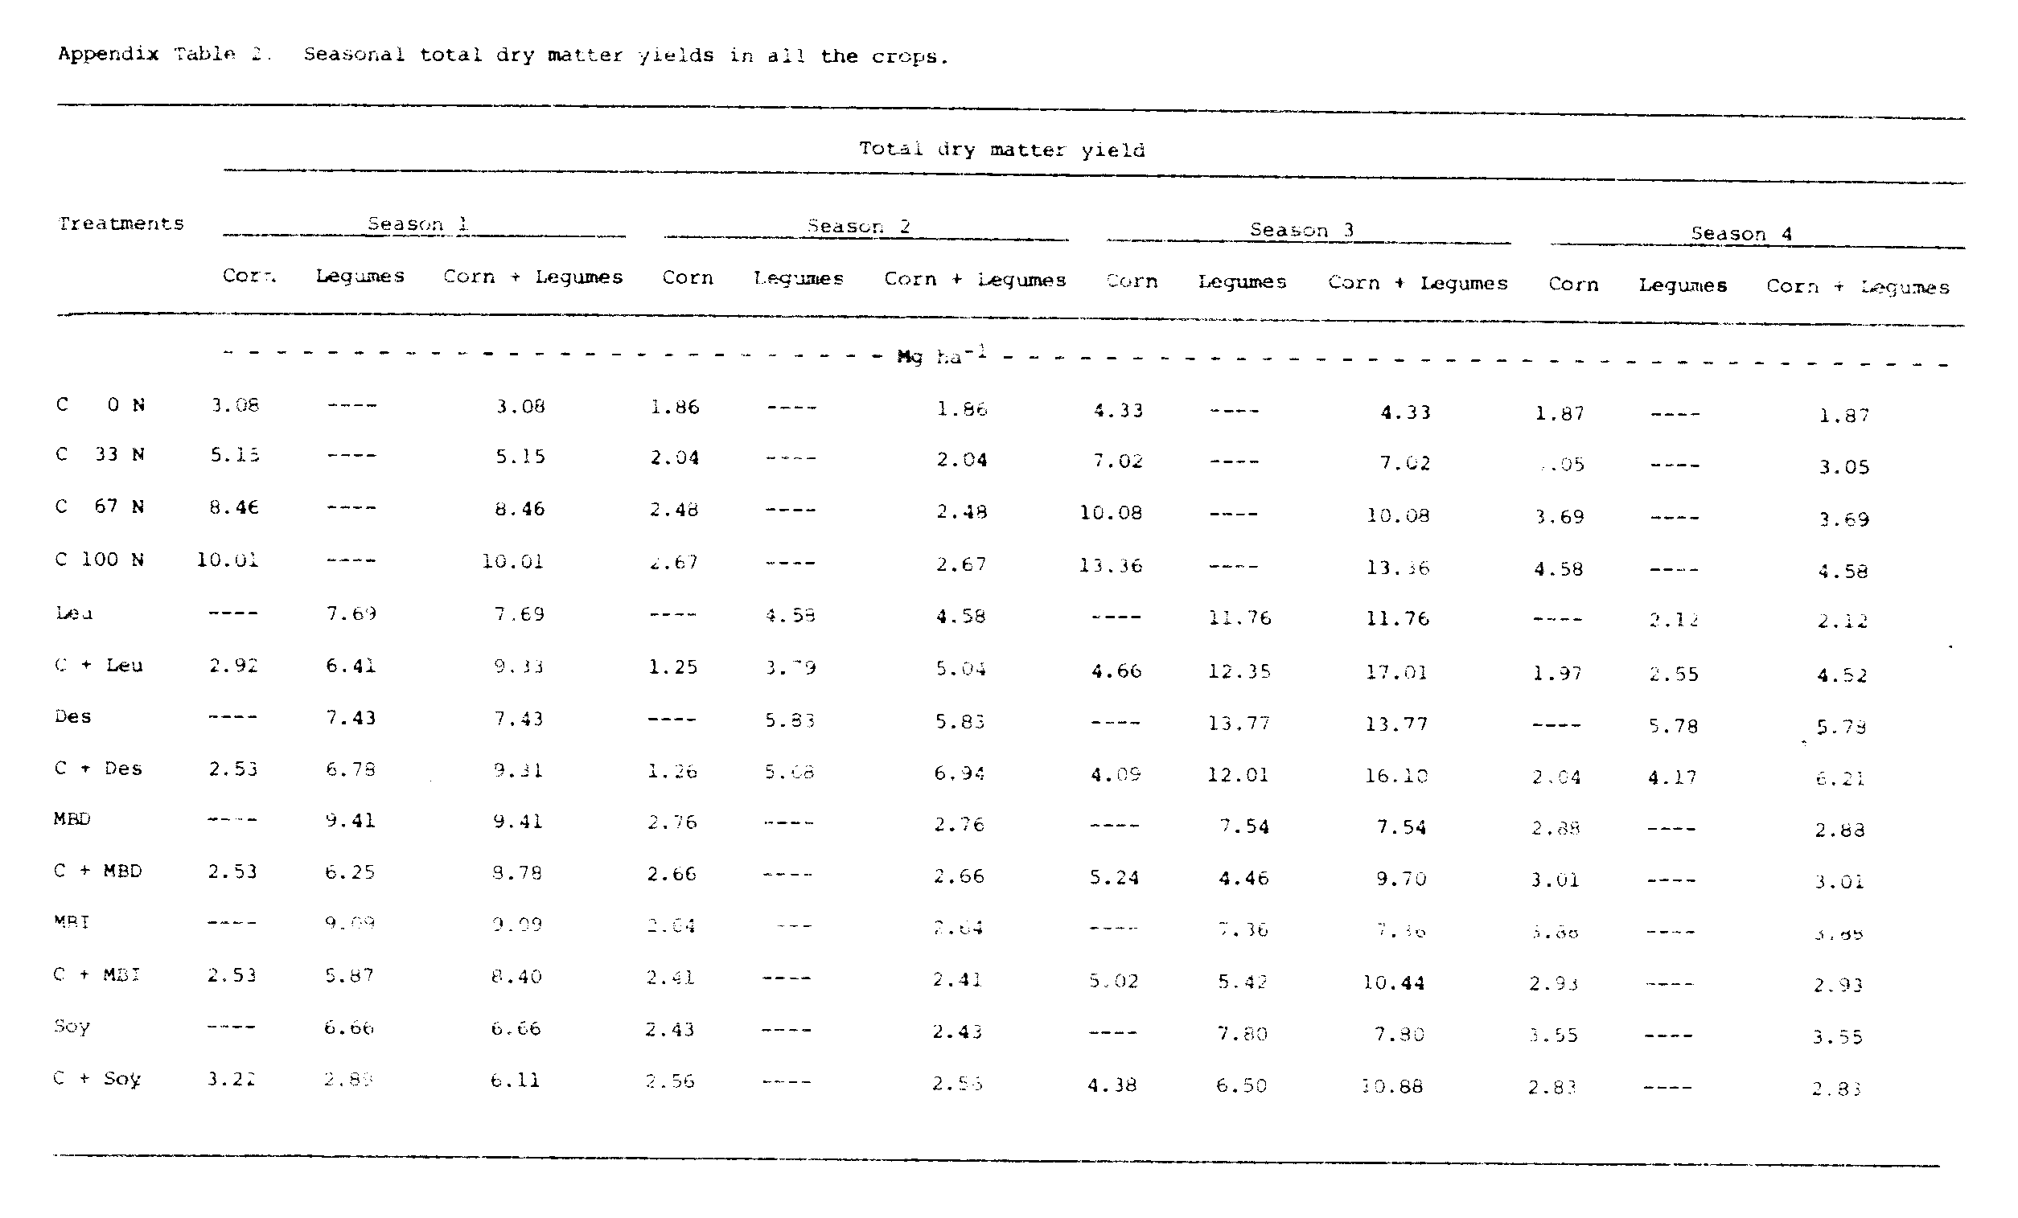
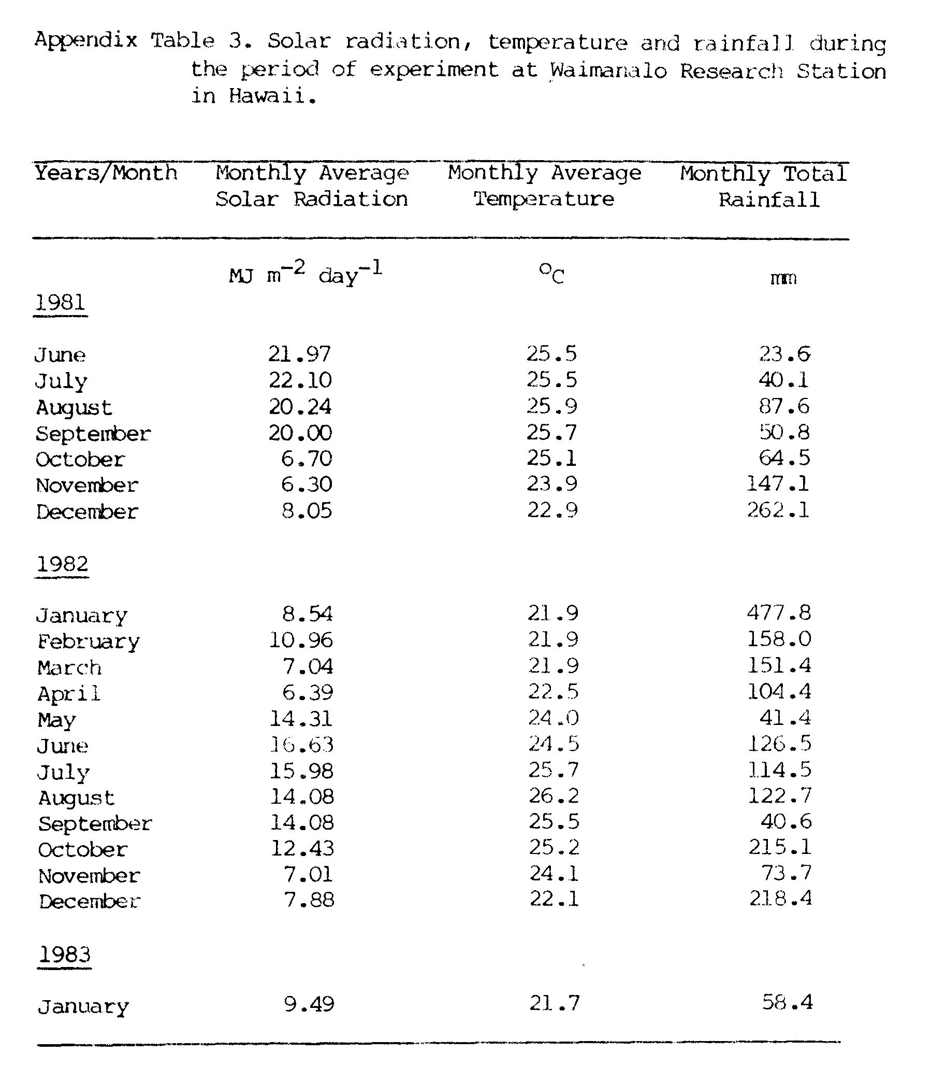
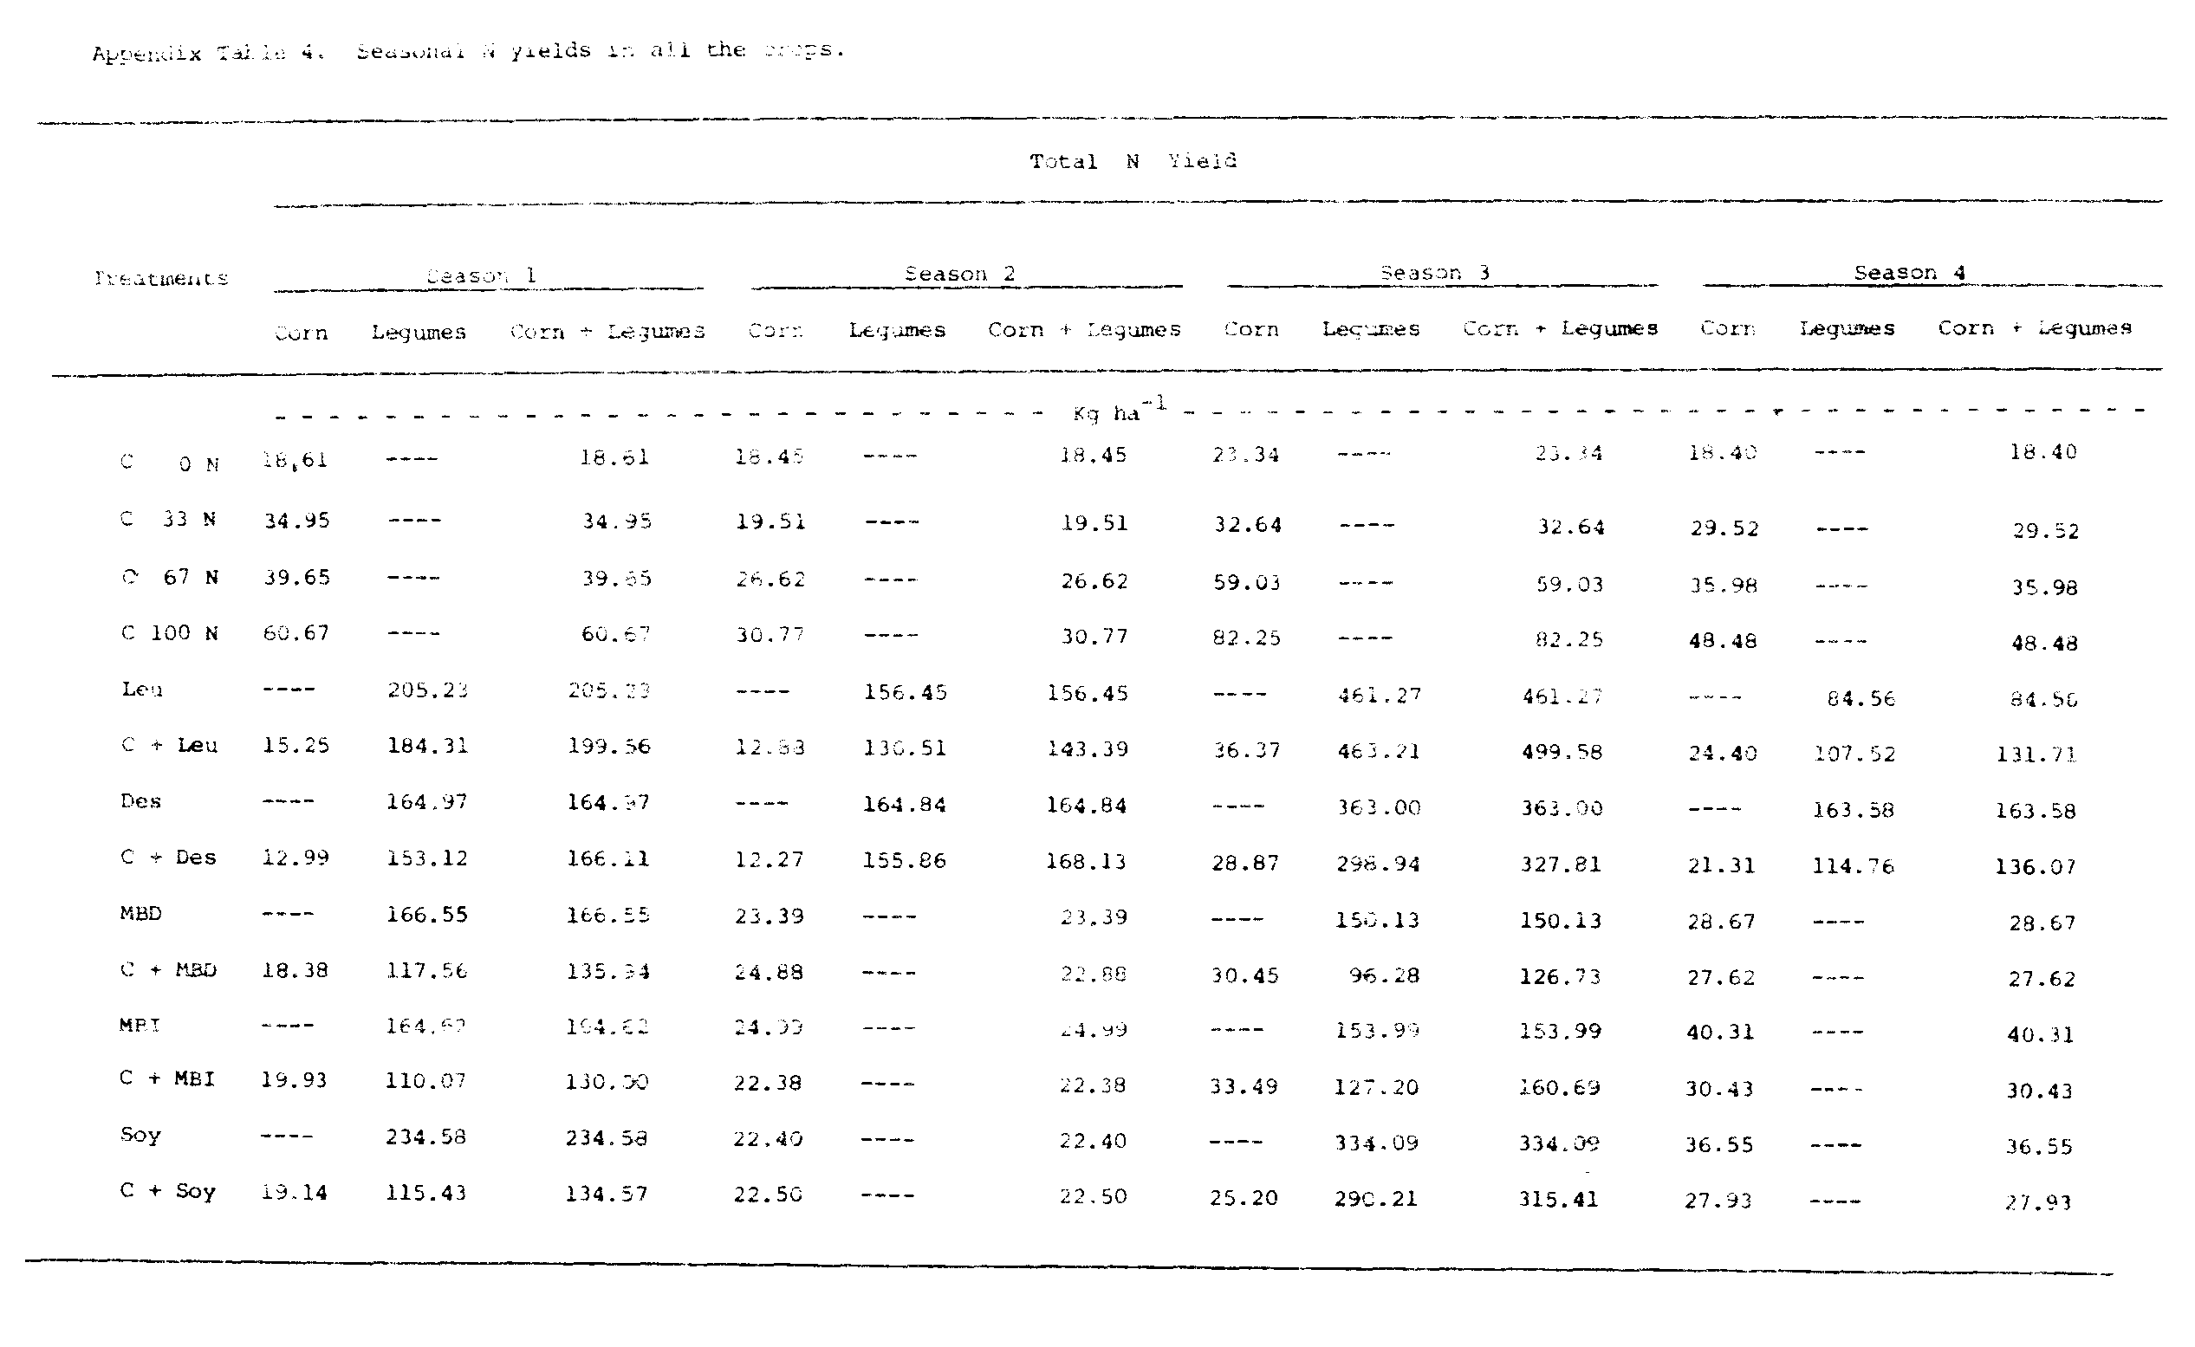
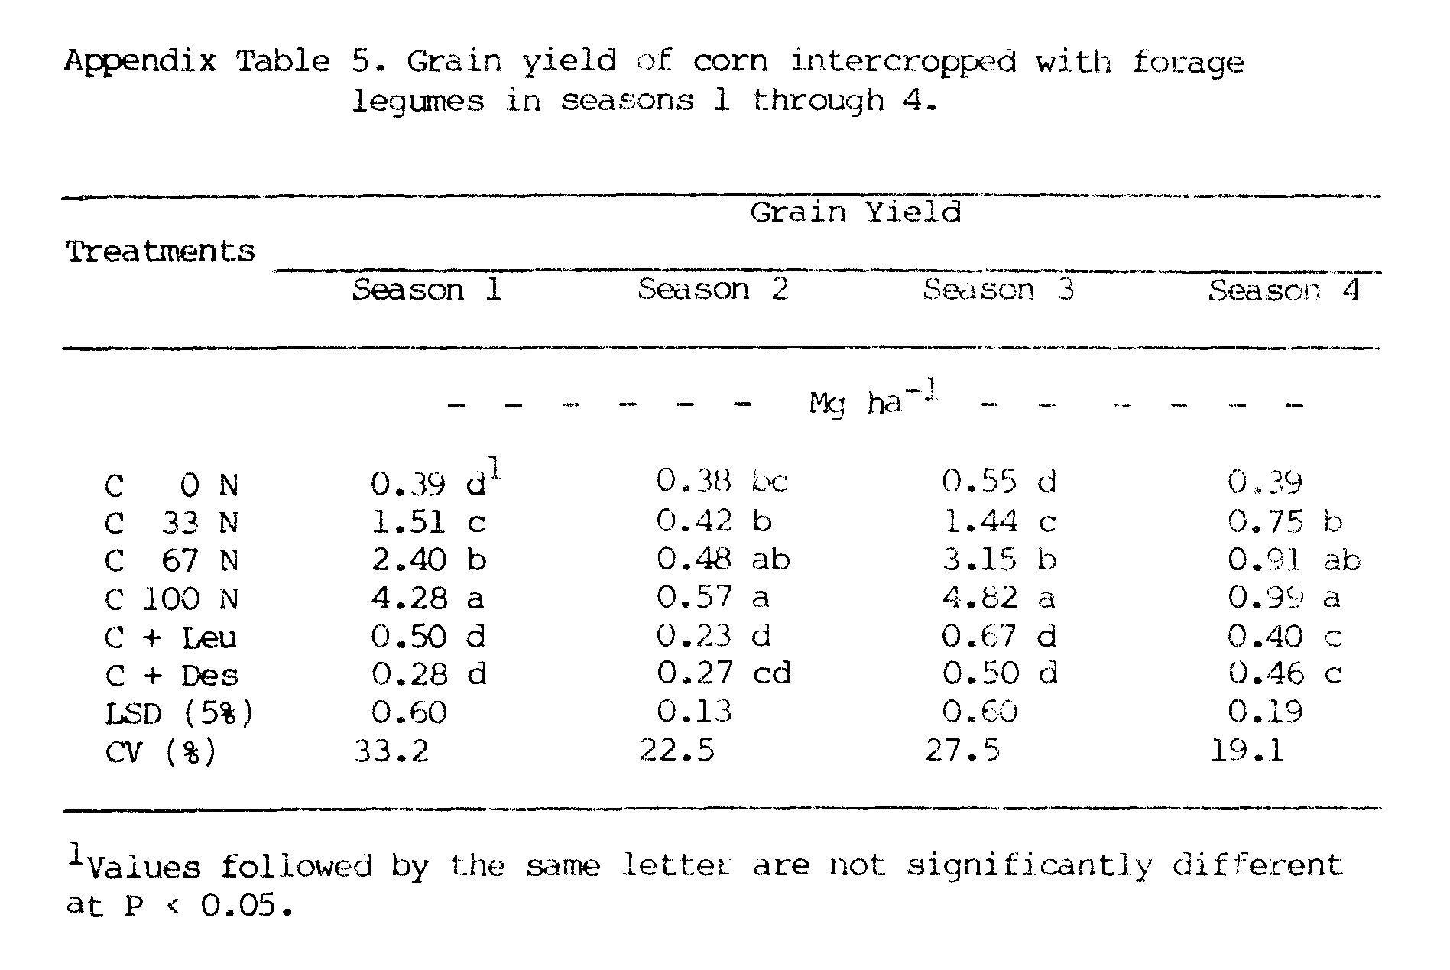
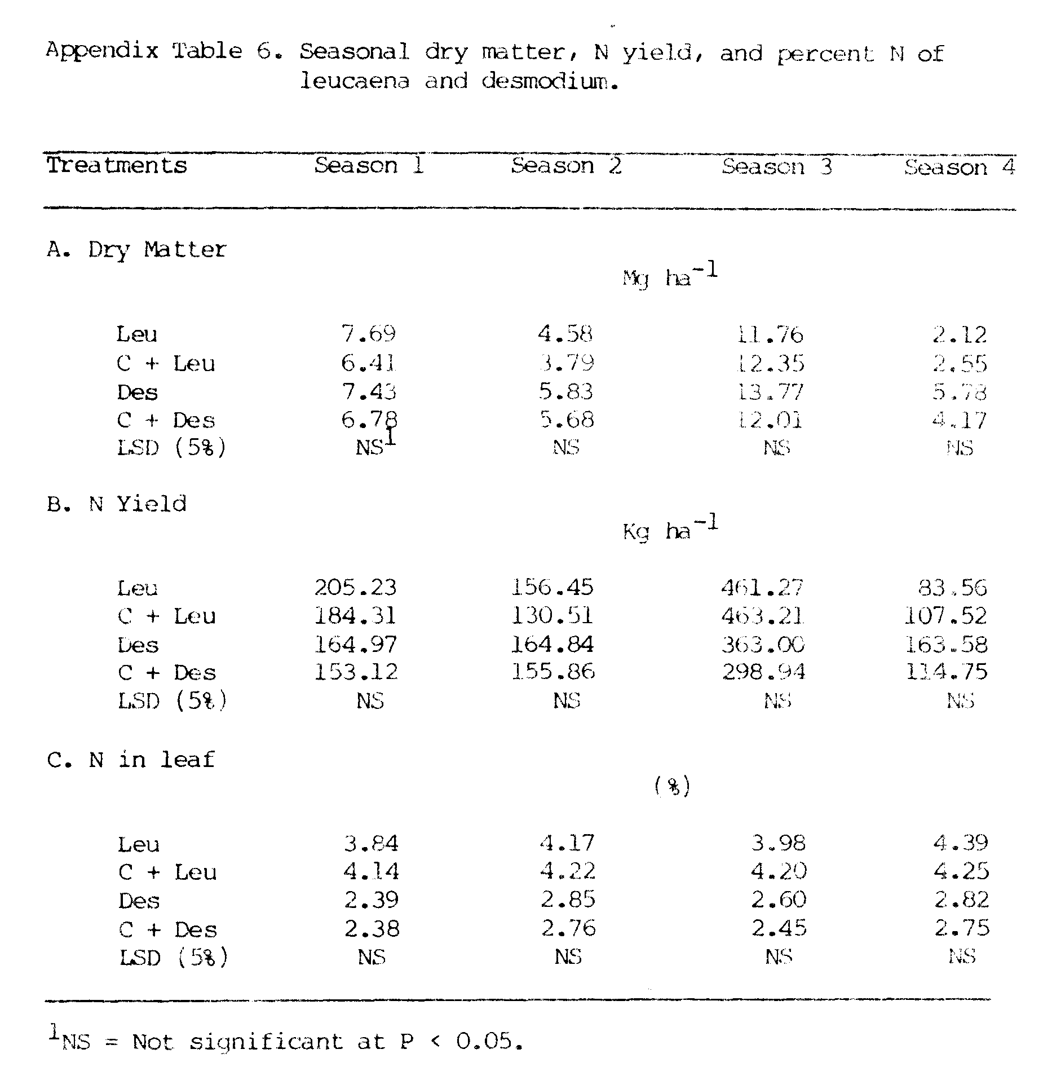
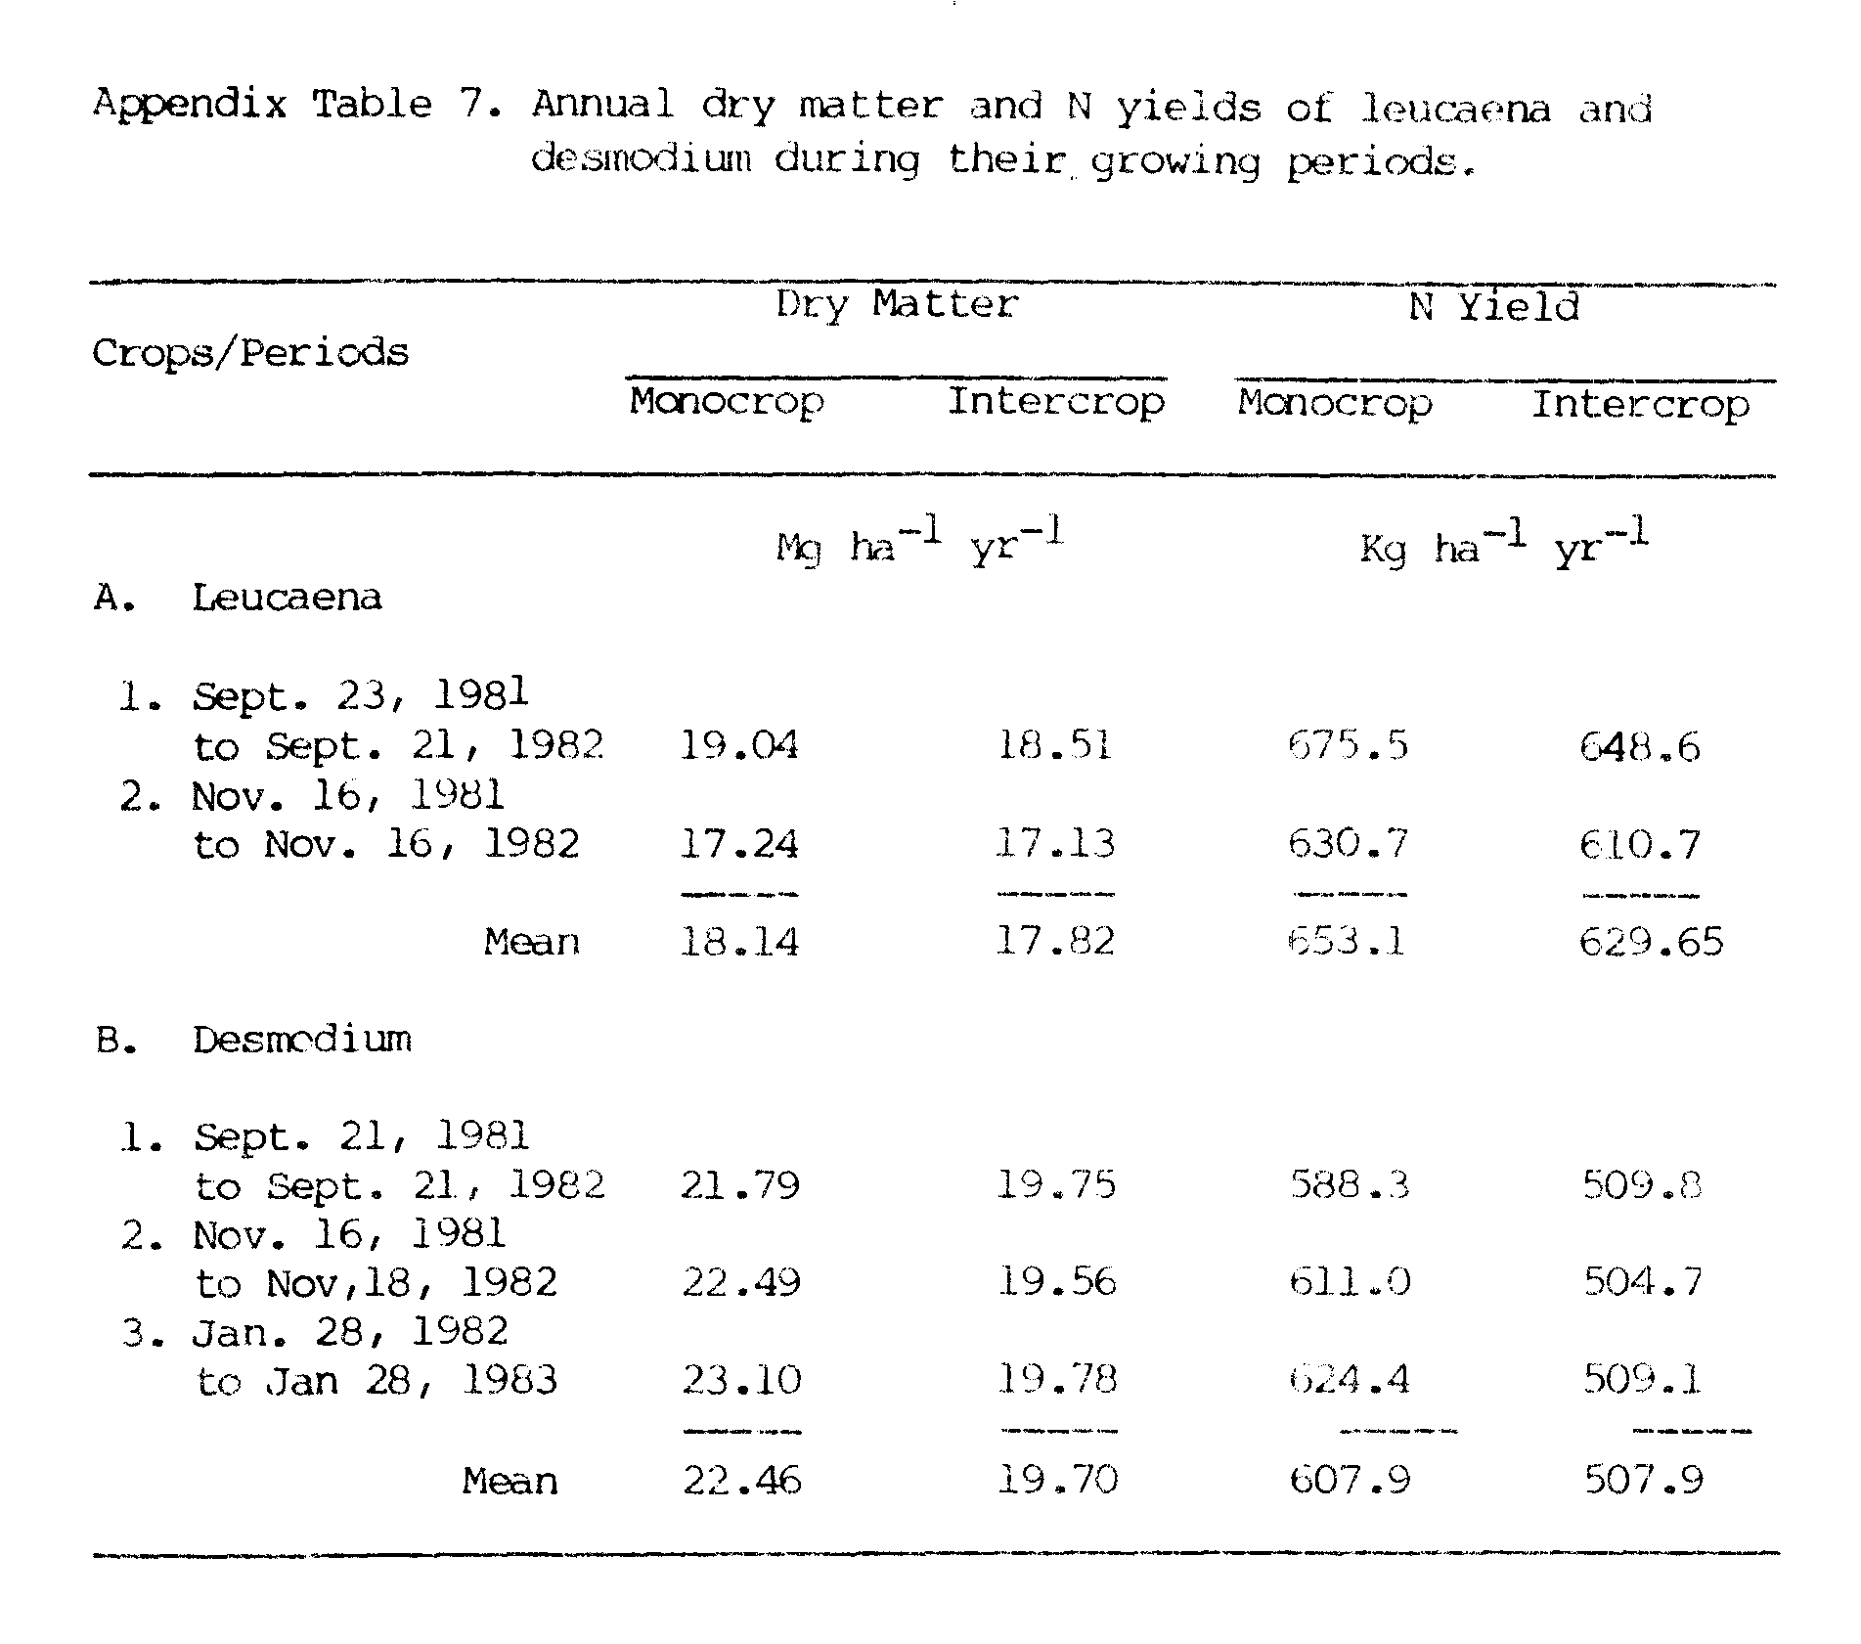
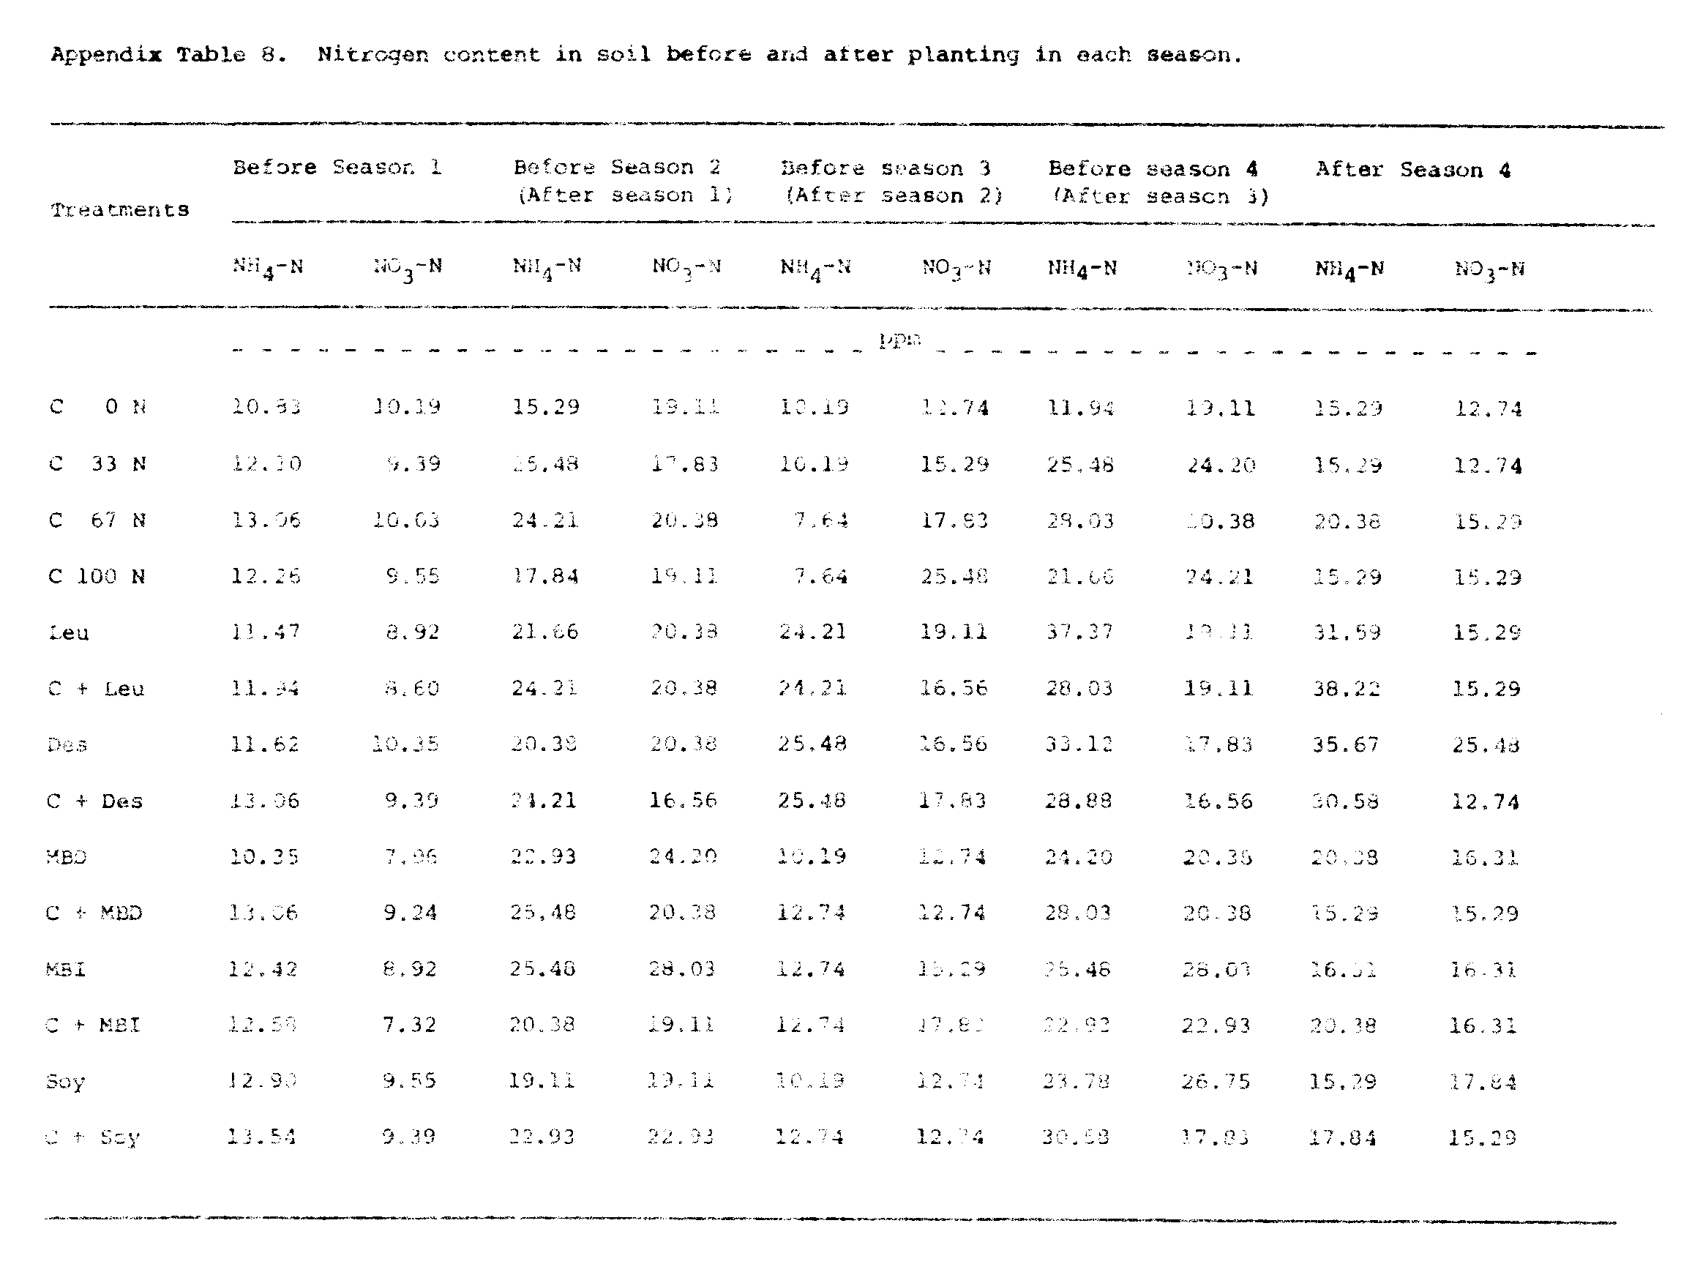
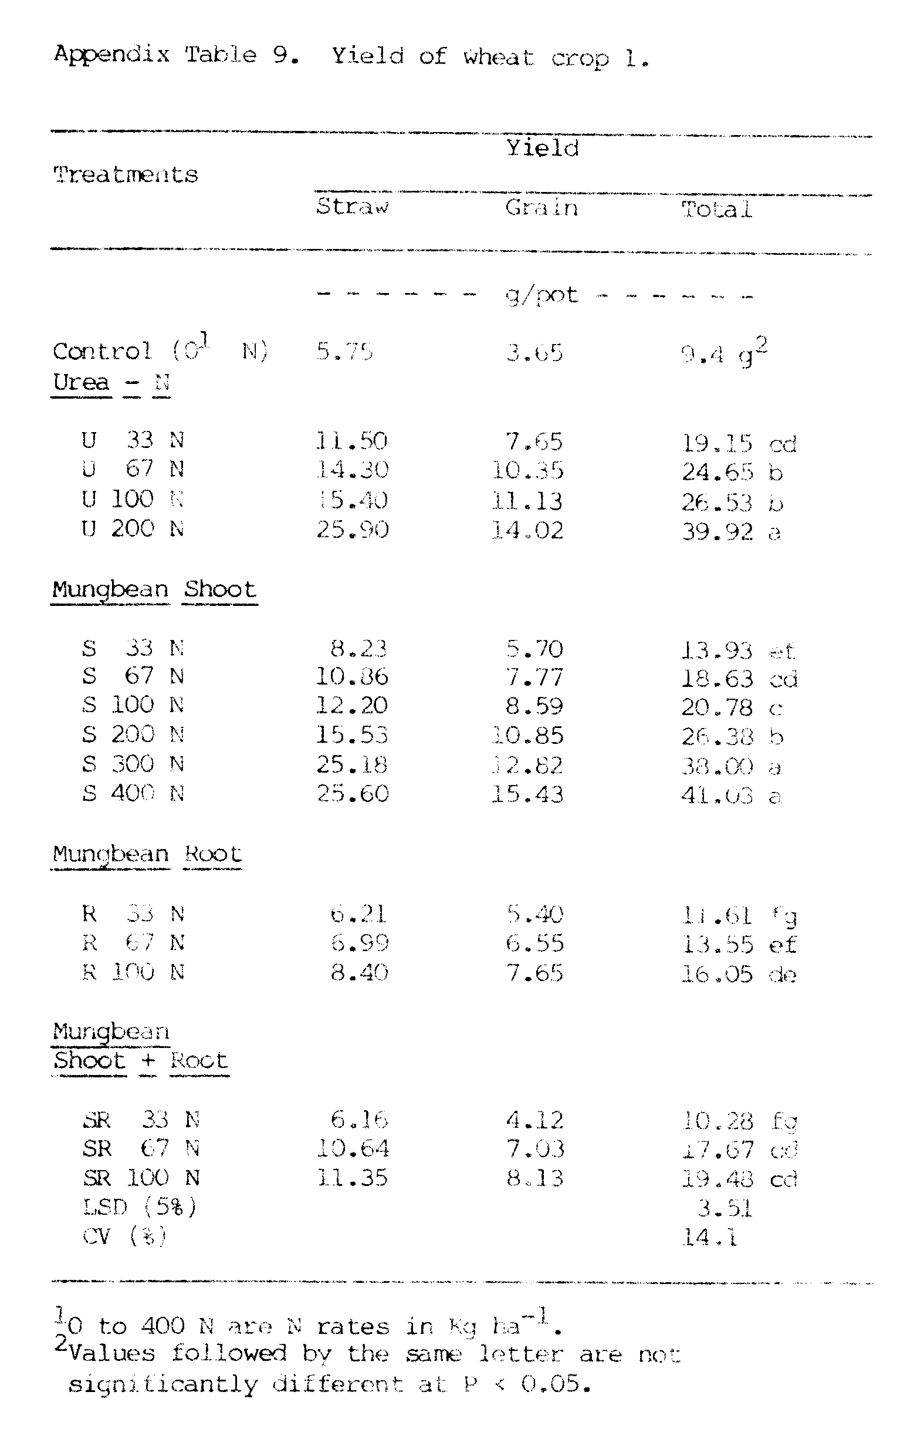
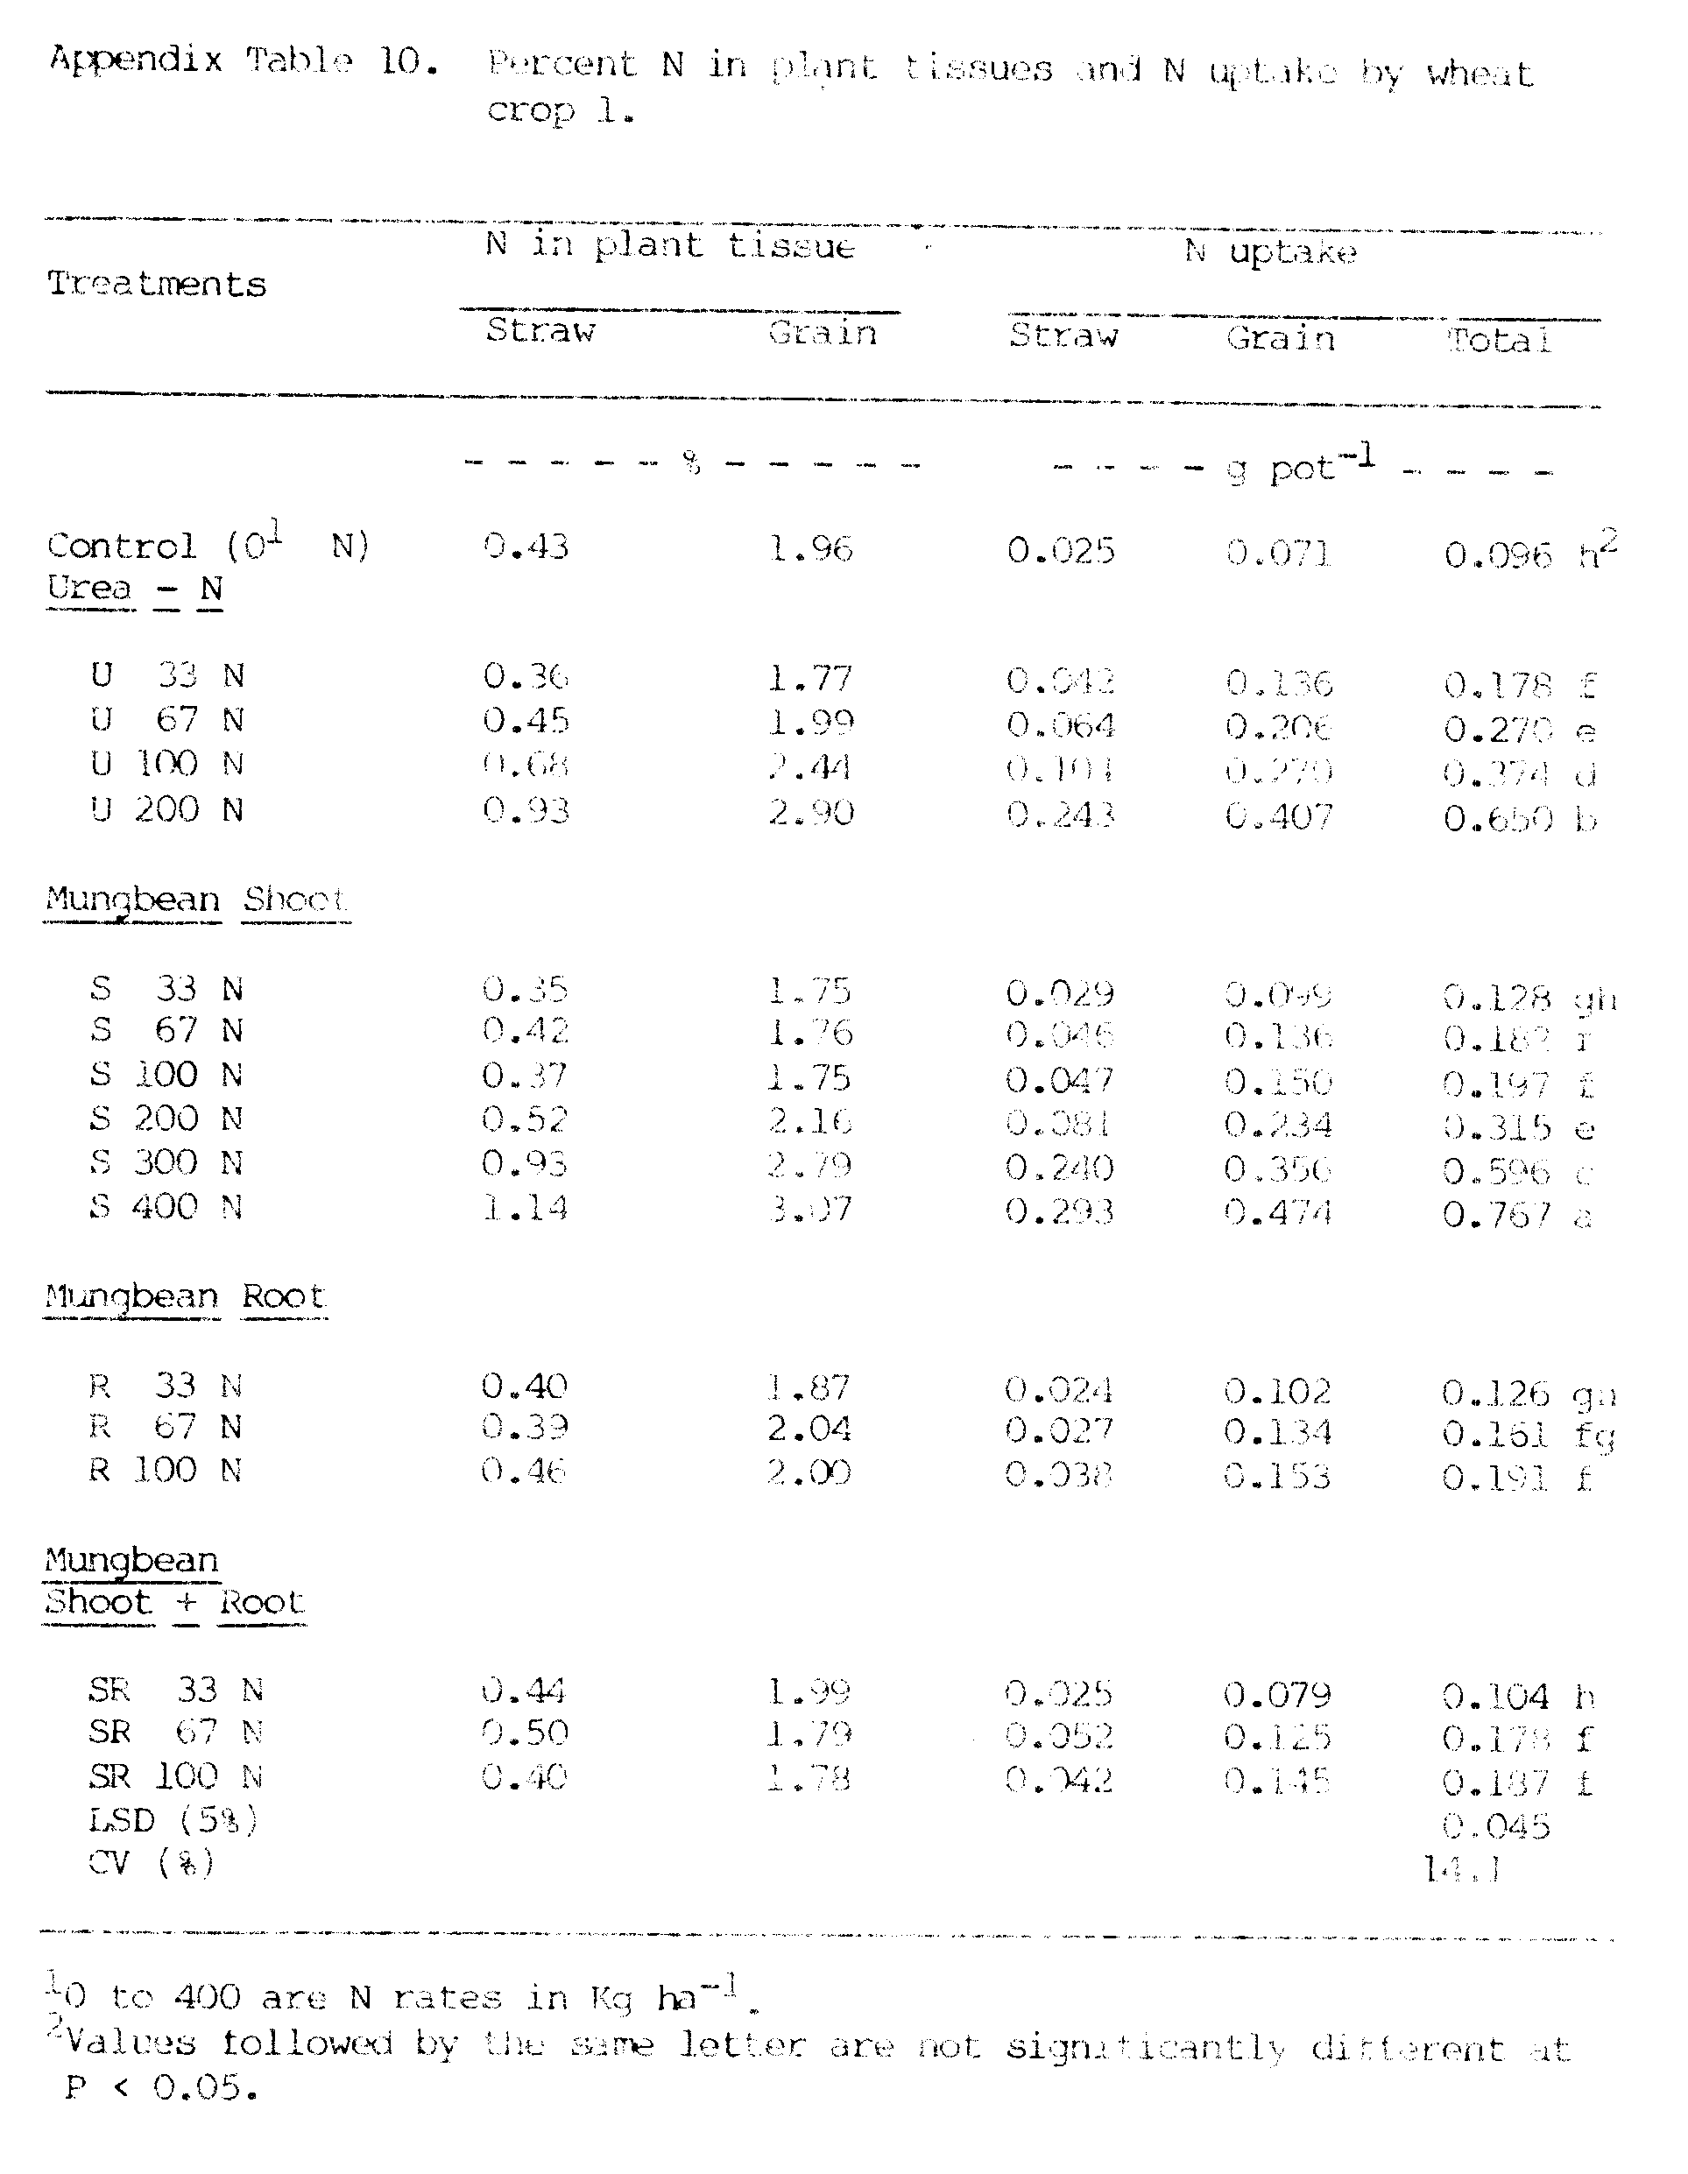
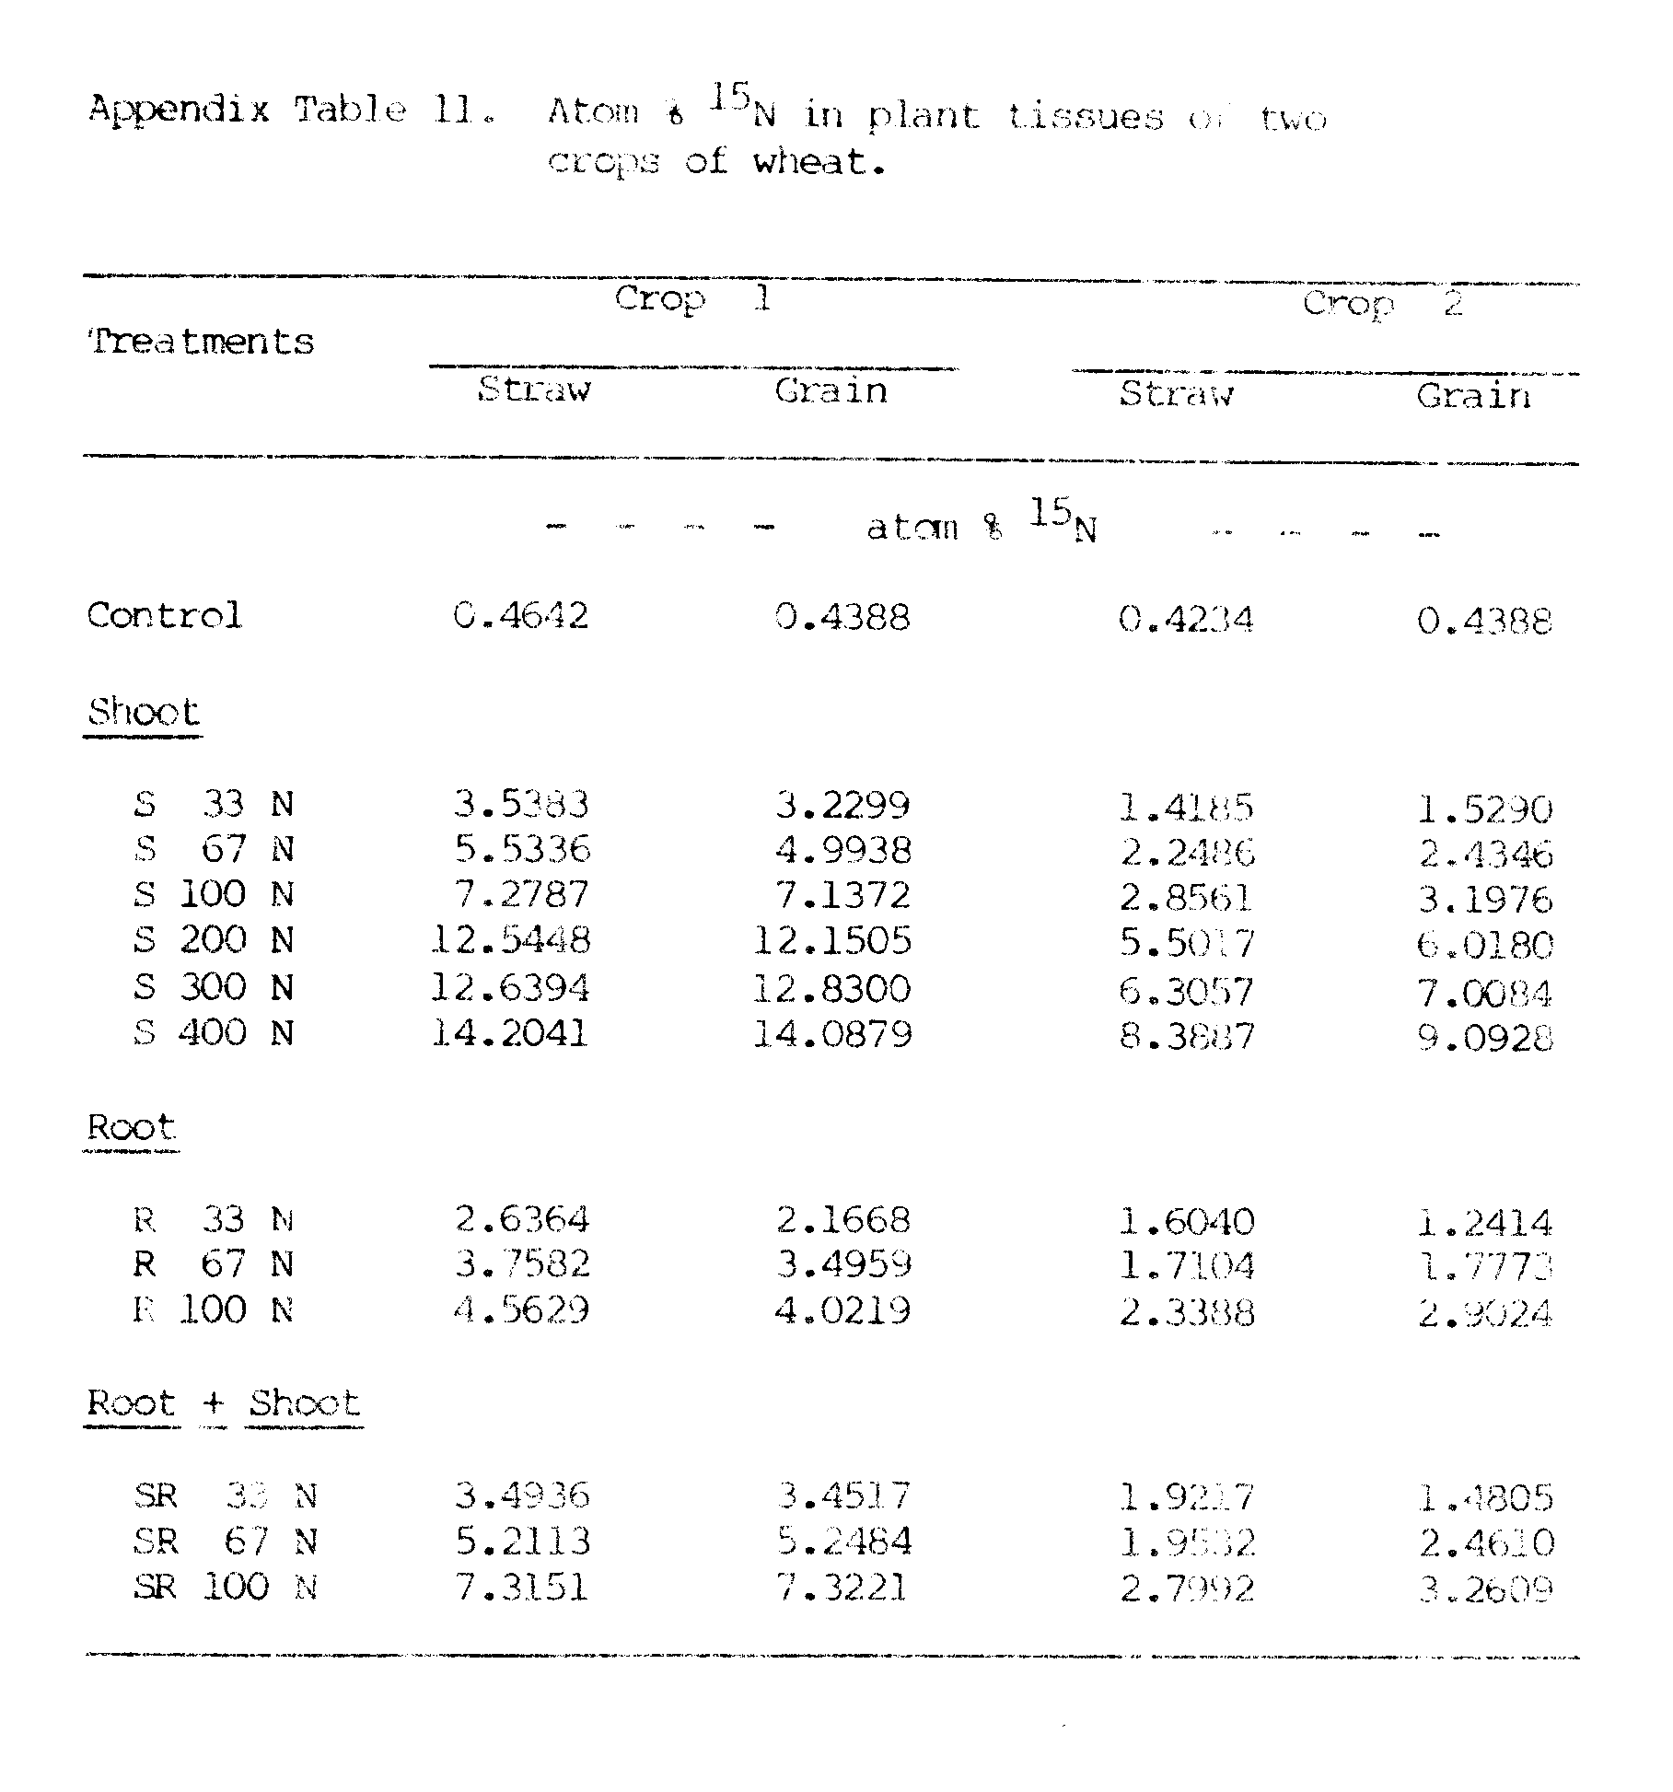

Appendix Figure 1. Planting Patterns of crops in:
A. monocrops, B. intercrops.
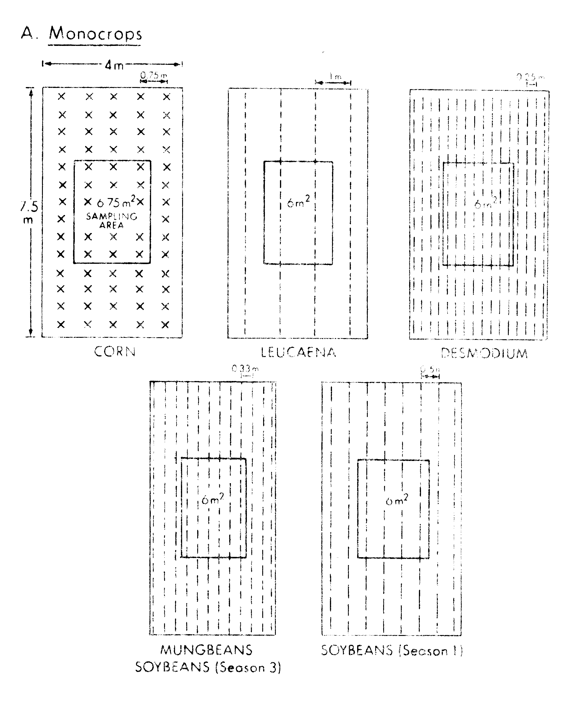

Appendix Figure 2. Growth of soybeans in: A) monocrop,
B) intercrop in season 1 (shaded), and C)
intercrop in season 3 (not shaded).

Appendix Figure 3. Growth of determinate mungbeans
as A) monocrop and B) intercrop, and
of indeterminate mungbeans as C)
monocrop and D) intercrop.

Appendix Figure 5. Growth of leucaena A) monocrop and
B) intercrop, and desmodium C) monocrop
and D) intercrop.

Appendix Figure 6. Growth of wheat crop l at various
rates of A) urea-N, B) mungbean shoot-N,
C) root-N, and D) shoot + root-N
applications.
LITERATURE CITED

Agboola, A. A., and A. A. Fayemi. 1971. Preliminary trials on the intercropping of maize with different tropical legumes in Western Nigeria. J. Agric. Sci. 77:219-225.

__________ and __________. 1972. Fixation and excretion of nitrogen by legumes. Agron. J. 64:409-412.

Ahlawat, I. P. S., A. Singh, and C. S. Saraf. 1981. Effects of winter legumes on the nitrogen economy and productivity of succeeding cereals. Expl. Agric. 17:57-62.

Ahmed, S. 1976. Studies on intercropping with grain legumes- A review of Trials III. PP. 239-248. In S. Ahmed and M. Sadiq (eds.) First Review Meeting INPUTS project. East-West Center, Honolulu.

__________ and H. P. M. Gunasena. 1979. Nitrogen utilization and economics of some intercropping systems in tropical countries. Trop. Agric. 56(2):115-123.

Alexander, M. 1961. Introduction to soil microbiology, Wiley, New York.

Ali, A. M., and Y. B. Morachan. 1974. Effects of irrigation levels and forms of manures on rice varieties IR8 and IR20. Madras Agri. J. 61(8):268-272.

Allen, L. H., T. R. Sinclair, and E. R. Lemon. 1976. Radiation and microclimate relationships in multiple cropping systems. PP. 171-200. In R. I. Papendick, R. A. Sanchez, and G. B. Triplett (eds.) Multiple cropping. Spec. Pub. No. 27. Am. Soc. of Agron., Madison, Wis.

Allison, F. E. 1965. Evaluation of incoming and outgoing processes that affect soil nitrogen. In W. V. Bartholomew and F. E. Clark (eds.) Soil nitrogen. Agronomy 10:573-606. Amer. Soc. Agron., Madison, Wis.

__________. 1966. The fate of Nitrogen applied to soils. Adv. Agron. 18:219-254.

Arnott, R. A., and C. R. Clemet. 1966. The use of herbicides in alternate husbandry as a substitute for plowing. Weed Res. 6:142-157.

Bartholomew, W. V. 1965. Mineralization and immobilization of nitrogen in the decanposition of plant and animal residues. PP. 285-306. In W. V. Bartholomew and F. E. Clark (eds.) Soil Nitrogen. Amer. Soc. Agron. Wisconsin.

Beets, W. C. 1977. Multiple cropping of maize and soybeans under a high level of crop management. Netherlands J. Agri. Sci. 25(2):95-102.

Bethlenfavay, G. J., and D. A. Phillips. 1977. Effect of light intensity on CO₂ and N reduction in Pisum sativum L. Plant Physiol. 60:868-871.

Blaser, R. E., and N. C. Brady. 1950. Nutrient competition in plant associations. Agron. J. 42:128-138.

Boatwrite, G. O., and H. J. Haas. 1961. Development and composition of spring wheat as influenced by nitrogen and phosphorus fertilization. Agron. J. 53:33-36.

Bremner, J. M. 1965a. Total nitrogen. PP. 1149-1178. In C. A. Black (ed.) Methods of soil Analysis. Amer. Soc. Agron. Madison.

__________. 1965b. Inorganic forms of nitrogen. PP. 1179-1237. In C. A. Black (ed.) Methods of soil Analysis. Amer. Soc. Agron. Madison .

Brewbaker, J. L., D. L. Plucknell and V. Gonzalez. 1972. Varietal variation and Yield trials of leucaena leucocephala (koa haole) in Hawaii. Agri. Exp. Stn. Res. Bull. 166.

Broadbent, F. E., T. Nakashima, and Grace Y. Chang. 1982. Estimates of nitrogen fixation by isotope dilution in field and greenhouse experiments. Agron. J. 74:625-628.

Bryan, W. W. 1962. Role of the legumes in legume/grass pastures. Bull. Bur. Past. Fld. Crops. No. 46, PP. 147-160.

Burns, R. H., and C. E. Miller. 1941. Application of ¹⁵N to the study of biological nitrogen fixation. Science 93:114-115.

Burton, J. W., C. A. Brim, and J. O. Rawling. 1983. Performance of nonnodulating and nodulating soybean isolines in mixed culture with nodulating cultivars. Crop Sci. 23:469-473.

Butler, G. W., R. M. Greenwood, and K. Soper. 1959. Effects of shading and defoliation on the turnover of root and nodule tissue of plants of Trifoleum repens, Trifoleum pratense and Lotus uliginous. N. Z. J. Agric. Res. 2:415-426.

Campos, F. F., and A. C. Macaso. 1976. Studies on mixed cropping sunflower with mung. PP. 259-268. In S. Ahmed and M Sadiq (eds.) First Review Meeting INPUTS Project. East-West Center, Honolulu.

Cassman, K. G., and D. N. Munns. 1980. Nitrogen mineralization as affected by soil moisture, temperature, and depth. Soil Sci. Soc. Am. J. 44:1233-1237.

Chandra, S. 1978. Monoculture, mixed cropping and rotation: implication for Fiji agriculture. Fiji Agri. J. 40(2):63-70.

Chatterjee, B. N, and M. A. Roquib. 1975. Soybean in multiple and intercropping. Ind. J. Gent. Plant Breed. 35:264-268.

Chowdhury, M. S. 1981. Nodulation and symbiotic nitrogen fixation in legumes under mixed cropping systems. P 469. In A. H. Gibson and W. E. Newton (eds.) Current perspectives in nitrogen fixation. Aust. Acad. of Sci., Elseviery/North-Holland Biomedical Press.

Cordero, A. 1978. Principles of intercropping; effects of nitrogen fertilization and row arrangement on growth, nitrogen accumulation, and yield of corn and interplanted annuals. Dissertation Abs. International, B (1978) 39(2)479-480. N. C. State Univ. Raleigh.

__________ and R. E. McCollum. 1979. Yield potential of interplanted food crops in Southeastern U.S. Agron. J. 71:834-842.

Dalal, R C. 1974. Effects of intercropping maize with pigeon peas on grain yield and nutrient uptake. Exp. Agri. 10(3):219-224.

__________. 1977. Effects of intercropping of maize with soybean on grain yield. Trop. Agri. 54(2):189-191.

Dart, P. J., and B. A. Krantz. 1977. Legumes in the semi-arid tropics. PP. 119-154. In J. M. Vincent, A. S. Whitney and J. Bose (eds.) Exploiting the legume-rhizobium symbiosis in tropical agriculture. College of Trop. Agri. Univ. Hawaii Pub. 145.

Das, S. K. and B. P. Mathur. 1980. Relative Performance of different Kharif legumes as pure and intercrops in maize and their residual effect on wheat. Ind. J. Agron. 25(4): 743-745.

Date, R. A. 1973. Nitrogen, a major limitation in the productivity of natural communities, crops and pastures in the pacific areas. Soil Bio Biochem. 5(1):5-18.

De, R., R. S. Gupta, S. P. Singh, R. N. Sharma, and S. K. Kaushik. 1978. Interplanting maize, sorghum and pearl millet with short duration grain legumes. Ind. J. Agri. Sci. 48(3):132-137.

de Wit, C. T. 1960. On competition. Versl. Landbouwk Onderz 66:8.

__________ and J. P. Vander Bergh. 1965. Competition between herbage plants. Neth. J. Agric. Sci. 13:212-221

Donald, C. M. 1963. Competition among crop and pasture plants. Adv. Agron. 15:1-118.

Egli, D. B., and J. E. Leggett. 1973. Dry matter accumulation patterns in determinate and indeterminate soybeans. Crop. Sci. 13:220-222.

Ericksen, F. I., and A. S. Whitney. 1982. Growth and N fixation as influenced by solar radiation regimes. Agron. J. 74:703-709.

Eusebio, R. V., and D. L. Umali. 1952. A test of four green manure crops for corn. Philippine Agriculturist 36(2):251-258.

Evans, D. O. 1981. The effect of management of Crotalaria juncea green manure on the yield and nitrogen uptake of maize. M.S. Thesis, Univ. of Hawaii.

Evensen, C. L. I. 1983. Seasonal yield variation, green leaf manuring, and eradication of Leucaena leucocephala (Lam) de wit. M.S. Thesis, University of Hawaii.

Finlay, R. C. 1974. Intercropping soybeans with cereals. PP. 75-85. In D. K. Wigham (ed.) Soybean production, protection and utilization. Univ. of Illinois, Inter. Agri. Pub., INTSOY Series No. 6.

Fisher, N. M. 1977. Studies in mixed cropping. II. Population pressures in maize-bean mixtures. Expl. Agri. 13(4):185-191.
Francis, C. A., A. Flor, and S. R. Temple. 1975. Adapting varieties for intercropped systems in the tropic. Multiple Cropping Symposium. ASA, Tennessee, Aug. 24-29.

Fried, M., and H. Broeshart. 1975. An independent measure of the amount of nitrogen fixed by a legume crop. Plant soil 43:707-711.

__________ and __________. 1981. A further extension of the method or independently measuring the amount of nitrogen fixed by a legume crop. Plant soil 62:331-336.

Gillard, P. 1967. Coprophagous beetles in pasture ecosystems. J. Aust. Inst. Agric. Sci. 33:30-34.

Gomez, A., A., and H. G. Zandstra. 1976. An analysis of the role of legumes in multiple cropping systmes. PP. 81-95. In J. M. Vincent, A. S. Whitney and J. Bose (eds.) Exploiting the legume-rhizobium symbiosis in tropical agriculture. College of Trop. Agri., Univ. of Hawaii, Mis. Pub. 145.

Graham, P. H., and D. H. Hubbell. 1975. Soil-plant-rhizobium interaction in tropical agriculture. In E. Bornemisza and A. Alvarado (eds.) Soil Management in Tropical America. N. C. State Univ., Raleigh, N. C.

Graham, P. H., and L. C. Rosas. 1978. Plant and nodule developement and nitrogen fixation in climbing cultivars of Phaseolus vulgaris L. grown in monoculture or associated with Zea mays L. J. Agri. Sci. 90:311-317.

Guevarra, A. B. 1976. Management of Leucaena leucocephala (Lam) de wit for maximum yield and nitrogen contribution to intercropped corn. Ph. D. Thesis. Univ. of Hawaii, 1976.

Gunasena, H. P. M., F. F. Campos, and S. Ahmed. 1978. Studies on intercropping and utilization of organic residues: A review of UNPUTS Trial III. PP. 99-122. In S. Ahmed and H. P. M. Gunasena (eds.) Second Review Meeting INPUTS Project. East-West Center, Honolulu.

__________, R. Sangakkara and P. Wickremasinghe. 1979. Studies on cereal- legume intercrop systems. J. National Sci. Council of Sri Lanka. 7(2): 85-93.

Hall, R.L. 1974a. Analysis of the nature of interference between plants of different species I. Concepts and extension of the de wit analysis to examine effects. Aust. J. Agric. Res. 25:739-747.

__________. 1974b. Analysis of the nature of interference between plants of different species II. Nutreint relations in a Nandi Setaria and Green leaf desmodium association with particular reference to potassium. Aust. J. Agric. Res. 25:749-756.

Hanway, J. J., and C. R. Weber. 1971. N. P. and K. percentages in soybean (Glycine max (L) Merril) plant parts. Agron. J. 63:286-290.

Hardy, R. W. F., R. D. Holsten, E. K. Jackson, and R. C. Burns. 1968. The acetylene-ethylene assay for N₂ fixation:Laboratory and field evaluation. Plant physiol. 43:118-1207.
Harper, J. E. 1976. Contribution of dinitrogen and soil or fertilizer nitrogen to soybean (Glycine max L. Merr) production. PP. 101-107. In L. D. Hill (ed.) World soybean research. The Interstate Printers and Publishers, Inc., Danville, Ill.

Hauck, R. D., and J. M. Bremner. 1976. Use of tracer for soil and fertilizer nitrogen research. Adv. Agron. 28:219-266.

Hegde, N. G. 1983. Improving yield and quality of leucaena. M.S. Thesis. University of Hawaii.

Henzell, E. F. 1962. Nitrogen fixation and transfer by some tropical and temperate pasture legumes in sand culture. Aust. J. Expl. Agri. Ani. Husb. 2:132-140.

Henzell, E. F. and I. Vallis. 1977. Transfer of nitrogen between legumes and other crops. PP. 73-88. In A. Ayanaba and P. J. Dart (eds.) Biological nitrogen and carbon under a Desmodium uncinatum pasture. Aust. J. Expl. Agric. Anim. Husb. 6:157-160.

__________ and I. F. Fergus, and A. E. Martin. 1966. Accumulation of soil nitrogen and carbon under a Desmodium uncinatum pasture. Aus . J. Expl. Agric. Anim. Husb. 6:157-160.

__________ and A. E. Martin, P. J. Ross, and K. P. Haydock. 1968. Isotopic studies on the uptake of nitrogen by pasture plants. IV. Uptake of nitrogen from labeled plant material by Rhodesgrass and Siratro. Aust. J. Agric. Res. 19:65-77.

Herridge, D. F. 1982. A whole-system approach to quantifying biological nitrogen fixation by legumes and associated grains and losses of nitrogen in agricultural systems. PP. 593-608. In P. H. Graham and S. C. Harris (eds.) Biological nitrogen fixation technology for tropical agriculture: Papers presented at a workshop held at CIAT, March 9-13, 1981. Cali, Colombia.

Ibrahim, A. F., K. M. Alrawi, and A. A. Salman. 1977. Performance of corn and soybean under intercropping in alternative rows and at different plant population densities. Zeitschrift fur Ackerund Pflanzenben. 145:224-237.

Indian Agricultural Research Institute. 1976. Beneficial effects from the introduction of legumes in crop rotations and intercropping systems. IARI Reporter. 1:1-5.

International Crops Research Institute for the Semi-arid Tropics. 1977. Report on the cropping systems research carried out during the kharif (monsoon) and rabi (post-monsoon) season of 1976. ICRISAT, Hyderabad, India.

International Institute of Tropical Agriculture. 1979. Annual Report 1979. IITA, Ibadan, Nigeria.

Ismaili, M. 1983. Measurement of N₂ fixation and transfer in a grass-legume mixture facilitated by use of N. P 157. In Agronomy Abs. 1983. Am. Soc. of Agron.

Jagannathan, N. T., Y. B. Morachan, and S. Ramain. 1979. Studies on the effect of maize and soybean association in different proportions on yield and grain. Madras Agric. J. 66(11):719-721.

Jones, M. J. 1974. Effects of previous crop on yield and nitrogen response of maize at Samaru, Nigeria. Exp. Agri. 10:273-279.

Jones, M. B., and K. W. Foster. 1983. Advantages of the isotope dilution for field measurement of dinitrogen fixation. P. 149. In Agronomy Abs. Am. Soc. of Agron.

Kang, B. T., L. Sipkens, G. F. Wilson, and D. Nangju. 1981a. Leucaena (Leucaena leucocephala (Lam) de wit) prunnings as nitrogen source for maize (Zea mays L.). Fertilizer Research 2:279-287.

Kang, B. T., G. F. Wilson and L. Sipkens. 1981b. Alley cropping maize (Zea mays L.) and Leucaena (Leucaena leucocephala) in Southern Nigeria. Plant Soil 63:165-179.

Karla, G. S., and B. Gangwar. 1980. Economics of intercropping of different legumes with maize at different levels of nitrogen under rainfall conditions. Indian J. Agron. 25(2):181-185.

Katznelson, H., J. W. Rouatt, and T. M. B. Payne. 1955. The liberation of amino-acids and reducing compounds by plant roots. Plant Soil 7:35-48.

Keya, N. C. O. 1974. Grass/legume pastures in Western Kenya. II. Legume performance at Kitale, Kislii, and Kakamega. E. Afr. Agri. Fores. J. 9:247-257.

Kitamura, Y., and S. Nishimura. 1976. Studies on mixed cultivation of tropical legumes and grasses. II. Effects of light intensity, inoculation and nitrogen application on early growth of Desmodium intortum. J. Japan Soc. Grassld. Sci. 22(2):116-120.

__________, A. S. Whitney, and A. B. Guevarra. 1981. Legume growth and nitrogen fixation as affected by plant competition for light and for soil nitrogen. Agron. J. 73:395-398.

Kretschmer, A. E., J. B. Brolmann, G. H. Synder, and G. J. Gascho. 1973. Production of six tropical legumes each in combination with three tropical grasses in Florida. Agron. J. 65:890-892.

Kuo, C. G., L. J. Wang, A. C. Cheng, and M. H. Chou. 1978. Physiological basis for mungbean yield improvement. PP. 205-209. In Cowell (ed.) The Ist International Mungbean Symposium, AVRDC, Taiwan.

Ladd, J. N., M. Amato, R. B. Jackson, and J. H. A. Butler. 1983. Utilization by wheat crops of nitrogen from legume residues decomposing from soils in the field. Soil Biol. Biochem. 15:231-238.

Lal, R. B., R. De, and R. K. Singh. 1978. Legume contribution to the fertilizer economy in legume-cereal rotations. Ind. J. Agri. Sci. 48:419-424.

Legg, J. O., and F. E. Allison. 1959. Recovery of ¹⁵N-tagged nitrogen from ammoniun fixing soils. Soil Sci. Soc. Am. Proc. 23:131-134.
__________ and C. Sloger. 1975. A tracer method for determining symbiotic nitrogen fixation in field studies. PP.661-666. In E. R. Klein and P. D. Klein (eds.) Proc. of the 2nd Int. Conference on Stable Isotopes, 20-23 Oct. 1975; Oak Brook, Ill.

Mahalingam, P. K., P. Kandaswamy, K. K. Krishnamoorthy, and K. K. Mathan. 1975. Efficiency of calcium ammonium nitrate compared to other sources of nitrogen for paddy. Madras Agri. J. 62(2):77-78.

Mahapatra, I. C., M. Singh, Daya Nand, and R. N. Singh. 1975. Pulses in cropping systems. Ind. J. Gent. Plant Breed. 35:188-193.

Malhi, S. S., and M. Nyborg. 1983. Field study of the fate of fall applied ¹⁵N-labeled fertilizers in three alberta soils. 1983. Agron. J. 75:71-74.

McGilchrist, C. A. 1965. Analysis of competition experiments. Biometrics 21:975-985.

Mendoza, R. C., T. P. Altamarino and E. Q. Javier. 1975. Herbage, crude protein and digestible dry matter yield of Ipil-Ipil (Leucaena) in hedge rows. Annual Scientific Convention of the Philippines Society of Animal Science.

Mendoza, R. C., L. R. Escano, and E. Q. Javier. 1981. Corn/leucaena intercropping trials. Leucaena Res. Reports 2:42. Inst. of plant Breeding, Los Banos, Philippines.

Miah, M. N. I., and V. R. Caranagal. 1980. Evaluation of mungbean cultivars under monoculture and intercropping systems. International Rice Research Newsletter (1980) 5(2):21-22. IRRI, Los Banos, Philippines.

Misra, A., and H. C. Misra. 1975. Effect of legumes on associated and subsequent crops. Ind. J. Genet. Plant Breed. 35(2):329-341.

Mohta, N. K., and R. De. 1980. Intercropping maize and sorghum with soybean. J. Agric. Sci. 95(1):117-122.

Moomaw, J. C., H. G. Park, and S. Shanmugasundaram. 1977. The role of legumes in South and South East Asia. PP. 155-169. In J. M. Vincent, A. S. Whitney and J. Bose (eds.) Exploiting the legume-rhizobium symbiosis in tropical agriculture. College of Trop. Agri. Univ. Hawaii Pub. 145.

Moore, A. W. 1974. Availability to rhodesgrass (Chloris gayana) of nitrogen in tops and roots added to soil. Soil Biol. Biochem. 6:249-255.

Nair, K. P. P., U. K. Patel, R. P. Singh, and M. K. Kaushik. 1979. Evaluation of legume intercropping in conservation of fertilizer nitrogen in maize culture. J. Agric. Aci. 93(1):189-194.

Narang, S. D., N. J. Kaul, and G. S. Gill. 1969. Intercropping of maize and soybean. Ind. Farming. 19(6):21.

Norman, A. G., and C. H. Werkman. 1943. The use of the nitrogen isotope ¹⁵N in determining nitrogen recovery from plant materials decomposing in soil. J. Am. Soc. Agron. 35:1023-1025.

Novak, J. M., and A. M. Blackmer. 1983. ¹⁵N transfer studies of reactions of nitric oxide during denitrification in soils. P. 159. In Agron. Abs. Am. Soc. Agron.

Nutman, P. S. 1971. Perspective in biological nitrogen fixation. Sci. Prog. (Oxford) 59:55-74.

Odu, C. T. I., and R. B. Akerele. 1973. Effects of soil, grass and legume root extract on heterotropic bacteria, nitrogen mineralization and nitrification in soil. Soil Biol. Biochem. 5: 1-867.

Patnaik, S., and N. V. Rao. 1979. Sources of nitrogen for rice production. PP. 25-44. In Nitrogen and rice. International Rice Research Institute, Los Banos, Philippines.

Pearce, S. C., and B. Gilliver. 1978. The statistical analysis of data from intercropping experiments. J. Agric. Sci. 91:625-632.

Perez-Escolar, R., T. W. Scott and M. A. Lugo-Lopez. 1978. Legume and non-legume crop residues as sources of N in Oxisols and Ulitisols. J. Agric. Univ. P. R. 62(4):361-366.

Pinchinat, A. M. 1977. The role of legumes in tropical America. PP. 171-182. In J. M. Vincent, A. S. Whitney and J. Bose (eds.) Exploiting the legume-rhizobium symbiosis in tropical agriculture. College of Trop Agri. Univ. Hawaii Pub. 145.

Pomares-Garcia, F., and P. F. Pratt. 1978. Recovery of ¹⁵N-labeled fertilizer from manured and sludge-amended soil. Soil Sci. Soc. Am. J. 42:717-720.

Powlson, D. S. 1980. Effects of cultivation on the mineralization of nitrogen in soil. Plant Soil 57:151-153.

Priebe, D. L., A. M. Blackmer, and J. M. Bremner. 1983. ¹⁵N-tracer studies of the fate of surface applied urea. P. 159. In Agron. Abs. Am. Soc. Agron.

Purchase, B. S. 1974. The influence of phosphate deficiency on nitrification. Plant Soil 41:541-547.

Rathore, S. S., G. S. Chauhan, and H. G. Singh. 1980. Stand geometry of maize and its intercropping with pulses under dryland agriculture. Ind J. Agron. 25(3):319-322.

Rattray, A. G. H., and B. S. Ellis. 1952. Maize and green manuring in Southern Rhodesia. Rhodesia Agricultural J. 49(4):188-197.

Read, M. D., Jr. 1982. Management alternatives for maize-bean and leucaena-based cropping systems. Ph. D. Dissertation. Colorado State University.

Reddy, M. N., and B. N. Chatterjee. 1973. Nodulation in soybean grown as pure and mixed crop. Ind. J. Agron. 18:410-415.

Remison, S. U. 1978. Neighbor effects between maize and cowpea at various levels of N and P. Exr. Agric. 14(3):205-212.
Rennie, R. J. 1982. Quantifying dinitrogen (N₂) fixation in soybeans by ¹⁵N isotope dilution: The question of the nonfixing control plant. Can. J. Bot. 60:856-861.

Rennie, R. J., S. Dubetz, J. B. Bole, and H. H. Muendel. 1982. Dinitrogen fixation measured by ^{l5}N isotope dilution in two Canadian soybean cultivars. Agron. J. 74:725-730.

Rhodes, I. 1970. Competition between herbage grasses. Herbage Abst. 40(2):115-121.

Roquib, A., A. Al. Kundu, and B. N. Chatterjee. 1973. Possibility of growing soybean in association with other crops. Ind. J. Agric. Sci. 43(8):792-794.

Rosa, J. M. D., R. M. Santiago, and M. B. Posas. 1980. Growth and yield of corn intercropped with giant ipil-ipil on a hillside. Annals of Trop. Res. 2(1):12-19.

Ruiz, M. J., and R. J. Laird. 1961. Tres leguminosas tropicales para abono verde. Agricultura Tecnica en Mexica 11:14-15.

Saraf, C. S., and R. De. 1975. Intercropping with legumes. Ind. J. Genet. Plant Breed. 35(2):209-215.

Saxena, M. C., and K. V. B. R. Tilak. 1975. Response to inoculation in soybean and its residual effects on wheat. Ind. J. Agron. 20:369-370.

__________ and D. S. Yadav. 1975. Multiple cropping with short duration pulses. Ind. J. Genet. Plant Breed. 35(2):194-208.

Schreven, D. A. van. 1968. Mineralization of the carbon and nitrogen of plant material added to soil and of the humus during incubation following periodic drying and rewetting of the soil. Plant Soil 28:226-245.

Schorder, V. N., and K. Hinson. 1974. Soil nitrogen from soybeans. Soil Crop Sci. Soc. Fla. Proc. 24:101-103.

Scott, W. R. 1973. Pasture plant nutrition and nutrient cycling. PP. 159-178. In R. H. M. Langer (ed.) Pastures and pasture plants, Wellington, Reed.

Scott, W. O., and S. R. Aldrich. 1970. Modern soybean production. S and A Pub. Illinois.

Searle, P. G. E., Y. Comudom, D. C. Shedden, and R. A. Nance. 1981. Effect of maize + legume intercropping systems and fertilizer nitrogen on crop yields and residual nitrogen. Field Crops Res. 4:133-145.

Sears, P. D. 1953. Pasture growth soil fertility. VII. General discussion of the experimental results and their application to farming practice in New Zealand. N. Z. J. Sci. Technol. 35:221236+

Shrader, W. D., W. A. Fuller, and F. B. Cady. 1966. Estimation of a common nitrogen response function of corn (Zea mays) in different crop rotations. Agron. J. 58:397-401.
Simpson, J. R. 1965. The transference of nitrogen from pasture legumes to an associated grass under several systems of management in pot culture. Aust. J. Agric. Res. 16:915-926.

__________. 1976. Transfer of nitrogen from three pasture legumes under periodic defoliation in a field environment. Aust. J. Exp. Agri. and Ani. Husb. 16:863-870.

Singh, N. D. 1977. Effects of intercropping maize with soybean on nematode and grain yield. Abst. Trop. Agri. 4:20446.

Singh, K. K., and O. P. Awasthi. 1978. Maintenance of soil fertility in the hills with incorporation of legumes in cropping sequences. Ind J. Agric. Sci. 48:41-46.

Singh, C. M., and P. Chand. 1980. Note on economics of grain legume intercropping and N fertilization in maize. Ind. J. Agric. Res. 14(1):62-64.

Singh, R. P., and M. V. R. Prasad. 1975. Intercropping of short duration grain legumes in sown pastures and field crops. Ind. J. Genet. Plant Breed. 35(2):271-275.

Singh, R. P., K. C. Singh, and Y. S. Ramakrishna. 1978. Effects of systems of planting greengram on the yield, total productivity, moisture use and monetary returns. Ind. J. Agric. Sci. 48(6):320323

Singh, M. and R. K. Singh. 1975. Prospects of growing pulses under multiple and intercropping. Ind. J. Genet. Plant. Breed. 35(2):216-220.

__________, W. L. Ogren, and J. M. Widholm. 1974. Photosynthetic characteristics of several C₃ and C₄ plant species grown under different light intensities. Crop Sci. 14:563-566.

Singh, B. D. S. Rana, and G. S. Sekhon. 1978. Some measures of reducing leaching loss of nitrates beyond potential rooting zone IV. Intercropping. Plant Soil 4:633-639.

Singh, J. N., S. K. Tripathi, and P. S. Negi. 1974. Yield and nitrogen content of non-nodulating soybean grown in association with nodulating lines. Proc. Indian Natl. Sci. Acad. Part B 40:507-511.

Singh, T., Y. Nagaraja Rao, and M. N. Sadaphal. 1980. Effect of legumes on physical properties of soil in mixed cropping with maize. Ind. J. Agron. 25(4):592-599.

Sampongse, D., E. T. Craswell, and B. H. Byrnes. 1983. Effect of soil puddling on loss of ¹⁵N-labeled urea under various flooded conditions. P. 180. In Agron. Abs. Am. Soc. Agron.

Soper, R. J., G. J. Raez, and P. I. Fehr. 1971. Nitrate nitrogen in the soil as a means of predicting the fertilizer nitrogen requirements of barley. Can. J. Soil Sci. 51:45-49.

Srivastava, V. C., C. Soran, and M. N. Shahani. 1980. Performance of soybean (Glycine max (L.) Merr.) in association with companion crop Tropical Grain legume Bulletin No. 22:11-14. Ranchi, India.
Stern, W. R., and C. M. Donald. 1962. Light relationships in grass-clover swards. Aust. J. Agric. Res. 13(4):599-614.

Stickler, F. C., W. D. Shrader, and J. J. Johnson. 1959. Comparison of leguminous green manures with inorganic nitrogen for corn production. Agron. J. 51:157-160.

Stutte, C. A., R. T. Weiland, and A. R. Blem. 1979. Gaseous nitrogen loss from soybean foliage. Agron. J. 71:95-97.

Subba Rao, N. S. 1975. Nitrogen gain by legumes and residual nitrogen left behind in the soil through rhizobium application. Ind. J. Genet. Plant Breed. 35(2):236-238.

Sundara, Rao, W. V. B. 1975. The scope and limitations of biological fixation of atmospheric nitrogen by legumes, non-legumes and asymbiotic N fixers and their contribution to our nitrogen economy. Ind. J. Genet. Plant Breed. 35(2):306-307.

Talbott, N. J., W. J. Kenworthy, and J. O. Legg. 1982. Field comparison of the nitrogen-15 and difference methods of measuring nitrogen fixation. Agron. J. 74:799-804.

Talleyrand, H., R. Perez-Escolar, M. A. Lugo-Lopez, and T. W. Scott. 1977. Utilization of nitrogen from crop residues in Oxisols and Ultisols. J. Agri. Univ. P. R. 61(4):450-455.

Tanaka, A., and S. A. Navasero. 1964. Loss of nitrogen from the rice plant through rain or dew. Soil Sci. Plant Nutr. 10:36-39.

Terman, G. L., and S. E. Allen. 1974. Losses of nitrogen and mineral nutrients from corn grown in greenhouse pot experiment. Soil Sci. Soc. Am. Proc. 38:322-326.

Theron, J. 1951. The influence of plants on the mineralization of nitrogen and the maintenance of organic matter in the soil. J. Agric. Aci. 41:289-296.

Thompson D. R. 1977. The effect of cereal height on performance of stands intercropped with soybean. M. Sc. Thesis. Univ. of Dares Salaam, Morogoro, Tanzania.

Tiwari, B. P., and C. R. Bisen. 1975. Legumes in crop rotations, mixtures and intercropping. Ind. J. Genet. Plant Breed. 35(2):282-290

Trang, K M., and J. Giddens. 1980. Shading and temperature as environmental factors affecting growth, nodulation, and symbiotic N fixation by soybeans. Agron. J. 72.:305-308.

Toews, W. H., and R. J. Soper. 1978. Effects of nitrogen source, methods of placement and soil type on seedling emergence and barley crop yields. Can. J. Soil Sci. 58:311-320.

Tomar, J. S., and R. J. Soper. 1981. Fate of tagged Urea-N in the field with different methods of N and organic matter placement. Agron. J. 3:991-995.

Urey, H. C., M. Fox, J. R. Huffman, and H. G. Thode. 1937. A concentration of ¹⁵N by a chemical exchange reaction. J. Am. Chem. Soc. 59:1407-1408.

Vallis, I. 1978. Nitrogen relationships in grass/legume mixtures. PP. 190-201. In J. R. Wilson (ed.) Plant relations in pastures. CSIRO Aust: Melbourne.

Vallis, I., K. P. Haydock, P. J. Ross, and E. F. Henzell. 1967. Isotopic studies on the uptake of nitrogen by pasture. III. The uptake of small addition of N-labeled fertilizer by Rhodesgrass and Townsville lucerne. Aust. J. Agric. Res. 18:867-877.

Van de Goor, G. A. W. 1954. The value of some leguminous plants as green manure in comparison with Crotalaria juncea. Net. J. Agric. Sci. 2(1):37-43.

Vest, Grant. 1971. Nitrogen increases in a nonnodulating soybean genotype grown with nodulating genotypes. Agron. J. 63:356-359.

Virtanen A. I. 1947. The biology and chemistry of nitrogen fixation by legume bacteria. Biol. Rev. 22:239-400.

__________, S. Von Hausen, and T. Laine. 1937. Investigation on the root nodule bacteria of leguminous plants. XX. Excretion of nitrogen in associated cultures of legumes and nonlegumes. J. Agric. Sci. 27:584-610.

Wade, M. K., and P. A. Sanchez. 1983. Mulching and green manure applications for continuous crop production in the Amazon Basin. Agron. J. 75:39-45.

Wagner, G. H., and F. Zapata. 1982. Field evaluation of reference crops in the study of nitrogen fixation by legumes using Isotopic techniques. Agron. J. 74:607-612.

Wahua, T. A. T., and D. A. Miller. 1978a. Effects of intercropping on soybean N fixation and plant composition on associated sorghum and soybeans. Agron. J. 70:292-295.

__________ and __________. 1978b. Effects of shading on the N fixation, yield an pant composition of field-grown soybeans. Agron. J. 70:387-392.

Walker, T. W., A. F. R. Adams, and H. D. Orchiston. 1956. Fate of labeled nitrate and ammonium nitrogen when applied to grass and clover grown separately and together. Soil Sci. 81:339-351.

__________, H. D. Orchiston, and A. F. R. Adams. 1954. The nitrogen economy of grass legume associations. J. Brit. Grassla. Soc. 9:29-274.

Watson, E. R., and P. Lapins. 1964. The influence of subterranean clover pastures on soil fertility. II. The effects of certain management systems. Aust. J. Agric. Res. 15:885-894.

__________ and __________. 1969. Losses of nitrogen from urine on soils from South-Western Australia. Aust. J. Exp. Agric. Anim. Husb. 9:85-91.
Weber, C. R. 1966a. Nodulating and non-nodulating soybean isolines. II. Response to applied nitrogen and modified soil conditions. Agron. J. 58:46-49.

__________. 1966b. Nodulating and non-nodulating soybean isolines. I. Agromomic and chemical attributes. Agron. J. 58:43-46.

Weber, D. F., B. E. Caldwell, C. Sloger, and H. G. Vest. 1971. Some studies on the soybean-rhizobium symbiosis. Plant Soil Spec. Vol. 293-304 .

Westerman, R. L., and L. T. Kurtz. 1974. Isotopic and non-isotopic estimation of fertilizers N uptake by sudangrass in field experiments. Soil Sci. Soc. Am. Proc. 38:107-109.

Wetselaar, R. 1983. ¹⁵N balance studies in flooded rice soils. P 49. In Agro. Abs. Am. Soc. Agron.

Whiteman, P. C. 1970. Seasonal changes in growth and nodulation of perennial tropical pasture legumes in the field. Aust. J. Agric. Res. 21:207-214.

Whitney, A. S. 1970. Effects of harvesting interval, height of cut and nitrogen fertilization on the performance of Desmodium intortum mixtures in Hawaii. Proc. XI. Int. Grassld. Cong. 631-636.

__________. 1977. Contribution of forage legumes to the nitrogen economy of mixed swards: A review of relevant Hawaiian research. PP. 89-96. In A. Ayanaba and P. J. Dart (eds.) Biological nitrogen fixation in farming systems in the tropics. Wiley, New York, NY, U.S.A.

__________. 1982. The role of legumes in mixed pastures. PP. 361-367. In P. H. Graham and S. C. Harris (eds.) Biological nitrogen fixation technology for tropical agriculture: Papers presented at a workshop held at CIAT, March 9-13, 1981. Cali, Colombia.

__________ and R. E. Green. 1969. Legume contributions to yield and composition of Desmodium spp.-pangolagrass mixtures. Agron. J. 61:741-746.

__________ and Y. Kanehiro. 1967. Pathways of nitrogen transfer in tropical legume-grass association. Agron. J. 59:585-588.

__________, __________ and G. D. Sherman. 1967. Nitrogen relationships of three tropical forage legumes in pure stands and in grass mixture. Agron. J. 59:47-50.

__________, B. L. Koch, and T. J. Wacek. 1976. Nitrogen fixation by tropical agricultural legumes. PP. 275-280. In S. Ahmed and M. Sadiq (eds.) First Review Meeting INPUTS Project. East-West Center, Honolulu, Hawaii.

Willey, R. W. 1979a. Intercropping – it’s importance and research needs. Part I. Competition and yield advantages. Field Crop Abst. 32:1-10.

__________. 1979b. Intercropping – it’s importance and research needs. Part II. Agronomy and research approaches. Field crop Abst. 32:73-85.

__________. 1981. A Scientific approach to intercropping research. PP. 4-14. ICRISAT (International Crops Research Institute for the Semi-Arid Tropics). Proceedings of the international workshop on intercropping. 10-13 Jan. 1979. Hyderabad, India.

Wilson, P. W. 1940. The biochemistry of symbiotic nitrogen fixation. The Univ. of Wis. Press, Madison.

__________ and J. C. Burton. 1938. Excretion of nitrogen by leguminous plants. J. Agric. Sci. 28:307-323.

__________ and O. Wyss. 1937. Mixed cropping and the excretion of nitrogen by leguminous plants. Soil Sci. Soc. Am. Proc. 2:289-297.

Woledge, J. 1978. The effect of shading during vegetative and reproductive growth on the photosynthetic capacity of leaves in a grass sward. Ann. Bot. 42:1085-1089.

Wong, K. C., and F. S. C. P. Kalpage. 1976. A study on intercropping maize with soybean. Malaysian Agric. Res. 5(2):125-130.

Wong C. C., and J. R. Wilson. 1980. Effects of shading on the growth and nitrogen content of greenpanic and siratro in pure and mixed swards defoliated at two frequencies. Aust. J. Agric. Res. 31:69-285 .

Wyss, O., and P. W. Wilson. 1941. Factors influencing excretion of nitrogen by legumes. Soil Sci. 52:15-29.

Yaacob, O., and G. J. Blair. 1980. Minerialization of ¹⁵N-labeled legume residues in soils with different nitrogen contents and its uptake by rhodesgrass Plant Soil 57:237-248.

Yingchol, P. 1976. The effect of corn density and mungbean varieties on the productivity of corn-mung intercrop. PP. 269-274. In S. Ahmed and M. Sadiq (eds.) First Rev. Meeting INPUTS Projects. East-West Center, Honolulu, Hawaii.

Younge, O. R., D. L. Plucknett and P. P. Rotar. 1964. Culture and yield performance of Desmodium intortum and D. canum in Hawaii Agric. Exp. Stn. Tech. Bull. 59.

